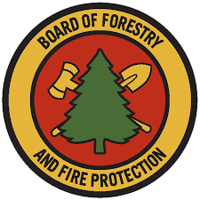

Range Management Advisory Committee
State Lands Grazing License and Land Management
Guidance Packet

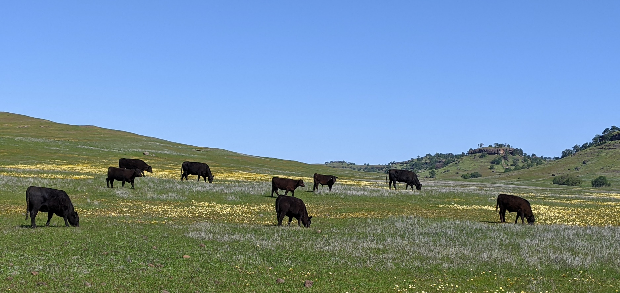

Created July 2022

Table of Contents:

Cover | 1
Table of Contents | 2
Background, Foreword & Team Members | 3
References and Resources | 4
Comprehensive Land/Grazing Management Plan Template | 5
Recommended items for consideration in a grazing license
Frequently asked questions (DGS Q & A)

Background: The Range Management Advisory Committee (RMAC) is authorized by Section 741 of the Public Resources Code of the State of California to provide a source of counsel for the Board of Forestry and Fire Protection (Board) concerning the rangelands of California. The mission of RMAC is to consider issues related to California’s rangeland resources, provide recommendations on addressing them, facilitate strong relationships with local, state and federal agencies and develop solutions that are based on environmental, social, and economic information that is current, data-driven, and considers diverse perspectives. This Guidance Packet meets RMAC’s Strategic Plan objective to “Share information and education with Certified Range Managers and government agency rangeland and forestry staff to grow professional knowledge in the field of rangeland health.”

Foreword: This Guidance Packet was developed to support California government agencies looking to utilize managed livestock grazing as a tool to enhance ecological values and reduce fire fuels loads on public lands. Many historical sustainable grazing management programs exists on state lands that can serve as a model to those looking to utilize grazing as a land management tool on public lands. While this Guidance Packet seeks to assist staff with a desire to implement new grazing management programs with resources and tools to streamline processes.

Team Members:
Lance Criley; RMAC, U.S. Department of Agriculture (USDA) United States Forest Service
Jeanette Griffin; California Department of Fish & Wildlife (CDFW)
Richard M. Ross; RMAC, legal counsel
Kevin Conway; Jackson State Demonstration Forest
Tony Psihopaidas; State Department of General Services
Lawrence Ford*; LD Ford Rangeland Conservation Science
Bart Cremers*; CA Farm Bureau and WILDLANDS
Tracy Kay Schohr*; U.C. Cooperative Extension and rancher
Katie Delbar; USDA Farm Service Agency and rancher
Advisor: Kristina Wolf*, California State Board of Forestry & Fire Protection

*Certified Rangeland Manager, licensed under a specialty certificate within the California’s Forest Practice Rules under California Board of Forestry and Fire Protection

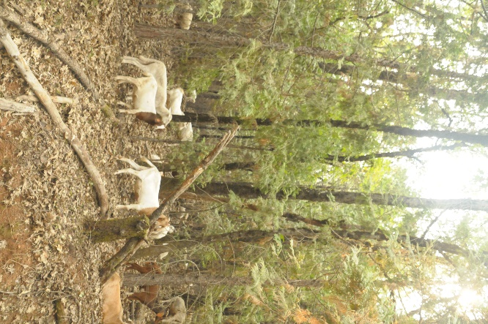
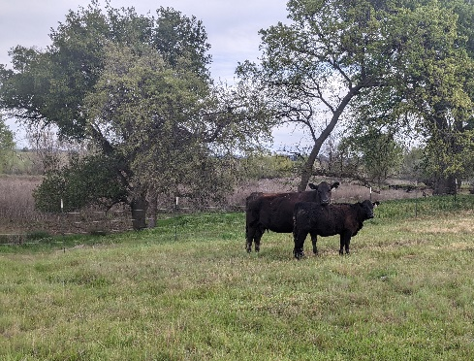
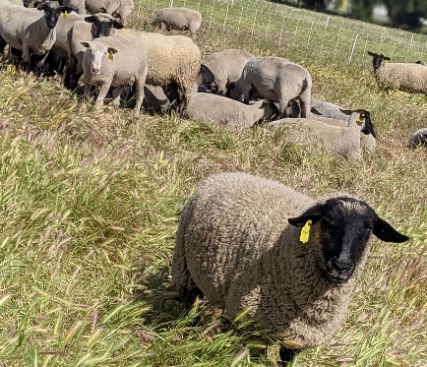

References & Resources:

Guide to Regenerative Grazing Leases: Opportunities for Resilience
https://www.californiafarmlink.org/resources/guide-to-regenerative-grazing-leases-opportunities-for-resilience/

Other Resources

University of California Cooperative Extension Livestock and Natural Resources Advisors: A network of scientists and educators located across the state of California that can provide technical advice on the development of grazing programs, assist with solicitation of grazing opportunities to the livestock industry, and more. UC Cooperative Extension Advisors conduct science-based extension and outreach; along with scientific studies to advance sustainable livestock grazing management.

Certified Rangeland Mangers: There are over 100 individuals in California that are a "Certified Rangeland Manager" (CRM), licensed under the California Board of Forestry and Fire Protection. These professionals can serve as technical advisors to state agencies looking to implement grazing programs. Learn more at https://casrm.rangelands.org/index.html.

Guide to Regenerative Grazing Leases: Opportunities for Resilience – Published in 2022, this booklet provides dozens of resources and reference for land managers. This publications focuses on livestock grazing leases on private lands, but can provide useful resources and case studies for public land managers. https://www.californiafarmlink.org/resources/guide-to-regenerative-grazing-leases-opportunities-for-resilience/

Other items to deal with

- Include a process for making decisions, resolving conflict, and settling on details of the agreement.
- Do we want to give any general monitoring guidelines in the Guidance Document such as when RDM monitoring would be appropriate vs. vegetation heights, vs. species relevè, etc. or some combination? Or does that start to get too complex?
- Other Comments:
It may be helpful to attach exhibits showing assessors parcels, fencing, infrastructure, etc. In addition to the list above, it is advised that in sensitive habitat areas, a land management plan is developed to include habitat stewardship goals, grazing management goals, and monitoring. The grazing license should focus primarily on the legal aspects of the agreement and work in conjunction with the management plan that focuses on the stewardship of the land. Refer to RMAC Grazing Management Plan Template and associated Guidance Document. These management plans may be developed with a Certified Range Manager and more information can be obtained working with your regional RCD or local UC extensions agent.

Notes related to specific items above:

2 c. Public lands may need to include non-discrimination language and Americans with Disabilities Act language.
3. Provide description of benefits of various lease terms, i.e. A typical grazing license would be one year minimum up to five years or more. In general, a longer-duration license is more desirable to the grazing tenant, allowing them to plan long-term and can also benefit the property by giving more incentive for the tenant to work on site improvements and providing continuity of management. This should probably go in the Guidance Document rather than the Outline.
3b. Possession or 'occupation' ~ If you move onto an allotment do you take possession or just occupy in conjunction with other users. Elaborate on this.
3c. Describe or give examples of conditions that might warrant early or late on/off dates. Early rain, early thaw, drought, etc.
3d. Provide examples of what could cause early termination, i.e. specifics of failing to comply with terms of linked Grazing Management Plan, or repeated failing to meet performance standards. Performance standards must be clear and measurable in order to be enforceable.
3e. Discuss different extension options and benefits, based on agency renewal policies. For example: Opportunity for extension of the license for 2-3 additional terms if licensee continually complies with linked Grazing Management Plan and meets performance standards.
4. Explain the idea of fee credits for improvements and give common examples: fencing, water development, etc.
4b. Discuss pluses and minuses of different fee structures. Depending on how rent is figured, it may incentivize different grazing management strategies or stocking rates.
7a. We would normally use the term 'lease' if you are entitled to exclusive use of the property or a portion of for some purpose.
9a. Should define what fence specs are to be used. Good and substantial is defined in Ag Code, but some agencies like smooth wire at some locations and max heights for top and bottom. Also cover spacing of tee posts (and weight of tee posts) and distance between wood posts and stretch points. May or may not include a dollar threshold where landlord pays for more expensive repairs, for example pump or well repairs.
11c. Use of ATVs / UTVs. Essential for many operations could be specified as implements of husbandry.
12a. Should also address taking in 'pasture cattle' (cattle / livestock not belonging to licensee.)
15a. Should specify what happens if it is an act of nature vs. vandalism vs. the fault of the licensee.
- From Land Management Plan Action Team:
  - Differentiate various purposes of land management plans, and tier any plan to existing planning documents.
  - We strongly recommend following the comprehensive plan template outlined in the Land Management Planning document; and recognize that some entities will not have the resources to complete it, thus requiring a condensed template.
  - Those authorizing such planning must identify who is to be responsible for developing these plans (usually the landowner, not the lessee/licensee if public lands).
  - Those authorizing such planning must also identify who will be responsible for conducting the required monitoring (usually the landowner, with supplementary monitoring by the licensee).
  - We strongly recommend employing professional expertise (such as a state-licensed Certified Rangeland Manager) to lead plan development and conduct the monitoring on non-federal rangelands covered by state resources code. Those authorizing such planning must identify who will pay for such services (usually the landowner).
  - Plan for pilot implementations of these templates as well as a review period for these templates after 3-5 years for testing, adjustments, and updates,.
  - RMAC should develop a Bibliography and Glossary to supplement the Land/Grazing Management Plan template, to be made available on a dedicated website.
  - Note: need to cite the FAC about “good and substantial fence”, and address conflicts between FAC and some agency guidelines.

Conduct of such work is required to comply with state resources code. Note that landowners are exempt from these requirements when directly managing their own lands. Refer to Professional Foresters Examining Committee (PFEC) Policy 12 “Guidance on the Certified Rangeland Manager Program” approved by the California Board of Forestry on July 14, 2021 (https://casrm.rangelands.org/pdfs/pfec-policy-statements-adopted-july-14-2021_ada.pdf ) and California Deputy Attorney General Bagley’s 2008 analysis (http://www.elkhornsloughctp.org/uploads/files/1223682249DAG%20Opinion%20on%20CRM.pdf ).

