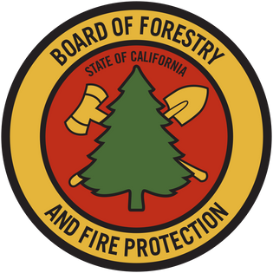

California Vegetation Treatment Program (CalVTP)
Project Data Entry User Guide
May 27, 2025

Table of Contents
CalVTP Project Data Submission User Guide 5
1. Introduction to the CalVTP and Project Submission Requirements 5
2. Important Terms 5
Approved Project 5
Fuel Type 6
Lead Agency 6
Project Boundary 6
Project Point 6
Project Proponent 6
Proposed Project 7
PSA (Project Specific Analysis) 7
SPR AD-7 7
Treatment Activity 7
Treatment Area 7
Treatment Type 8
3. Description of CalVTP Spatial Data and Environmental Documentation 8
A. Data: PROPOSED PROJECTS 8
B. Data: APPROVED PROJECTS 9
C. Data: ACTIVE PROJECTS 10
D. Data: COMPLETED PROJECTS 11
E. Data: WITHDRAWN PROJECTS 12
4. Detailed CalVTP Data and Documentation Completion and Submission Requirements 12
A. Submission: PROPOSED PROJECTS 12
B. Submission: APPROVED PROJECTS 16
C. Submission: ACTIVE PROJECTS 30
D. Submission: COMPLETED PROJECTS 31
E. Submission: WITHDRAWN PROJECTS 33
APPENDICES 34
Figure 1. Form SPR AD-7 for Proposed Projects 34
Figure 2. Online Submission Tool for a Proposed Project: Enter Proposed Project Point. 35
Figure 3. Online Submission Tool for a Proposed Project: Enter Proposed Project Contact Information. 36
Figure 4. Online Submission Tool for a Proposed Project: Enter Treatment Types and Activities. 37
Figure 5. Online Submission Tool for a Proposed Project: Enter Comments and Submit. 38
Figure 6. Online Viewer for Proposed Projects. 39
Figure 7. Manual Submission for Proposed Projects: Add Data for Proposed Project. 40
Figure 8. Manual Submission for Proposed Projects: Create Features for Proposed Project. 41
Figure 9. Manual Submission for Proposed Projects: Open and Edit Attribute Table for Proposed Project; Save Edits. 42
Figure 10. Online Submission Tool for Approved and Completed Projects: Click OK. 43
Figure 11. Online Submission Tool for Approved and Completed Projects: Uncheck CalVTP Treatment Areas EDIT view. 44
Figure 12. Online Submission Tool for Approved and Completed Projects: Uncheck CalVTP Project Boundary EDIT view. 45
Figure 13. Online Submission Tool for Approved and Completed Projects: Uncheck Generalize features for web display. 46
Figure 14. Online Submission Tool for Approved and Completed Projects: Upload Zipped Shapefile. 47
Figure 15. Online Submission Tool for Approved and Completed Projects: Use Smart Editor to Select Project Boundary. 48
Figure 16. Online Submission Tool for Approved and Completed Projects: Use Smart Editor to Select Treatment Area. 49
Figure 17. Online Submission Tool for Approved and Completed Projects: Apply Field Matching and Create Feature in Smart Editor. 50
Figure 18. Online Submission Tool for Approved and Completed Projects: Apply Field Matching in Smart Editor. 51
Figure 19. Online Submission Tool for Approved and Completed Projects: Complete Field Entries for Project Boundary. 52
Figure 20. Online Submission Tool for Approved and Completed Projects: Complete Field Entries for Treatment Area. 53
Figure 21. Online Viewer for Approved and Completed Projects. 54
Figure 22. Online Box Submission Form for CalVTP Documents. 55
Figure 23. Manual Submission for Approved and Completed Projects: Add Data for Project Boundary. 56
Figure 24. Manual Submission for Approved and Completed Projects: Create Features for Project Boundary. 57
Figure 25. Manual Submission for Approved and Completed Projects: Open and Edit Attribute Table for Project Boundary; Save Edits. 58
Figure 26. Manual Submission for Approved and Completed Projects: Add Data for Treatment Area. 59
Figure 27. Manual Submission for Approved and Completed Projects: Create Features for Treatment Area. 60
Figure 28. Manual Submission for Approved and Completed Projects: Open and Edit Attribute Table for Treatment Area; Save Edits. 61

CalVTP Project Data Submission User Guide
Please note: This is the first draft of the new Data Submission User Guide. If you would like to report potential errors, or find need for additional clarifications in this document, please email CalVTPProjects@fire.ca.gov.

Introduction to the CalVTP and Project Submission Requirements
The Board of Forestry and Fire Protection (‘Board’) certified the California Vegetation Treatment Program (CalVTP) Program Environmental Impact Report (Program EIR) in December 2019. As a Program EIR under the California Environmental Quality Act (CEQA), the CalVTP requires certain information to be publicly available. The geographic area analyzed in the CalVTP Program EIR includes 20.3 million acres primarily within the State Responsibility Area (SRA) and is referred to as the Treatable Landscape. The ability of project proponents to use the CalVTP and prepare a Project-Specific Analysis (PSA) for vegetation treatment projects provides a streamlined mechanism to achieve CEQA compliance and supports opportunities for increased vegetation treatment to contribute to the State’s wildfire management and mitigation efforts. As part of the CalVTP, CAL FIRE and other project proponents would implement vegetation treatment activities in the treatable landscape to help meet the Governor’s goals in response to California’s wildfire crisis.
Throughout the life of tiered covered Treatment Activities, project proponents will need to submit spatial data and environmental documentation to the Board so that they can be reviewed and posted on the Board’s CalVTP webpage, where they are accessible to the public. This Data Entry ‘User Guide’ will assist project proponents in fulfilling the documentation and data requirements. Additional components of this User Guide include the following sections:
- Section 2. Important Terms
- Section 3. Description of CalVTP Spatial Data and Environmental Documentation – brief overview of the types of spatial data required for CalVTP projects
- Section 4. Detailed CalVTP Data and Documentation Completion and Submission Requirements – instructions for how and when to submit spatial data and other environmental documentation throughout the life of the project

Important Terms
Common terms used throughout this User Guide are discussed below.

Approved Project
Upon approval of the PSA, the project status is designated as “Approved”. The Board is notified of the approval of these projects by the lead agency or project proponent as described in Section 4-B. Submission: APPROVED PROJECTS.

Fuel Type
The treatable landscape is divided into three broad categories of hazardous vegetative fuels (referred to as “Fuel Types”) that exhibit similar fire behavior characteristics: grass, shrub, and tree. While separate spatial data files for Fuel Types are not required, Fuel Type is designated within the spatial data for Treatment Activity (see Treatment Activity, below).

Lead Agency
If any component of a proposed later vegetation treatment project is not within the scope of the CalVTP PEIR, thereby requiring an addendum to the PEIR (i.e., a PSA/Addendum) or another CEQA document (i.e., Negative Declaration, Mitigated Negative Declaration, or EIR), then the project proponent would assume a lead agency role in the preparation of the additional environmental documentation that accompanies the PEIR for CEQA compliance. The Lead Agency evaluates whether a PSA or PSA Addendum is appropriate based on the project's environmental impacts and its consistency with the PEIR.
The Lead Agency is the government body responsible for conducting the CEQA review, while the Project Proponent (see Project Proponent, below) is the entity seeking project approval and initiating the development or action.

Project Boundary
The entire area to be treated, encompassing the outer boundary of all areas assessed in the PSA or PSA/Addendum. This area is represented spatially as a polygon that may include areas that are not targeted for treatment (i.e., the Project Boundary). The Project Boundary will be at least equal to, but often larger than, the Treatment Area footprint (see Treatment Area, below). The Project Boundary is one of two layers contained within the Approved and Completed GDB template, which is used for submission of spatial data on Approved or Completed Projects (Treatment Area is the second layer). Spatial data for the Project Boundary are described in Section 3-B-i-a. Project Boundary (Required). The Board is notified of Approved Projects as described in Section 4-B. Submission: APPROVED PROJECTS.

Project Point
The approximate center of the project identified at the Proposed Project Stage. The Project Point is a layer contained within the Proposed Projects GDB template, which is used for submission of spatial data on Proposed Projects. Spatial data for the Project Point are described in Section 3-A. Data: PROPOSED PROJECTS. The Board is notified of Proposed Projects as described in Section 4-A. Submission: PROPOSED PROJECTS.

Project Proponent
Public agencies that can use the CalVTP PEIR are called “Project Proponents.” A project proponent is a state or local public agency that provides funding for vegetation treatment or has land ownership, land management, or other regulatory responsibility in the treatable landscape and is seeking to fund, authorize, or implement vegetation treatments consistent with the CalVTP. This includes CAL FIRE, Counties, Cities, Water Agencies, Special Districts, Open Space Districts, California State Parks, California Department of Fish and Wildlife, Universities, Conservancies, and many other public agencies.
The Lead Agency (see Lead Agency, above) is the government body responsible for conducting the CEQA review, while the Project Proponent is the entity seeking project approval and initiating the development or action.

Proposed Project
Prior to approval of the PSA, the project status is designated as “Proposed”. The Board is notified of Proposed Projects as described in Section 4-A. Submission: PROPOSED PROJECTS.

PSA (Project Specific Analysis)
The environmental analysis for your project will include at least a PSA, and potentially an addendum and other attachments. This should be signed and dated by an authorized representative of the lead agency approving the project.

SPR AD-7
This form provides the basic information about a Proposed Project, including contact information, treatment types, estimated acreage for each proposed treatment activity, and the acreage of the footprint of the area(s) to be treated.

Treatment Activity
Five treatment activities are covered by the CalVTP: prescribed fire (pile burning and broadcast burning), manual treatment, mechanical treatment, prescribed herbivory, and herbicides application. Spatial data for each treatment activity is represented by a separate polygon that shows the extent of each treatment that has been completed and should be submitted to the Board on a regular basis. Treatment Activities are implemented within Treatment Areas (see Treatment Area, below; also see Section 4-B-1-a-ii. Treatment Areas (Optional) for online submission, and Section 4-B-2-a-ii. Treatment Areas (Optional) for manual submission).

Treatment Area
Generic term for areas on which covered Treatment Activities will occur (see Treatment Activity, above). Treatment Activities are implemented within the Treatment Area, and these areas are represented spatially as a one or more Treatment Area polygons. The Treatment Area is one of two layers contained within the Approved and Completed GDB template, which is used for submission of spatial data on Approved or Completed Projects (Treatment Area is the second layer). Submission of spatial data for the Treatment Area is described in Section 4-B-1-a-ii. Treatment Areas (Optional) for online submission, and Section 4-B-2-a-ii. Treatment Areas (Optional) for manual submission.

Treatment Type
Three treatment types are covered by the CalVTP PEIR: 1) ecological restoration, 2) fuel breaks (shaded and non-shaded), and 3) wildland-urban interface (WUI) fuel reduction. While separate spatial data files for Treatment Types are not required, Treatment Type is designated within spatial data for Treatment Activity (Treatment Activity, above).

Description of CalVTP Spatial Data and Environmental Documentation
Project data are submitted at various stages in the life of a CalVTP Project. The CalVTP Project Stages are:
- Proposed Projects – 15 days prior to approval of a project by the lead agency
- Approved Projects – the lead agency signs off on the Notice of Determination page (NOD) of the PSA
- Active Projects – the project proponent or lead agency (if a PSA Addendum was required) signs off on the Notice of Determination page (NOD) of the PSA
- Completed Projects – all treatment activities are completed, and no additional work will be conducted under the associated PSA
- Withdrawn Projects – projects may be withdrawn after they are Proposed or Approved for a variety of reasons
There are two types of data generally required for submission of CalVTP Projects to the Board at each Project Stage: 1) Spatial Data, and 2) Environmental Documentation. These are discussed in more detail below for each Project Stage (i.e., Proposed, Approved, Active, Completed, Withdrawn).

Data: PROPOSED PROJECTS

Spatial Data for Proposed Projects

Project Point (Required)
The Proposed Project point identifies the approximate center of the area in which the project will occur.

Environmental Documentation for Proposed Projects
Form SPR AD-7 (see APPENDICES Figure 1) provides the basic information about a Proposed Project, including contact information, treatment types, estimated acreage for each proposed treatment activity, and the acreage of the footprint of the area(s) to be treated.
For detailed instructions on submitting your Proposed Project, see Section 4-A. Submission: PROPOSED PROJECTS.

Data: APPROVED PROJECTS

Spatial Data for Approved Projects
Two layers, described below, are related to Approved Projects: a. Project Boundary (Required), and b. Treatment Areas (Optional).

Project Boundary (Required)
The Project Boundary includes the entire area to be treated, generally encompassing the outer boundary of all areas assessed in the PSA or PSA/Addendum. The Project Boundary is submitted to the Board as a Project Boundary polygon. This polygon may be a multi-part feature (i.e., non-contiguous polygon) and include areas that are not targeted for treatment. The determination of how to represent the Project Boundary is made by the lead agency and/or project proponent.
At a minimum, one contiguous polygon representing the Project Boundary should be included, and, generally, this is sufficient to report the area encompassing planned treatment activities. The Project Boundary will be at least equal to, but often larger than, the footprint of the Treatment Areas, especially for projects with non-contiguous Treatment Areas.
If a Project Boundary is revised at any time, the new spatial data reflecting the changes should be submitted to the Board within one week.

Treatment Areas (Optional)
Once your project is approved, Treatment Activities may proceed as described in the PSA. Submission of Approved (i.e., ‘Planned’) Treatment Activities is highly encouraged upon project approval and submission but not required.

Planned Treatments (Optional)
Planned Treatment Activities may be submitted at any time during the life of the project after a project has been approved, including at the time of initial submission of the signed, approved PSA to the Board (i.e., when the Approved Project is submitted), or anytime thereafter as new treatments are implemented or previously planned treatments are revised.
Planned Treatment Activities will be represented by Treatment Area polygons. Treatment Area polygons must show the extent of areas planned for treatment, and should be partitioned by Treatment Activity (i.e., prescribed burning [broadcast or pile], manual or mechanical treatment, prescribed herbivory, herbicide application). Treatment activities may overlap in space and/or time within a project boundary.

Environmental Documentation for Approved Projects
The environmental documentation includes the PSA, PSA Addendum (if required), and any additional attachments or other relevant environmental documentation. These usually come in the form of a PDF. If the project PSA and/or Addendum is revised, the revised environmental documentation should be submitted to the Board within one week.
Cultural or archaeological resource records, or any other confidential information that should not be made publicly available, should NOT be included in your submission.
For detailed instructions on submitting your Approved Project, see Section 4-B. Submission: APPROVED PROJECTS.

C. Data: ACTIVE PROJECTS

Spatial Data for Active Projects
Once implementation of the project has begun, it is considered an Active Project. Treatment Areas may be submitted as they are Planned, Active, Completed, or Withdrawn. Only Completed Treatments are required.

Treatment Areas (Some required, some optional)

Active Treatments (Optional)
Treatments Area polygons are not commonly submitted while in progress, but the project proponent may submit spatial data on active treatment activities (i.e., those currently in progress but have not been completed) at any time.

Completed Treatments (Required)
This is the most common Treatment Stage for which Treatment Area data are submitted. The Board encourages project proponents to submit Completed Treatment Activities as they are finalized, or at least on a bi-annual basis. At a minimum, spatial data for Completed Treatment Activities must be submitted after the CalVTP Project has been fully completed and closed out.

Withdrawn Treatments (Required, if applicable)
If you previously submitted Planned Treatment Activities (i.e., you conducted the actions described in Section 4-B-1-a-ii. Treatment Areas (Optional) for Online Submissions, or Section 4-B-2-a-ii. Treatment Areas (Optional) for Manual Submissions, and they will no longer be implemented for any reason, project proponents should provide that information to the Board as soon as possible after Planned Treatment Activities have been cancelled to support agency planning, tracking, and reporting efforts related to vegetation management across the state.

Environmental Documentation for Active Projects
Additional environmental documentation is not required to be submitted with spatial data for active projects, but often project proponents develop an implementation report or use the CalVTP Project Specific Analysis Completion Report to accompany their spatial data. Any implementation reports developed should be submitted along with any related spatial data.
If the project PSA and/or Addendum is revised, the revised environmental documentation should be submitted to the Board within one week.
For detailed instructions on submitting data for your Active Project, see Section 4-C. Submission: ACTIVE PROJECTS.

Data: COMPLETED PROJECTS
When the CalVTP Project is fully complete and no additional treatment activities will be implemented under the corresponding PSA, the project is considered Complete.

Spatial Data for Completed Projects

Treatment Areas (Required)

Completed Treatments (Required)
Spatial data for all previously unsubmitted Completed Treatment Activities should be submitted to the Board.

Withdrawn Treatments (Required, if applicable)
If any previously submitted Planned Treatment Activities (see Section 3-B-i-b. Treatment Areas (Optional) were not implemented for any reason, project proponents should provide that information to the Board at this time.

Environmental Documentation for Completed Projects
Additional environmental documentation is not required to be submitted with spatial data for active projects, but often project proponents develop an implementation report to accompany their spatial data. Any implementation reports developed should be submitted along with any related spatial data.
If the project PSA and/or Addendum is revised, the revised environmental documentation should be submitted to the Board within one week.
For detailed instructions on submitting data for your Completed Project, see Section 4-D. Submission: COMPLETED PROJECTS.

Data: WITHDRAWN PROJECTS
A CalVTP Project may be Withdrawn prior to Implementation for a variety of reasons (e.g., catastrophic natural disaster, lack of funding, alternate CEQA pathway utilized). Generally, if a project will be Withdrawn, this occurs after it has been Proposed, but before it is Approved, although Approved Projects may also be Withdrawn. If a CalVTP Project is no longer going to be conducted for any reason, the project proponent should notify the Board of the reasons for cancellation as soon as possible. No spatial data or environmental documentation is required.
For detailed instructions on notifying the Board about your Withdrawn Project, see Section 4-E. Submission: WITHDRAWN PROJECTS.

Detailed CalVTP Data and Documentation Completion and Submission Requirements

A. Submission: PROPOSED PROJECTS
At least 15 days prior to project approval, use one of the following two methods to submit the required Spatial Data (i.e., ‘Project Point’) and Environmental Documentation for your Proposed Project: Section 4-A-1. Online Submission (Preferred) or Section 4-A-2. Manual Submission:

1. Online Submission (Preferred)
Online submission fulfills all the requirements of form SPR AD-7 (see APPENDICES Figure 1) as described in the Program EIR. You do not need to submit form SPR AD-7 separately if you choose this submission option.
- Navigate to the Online Submission Tool to submit your CalVTP Proposed Project Information.
- Fill out each field in the Online Submission Tool to provide your project information.
Note: Fields with an asterisk (*) are required. You will not be able to submit your Proposed Project without filling out all required fields in this form.
Note: The required formatting of the data for each individual cell is indicated above or within each cell.
- Project Location – enter the project location as the approximate center of your project area (i.e., your Project Point spatial data). You may do this in one of three ways (see APPENDICES Figure 2):
- Directly enter the Latitude (Lat) and Longitude (Lon) into the corresponding fields at the bottom of the map in decimal degrees (dd); or,
- Enter an address in the address bar at the top of the map to center to that address. The Lat and Lon fields will automatically populate based on the address you entered.
- Navigate to a location on the map using the zoom-in and zoom-out buttons and your mouse. Click the map to drop a blue pin. The Lat and Lon fields will automatically populate based on the location where you dropped a blue pin.
Note: The county will automatically be determined based on the location selected in the map. Ensure the county reflected is as expected.
- Date Proposed – this is automatically populated to the date you submit the project online (see APPENDICES Figure 3).
- Project name – the name of your Proposed CalVTP Project; this is often place-based or references the main treatment type or purpose (see APPENDICES Figure 3).
- Organization Name – generally the name of the lead agency (see APPENDICES Figure 3).
- Contact Name – provide at least one primary contact for your CalVTP Project. In general, this should be the contact information for the lead agency (see APPENDICES Figure 3).
- Contact Phone – include the phone number and extension if applicable for the primary contact (see APPENDICES Figure 3).
- Contact E-mail – include the email for the primary contact (see APPENDICES Figure 3).
- Contact Address – full address including city, state, and zip code of the lead agency (see APPENDICES Figure 3).
- Second Contact - Provide at least one contact that can be reached as a back-up to answer questions about your project (see APPENDICES Figure 3).
- Treatment Types – select all Treatment Types that apply to your project; multiple options may be selected, but at least one option must be selected (see APPENDICES Figure 4). If the Treatment Type does not apply to your project, leave it unchecked.
- Treatment Activities – enter the acreage of each Proposed Treatment Activity for all six Treatment Activities. If you are not proposing to conduct a given Treatment Activity, enter ‘0’ in the cell (see APPENDICES Figure 4). For each Treatment Activity, report only the acreage of Proposed Initial Treatments; repeated Maintenance Treatments are not included in reported Treatment Activity estimates at this stage.
- Treatment Footprint (Acres) – enter the acreage of the Treatment Footprint. Often, the sum of acreage of all Treatment Activities may exceed the acreage of the Treatment Footprint, as Treatment Activities may be applied repeatedly over time, and different Treatment Activities may overlap in space.
- Comments (optional) – enter any additional information relevant to the project (see APPENDICES Figure 5).
- Project Status – the project status automatically defaults to ‘Proposed’ (see APPENDICES Figure 5).
- Click ‘Submit’ (see APPENDICES Figure 5).
- Upon online submission of your Proposed Project, you will receive an automated email to confirm your submission has been received. If additional clarifications or corrections are needed, Board staff will contact you via email or phone with the contact information provided in your initial submission email and files.
- Once Board staff have reviewed your project, it will be posted to the Proposed Projects Online Viewer and you will receive an email with your CalVTP Project ID (see APPENDICES Figure 6). Use this CalVTP Project ID in all email correspondence to the Board hereafter. If you do not receive an email within two weeks of your online submission, contact the Board via email at CALVTPprojects@fire.ca.gov.

2. Manual Submission
Manual submission of your Proposed Project requires at least submission of Form SPR AD-7 (see Section 4-A-2-a. Form SPR AD-7 (Required), below), and optionally, submission of your spatial data (see 4-A-2-b. Spatial Data (Optional), below).

Form SPR AD-7 (Required)
Fill out form SPR AD-7 (see APPENDICES Figure 1). Required fields in form SPR AD-7 are:
- Planned project name – the name of your CalVTP Project; this is often place-based or references the main treatment type or purpose.
- Planned project latitude (Y) – latitude (north/south of the equator) in decimal degrees (dd).
- Planned project longitude (X) – longitude (east/west of the prime meridian) in decimal degrees (dd).
- Lead Agency/Organization Name – Enter the name of the lead agency.
- Contact Name – Provide at least one primary contact for your CalVTP Project. In general, this should be the contact information for the lead agency. Also provide at least one contact name that can be reached as a back-up to answer questions about your project.
- Contact Phone – include the phone numbers and extensions, if applicable. for the primary and back-up contacts.
- Contact E-mail – include emails for the primary and back-up contacts.
- Contact Address – full address including city, state, and zip code of the lead agency contact.
- Treatment Type – select all Treatment Types that apply to your project; multiple options may be selected (up to three), but at least one option must be selected. If the Treatment Type does not apply to your project, leave it unchecked.
- Planned Treatment Activity (1 through 6)
  - Select only one Treatment Activity for each of the listed sections for Treatment Activity. You may have up to six different Planned Treatment Activities included in your CalVTP Project, and they may overlap in space and time.
  - For each Treatment Activity, report only the acreage of initial treatments; repeated maintenance treatments are not included in reported Treatment Activity estimates at this stage. For Treatment Activities that do not apply to your project, enter 0 for acres.
- Treatment Footprint – enter the acreage of the net Treatment Footprint. This is the area of land that will receive treatments, whether or not they overlap in time and/or space. Often, the sum of acreage of all Treatment Activities will exceed the acreage of the Treatment Footprint, as different Treatment Activities may overlap in time and space (see Planned Treatment Activity [1 through 6] in the bullet point above).

Spatial Data (Optional)
If you do not want to complete this optional step, skip to Section 4-A-2-c. Email Files to Board, below. Otherwise, download the Proposed Projects GDB template and unzip the files to a known location on your computer.
Note: if you are using a VPN, extracting to a local drive on your computer works best.
- Add the CalVTP Proposed_Projects feature class to a new ArcGIS Pro map using the Add Data function in the Map ribbon (see APPENDICES Figure 7).
- Navigate to the location of your project on the map. Create your Proposed Project point using the Create function under the Edit ribbon (see APPENDICES Figure 8).
- Right click on the CalVTP_Proposed_Project feature class in the Contents panel and open the Attribute Table. Fill out the highlighted null fields following the examples provided in the Projects GDB template. When you are finished, click Save (see APPENDICES Figure 9).
- When you have completed your own project record, delete any example records in the template, thereby including only your CalVTP Proposed Project information in the final, submitted GDB. Required information to be provided in the Proposed Projects GDB is similar to that described above in item Section 4-A-2-a. Form SPR AD-7 (Required); additional formatting requirements specific to six fields in the Proposed Project GDB template are described below:
- Project ID – leave blank; this will be assigned by the Board.
- County – county in which the project will occur.
- Date – date on which the project is being proposed.
- Status – select ‘Proposed’ from the dropdown menu.
- Comments – enter any information that will be helpful to the Board or interested parties.
- Reviewed – leave blank.

Email Files to Board
- Send completed form SPR AD-7 (required) and completed zipped Proposed Projects GDB (optional) via email to the Board at CALVTPprojects@fire.ca.gov at least 15 days prior to project approval. The subject line should read “Manual submission of SPR AD-7 for Proposed CalVTP Project”.
- If additional clarifications or corrections are needed, Board staff will contact you via email or phone with the contact information provided in your initial submission email and files. Once the Board has reviewed your project, it will be posted to the Proposed Projects Online Viewer and you will receive an email with your CalVTP Project ID prompting you to confirm that your data are accurately reflected. Use this CalVTP Project ID in all email correspondence to the Board hereafter. If you do not receive an email within two weeks of your online submission, contact the Board via email at CALVTPprojects@fire.ca.gov.

B. Submission: APPROVED PROJECTS
Once your project has been approved, you must submit spatial data and environmental documentation to the Board. Use either one of two methods detailed below to submit your Project Boundary (required) and Treatment Area (optional): the Section 4-B-1. Online Submission (Preferred) method or Section 4-B-2. Manual Submission method.

1. Online Submission (Preferred)
Online submission of your Approved Project consists of two main steps detailed below: Section 4-B-1-a. Submit Approved Spatial Data (Online Submission), and Section 4-B-1-b. Submit Environmental Documentation (Online Submission).

Submit Approved Spatial Data (Online Submission)
Your spatial data at the Approved Project Stage should consist of at least the item described in Section 4-B-1-a-i. Project Boundary (Required), but may also include the optional item Planned Treatment Activities, which are submitted as described in Section 4-B-1-a-ii. Treatment Areas (Optional); details for submission of one or both items are provided below.

Project Boundary (Required)
To submit your Project Boundary online, follow the instructions below:

Submitting Project Boundary spatial data online
- Navigate to the Online Submission Tool to submit your approved Project Boundary information. Click ‘OK’ on the disclaimer (see APPENDICES Figure 10).
- Navigate to and click the Layer List widget (multiple overlapping squares) at the top right of the screen (see APPENDICES Figure 11). Ensure that only the CalVTP Project Boundary Edit view layer has a check next to it; that is, uncheck ‘CalVTP Treatment Areas EDIT view’ and ‘Treatable Areas’.
- Navigate to and click the Add Data widget (polygon with a plus sign) at the top right of the screen (see APPENDICES Figure 13).
- When the widget opens, uncheck the ‘Generalize features for web display’ box (see APPENDICES Figure 13).
- Section 4-B-2-a-i. Project Boundary (Required) provides directions on how to create and populate fields for Project Boundaries. Once you have created your features in your template geodatabase, return to this section to complete the final steps.
- Convert the feature(s) which you are planning on submitting to a shapefile. Zip up your shapefile. Ensure that the .shp, .shx, .dbf, .prj, .xml, .sbn, and .sbx files are included in the zipped file (see APPENDICES Figure 14).
- Drag and drop your zipped shape file or click ‘Browse’ and locate the file on your computer. Once you have found your file then click ‘Open’ and the file will be added to the map (see APPENDICES Figure 14).
- Navigate to and open the Smart Editor widget (with the light bulb and pencil in the icon) at the top right of the screen directly to the right of the Add Data widget. The Smart Editor widget allows you to submit your Project Boundary by adding it from the zipped shapefile you added to the map (see APPENDICES Figure 15).
- Click on either the ‘CAL FIRE’ or ‘non-CAL FIRE’ option, which ever one applies (see APPENDICES Figure 15).
- Change the option in the drop-down menu from ‘Polygon’ to ‘Copy by rectangle’ (see APPENDICES Figure 15).
- Click and drag to draw a small box that overlaps with the boundary of the uploaded shape that you would like to use to create your Project Boundary (see APPENDICES Figure 15).
- Check the list(s) in the Smart Editor box on the right side of the page; you should see ‘(1/1)’, which means only one polygon is selected. If you see ‘(2/2)’, ‘(3/3)’, etc., unselect polygons on the list until only the polygon that you would like to submit is highlighted on the map (see APPENDICES Figure 17).
- If you would like to match feature data from your data's table (i.e., fields) to the table fields of the Project Boundary submission layer, click ‘Apply Field Matching’ and match your fields to the proper table field in the Apply Field Matching window. Click ‘Apply’ when you are finished (see APPENDICES Figure 18).
- Click ‘Create Feature’ in the Smart Editor box (see APPENDICES Figure 17).
- Fill out each field in the Online Submission Tool to provide your project information. Fields with an asterisk (*) are required (see APPENDICES Figure 19).
- Upon online submission of your Project Boundary, you will receive an automated email to confirm your spatial data submission has been received.
- At this stage, you still need to submit your PSA. A link to Box will be provided in the email. For directions on how to submit your PSA on Box, see Section 4-B-1-b. Submit Environmental Documentation (Online Submission) below. If additional clarifications or corrections are needed, you will be notified via email.
- Once the Board has reviewed your Project Boundary, it will be posted to the Approved and Completed Projects Online Viewer (see APPENDICES Figure 21) and you will receive an email with your CalVTP Project ID. Please use this CalVTP Project ID in all email correspondence to the Board hereafter. If you do not receive an email within two weeks of your online submission, contact the Board via email at CALVTPprojects@fire.ca.gov. If there are any issues with your submission, Board staff will contact you via email or phone with the contact information provided in your initial submission email and files.
- If you would like to submit Planned Treatment Areas, proceed to Section 4-B-1-a-ii. Treatment Areas (Optional) below.
- If you are not submitting Planned Treatment Areas, skip to Section 4-B-1-b. Submit Environmental Documentation (Online Submission).

Treatment Areas (Optional)
Once your project has been approved, it is considered Active, and treatment activities may proceed as described in the PSA. Treatment Area polygons may be submitted at various times throughout the life of the Approved Project and may represent different treatment statuses (i.e., Planned, Active, Completed, Withdrawn). At a minimum, Treatment Areas should be submitted after the entire CalVTP Project is completed. Treatment Area polygons must show the extent of treated areas partitioned by treatment activity and may overlap in space and/or time within the Project Boundary.
When your project is first approved, and if you decide to submit Treatment Areas, it is likely that you will only be submitting Planned Treatments. Submission of Planned Treatment Area polygons upon project approval is highly encouraged but not required. Planned Treatment Areas may be submitted at any time during the life of the project, including at the time of initial submission of the signed, approved PSA to the Board, or anytime thereafter as new treatments are planned (but are not yet implemented), or previously planned treatments are revised.
Individual polygons should be provided for each unique combination of Treatment Type, Treatment Activity, Fuel Type, and Grant Type if completed various times over the course life of the project, regardless of how many times it was performed in the same footprint (i.e., the same area on the ground).
For information on submitting Treatments in other stages for an Active project (i.e., Active, Completed, Withdrawn), see Section 4-C. Submission: ACTIVE PROJECTS.
To submit your Planned Treatment Areas online, follow the instructions below:

Submitting Treatment Areas spatial data online
- Navigate back to the Online Submission Tool to submit your Planned Treatment Areas information. Click OK on the disclaimer (see APPENDICES Figure 10).
- Navigate to and click the Layer List widget (multiple overlapping squares) at the top right of the screen. Ensure that only the CalVTP Treatment Area Submissions layer has a check next to it (see APPENDICES Figure 12).
- Navigate to and click the Add Data widget (polygon with a plus sign) at the top right of the screen (see APPENDICES Figure 13).
- When the widget opens, uncheck the ‘Generalize features for web display’ box (see APPENDICES Figure 13).
- Section 4-B-2-a-ii. Treatment Areas (Optional) provides directions on how to create and populate fields for Treatment Areas. Once you have created your features in your template geodatabase, return to this section to complete the final steps.
- Convert the feature(s) which you are planning on submitting to a shapefile. Zip up your shapefile. Ensure that the .shp, .shx, .dbf, .prj, .xml, .sbn, and .sbx files are included in the zipped file (see APPENDICES Figure 14).
- Drag and drop your zipped shape file or click ‘Browse’ and locate the file on your computer. Once you have found your file then click ‘Open’ and the file will be added to the map (see APPENDICES Figure 14).
- Navigate to and open the Smart Editor widget (icon of the light bulb and pencil) at the top right of the screen directly to the right of the Add Data widget. The Smart Editor widget allows you to submit your Treatment Area by adding it from the zipped shapefile you added to the map (see APPENDICES Figure 16).
- Click on the type of treatment that you will be submitting. Note that you may only submit one treatment activity at a time (see APPENDICES Figure 16).
- Change the option in the drop-down menu from ‘Polygon’ to ‘Copy by rectangle’ (see APPENDICES Figure 16).
- Draw a small box that overlaps with the boundary of the uploaded shape that you would like to use to create your Treatment Area (see APPENDICES Figure 16).
- Check the list(s) in the Smart Editor box on the right side of the page; you should see ‘(1/1)’, which means only one polygon is selected. If you see ‘(2/2)’, ‘(3/3)’, etc., unselect polygons on the list until only the polygon that you would like to submit is highlighted on the map (see APPENDICES Figure 17).
- If you would like to match feature data from your data's table (i.e., fields) to the table fields of the Treatment Area submission layer, click ‘Apply Field Matching’ and match your fields to the proper table field in the Apply Field Matching window. Click ‘Apply’ when you are finished (see APPENDICES Figure 18).
- Once you are finished, click ‘Create Feature’ in the Smart Editor box (see APPENDICES Figure 17).
- Fill out each field in the Online Submission Tool to provide your project information. Fields with an asterisk (*) are required (see APPENDICES Figure 20).
- Upon online submission of your Treatment Area, you will receive an automated email to confirm your submission has been received. If additional clarifications or corrections are needed, you will be notified via email.
- Once the Board has reviewed your Treatment Area(s), it will be posted to the Approved and Completed Projects Online Viewer and you will receive an email with your CalVTP Project ID. Please use this CalVTP Project ID in all email correspondence to the Board hereafter. If you do not receive an email within two weeks of your online submission, contact the Board via email at CALVTPprojects@fire.ca.gov. If there are any issues with your submission, Board staff will contact you via email or phone with the contact information provided in your initial submission email and files (see APPENDICES Figure 21).

Submit Environmental Documentation (Online Submission)
- Upon online submission of your Project Boundary, you will receive an automated email to confirm your spatial data submission has been received.
- At this stage, you still need to submit your PSA. A link to the Box folder will be provided in the email. You may also navigate directly to https://calfire.app.box.com/f/085876afd0b547c192d03971e0b0c7cb to upload your PSA. When on the Box submission form, first type the Proponent Email Address. This should match the Contact Email Address field described in Section 4-B-2-a-i. Project Boundary (Required) (see APPENDICES Figure 22).
- Next type your CalVTP Project ID followed by a short description of what type of document you are submitting (e.g. PSA, Appendix A, etc.). The CalVTP Project ID should match the Project ID field described in Section 2-a-i. Project Boundary (Required) (see APPENDICES Figure 22).
- Drag and drop your PSA and/or associated documents into the CalVTP Document(s) box and click Submit (see APPENDICES Figure 22).

Manual Submission
Similar to the online submission (described above, Section 4-B-1. Online Submission (Preferred), manual submission of your Approved Project comprises two main steps: firstly, described in Section 4-B-2-a. Submit Approved Spatial Data (Manual Submission) and secondly, described in Section 4-B-2-b. Submit Environmental Documentation (Manual Submission).

Submit Approved Spatial Data (Manual Submission)
Your spatial data at the Approved Project Stage should consist of at least a Project Boundary, but may also include Planned Treatment Activities, which are submitted as Treatment Areas.
- Download the Approved and Completed Projects Spatial Files
template, which contains two spatial data layers: i. Project Boundary, and ii. Treatment Areas.
- Unzip the files to a known location on your computer.
Note: If you are using a VPN, it is best to save your working files to your desktop, and to the VPN when you are done working with the files.

i. Project Boundary (Required)
- Add the CalVTP_Project Boundaries feature class to a new ArcGIS Pro map using the Add Data function in the Map ribbon (see APPENDICES Figure 23).
- Navigate to the location of your project on the map. Create one record to represent your Project Boundary polygon using the Create function under the Edit ribbon (see APPENDICES Figure 24). This can be a single polygon feature or a multi-part polygon feature.
- Right click on the CalVTP_Project_Boundaries feature class in the Contents panel and open the Attribute Table. Fill out the highlighted null fields following the examples provided within the Project Boundary layer template of the Approved and Completed GDB (see APPENDICES Figure 25).
- Each layer within the Approved and Completed GDB template contains examples of how the data fields should be filled out. See instructions below for Filling out the Project Boundary fields manually.

Filling out Project Boundary fields manually
- Affiliation – from the dropdown menu, select “CAL FIRE” or “non-CAL FIRE” based on the identity of the lead agency.
- Project ID – input the CalVTP Project ID provided to you by the Board in the format YYYY-## (e.g., CalVTP Project ID 2023-12 was the twelfth proposed project received by the Board in the year 2023).
- Project Name – if the project name has changed since submission of the Proposed Project, indicate the revised name here.
- Organization – input the lead agency name.
- Contact Name – if the primary contact has changed since submission of the Proposed Project, indicate the revised name here. If more than one name is provided, input in the following format: “First Name Last Name or First Name Last Name” (e.g., “John Doe or Jane Doe”).
- Contact Number – if the primary contact number has changed since submission of the Proposed Project, indicate the revised contact number here. If more than one number is provided, input in format “XXX-XXX-XXXX or XXX-XXX-XXXX”; input those in order corresponding to the order of the Contact Names. If an extension is required, add text “ext XXX” to the end of the appropriate phone number. At least one number must be entered after ext or the field will be invalid and you must delete “ext” to advance to the next field.
- Contact E-mail - include the email for the primary contact.
- Contact Address – address of the lead agency; if the address has changed since submission of the Proposed Project, indicate the revised addressed here.
- Project Status – indicate whether the project is Approved, Active, Complete or Withdrawn.
- Date Proposed – date that the original Proposed Project was submitted.
- Date Certified – date of authorized signature on PSA Determination page
- Total Acres – the acreage of the footprint of the area in which Treatment Activities will be implemented. This does not include spatiotemporally overlapping Treatment Activities and should represent only the total area to be treated initially, regardless of how much Treatment Activities may overlap in space or time.
- Treatment Type
You may indicate from one to three Treatment Types, selecting from the dropdown menu in each of the three fields. If you only have one or two Treatment Types, leave the remaining Treatment Type fields blank (i.e., leave as or select <Null>).
    - Treatment Type 1 – Fuel Break, WUI, or Ecological Restoration
    - Treatment Type 2 – Fuel Break, WUI, or Ecological Restoration, or leave blank (i.e., select <Null>)
    - Treatment Type 3 – Fuel Break, WUI, or Ecological Restoration, or leave blank (i.e., select <Null>)
- Approved Treatment Activities
These represent the Treatment Activities as described and approved in the PSA. This does not include spatiotemporally overlapping Treatment Activities of the same kind and should represent only the total area to be treated initially, regardless of how much your Treatment Activities may overlap in space or time or how often Maintenance Treatment Activities will be conducted.
  - Prescribed Fire Broadcast Burn Acres – enter the acres to be treated by Broadcast Burning; if none, enter 0
  - Prescribed Fire Pile Burn Acres – enter the acres to be treated by Pile Burning; if none, enter 0
  - Mechanical Treatment Acres – enter the acres to be treated by Mechanical Treatments; if none, enter 0
  - Manual Treatment Acres – enter the acres to be treated by Manual Treatments; if none, enter 0
  - Prescribed Herbivory Acres – enter the acres to be treated by Prescribed Herbivory; if none, enter 0
  - Herbicides Application Acres – enter the acres to be treated by Application of Herbicides; if none, enter 0
- Comments – enter any information that will be helpful to the Board or interested parties; if corrections or revisions are submitted, indicate these corrections here.
- PSA Link – leave blank.
- Technical Assistance Project – leave blank.
- After you have filled out all of the fields, take the following steps:
  - SAVE your edits and your file.
  - When you have completed your own project records, delete any example records in the template, thereby including only your CalVTP Approved Project information in the final, submitted GDB.
  - SAVE your edits and your file (again).
  - OPTIONAL Submission Files
      - One or more Treatment Area polygons may also be submitted (see Section ii. Treatment Areas, below, for more information).
Note: While not required at this stage, as it is assumed treatment activities have not commenced, submission of Treatment Area polygons is encouraged as treatments are planned, revised, implemented, or withdrawn.
      - If you will be submitting any Treatment Areas, skip to Section 4-B-2-a-ii. Treatment Areas (Optional), below.
      - If you will NOT be submitting any Treatment Areas, zip your saved file. Attach your zipped GDB to an email and go to Section 4-B-2-b. Submit Environmental Documentation (Manual Submission) for additional required documentation to include in this email to the Board at CALVTPprojects@fire.ca.gov.

Treatment Areas (Optional)
As described for the online submission process in Section 4-B-1-a-ii. Treatment Areas (Optional) above, once your project has been approved, it is considered active, and treatment activities may proceed as described in the PSA. Treatment Area polygons may be submitted at various times throughout the life of the Approved Project and may represent different treatment statuses (i.e., Planned, Active, Completed, Withdrawn). At a minimum, Treatment Areas should be submitted after the entire CalVTP Project is completed. Treatment Area polygons must show the extent of treated areas partitioned by treatment activity and may overlap in space and/or time within the Project Boundary.
When your project is first approved, and you are submitting your Project Boundary, it is likely that you will only be submitting Planned Treatments. Submission of Planned Treatment Area polygons upon project approval is highly encouraged but not required. Planned Treatment Areas may be submitted at any time during the life of the project, including at the time of initial submission of the signed, approved PSA to the Board, or anytime thereafter as new treatments are applied or previously planned treatments are adjusted and/or adjusted and applied.
Individual polygons should be provided for each unique combination of Treatment Type, Treatment Activity, Fuel Type, and Grant Type if completed various times over the course life of the project, regardless of how many times it was performed in the same footprint (i.e., the same area on the ground).
For information on submitting Treatments in any of the other stages for an Active project (i.e., Active, Completed, Withdrawn), see Section 4-C. Submission: ACTIVE PROJECTS.
To submit your Planned Treatment Areas manually, follow the instructions below:
- After navigating to the Approved and Completed GDB template in which your Project Boundary layer was created, add the CalVTP_Project Boundaries feature class to a new ArcGIS Pro map using the Add Data function in the Map ribbon (see APPENDICES Figure 26).
Note: You can create these feature polygons in separate layers, but this is not necessary.
- Navigate to the location of your treatment on the map. Create one record to represent your Treatment Area polygon (see APPENDICES Figure 27). This can be a single polygon feature or a multi-part polygon feature.
- Right click on the CalVTP_Treatment_Areas feature class in the Contents panel and open the Attribute Table. Fill out the highlighted null fields following examples provided within the Treatment Areas layer of the Approved and Completed GDB (see APPENDICES Figure 28).
- The layer contains examples of how the data fields should be filled out. See instructions below for Filling out the Treatment Area fields manually.

Filling out Treatment Area fields manually
- Affiliation – from the dropdown menu, select “CAL FIRE” or “non-CAL FIRE” based on the identity of the lead agency
- Project ID – input the CalVTP Project ID provided to you by the Board after your Proposed Project was submitted, in the format YYYY-## (e.g., CalVTP Project ID 2023-12 was the twelfth proposed project received by the Board in the year 2023).
- Contact Name - if the primary contact has changed since submission of the Proposed Project, indicate the revised name here. If more than one name is provided, input in format “First Name Last Name or First Name Last Name” (e.g., “John Doe or Jane Doe”).
- Contact Number - if the primary contact number has changed since submission of the Proposed Project, indicate the revised contact number here. If more than one number is provided, input in format “XXX-XXX-XXXX or XXX-XXX-XXXX”; input those in order corresponding to the order of the Contact Names. If an extension is required, add text “ext XXX” to the end of the appropriate phone number. At least one number must be entered after ext or the field will be invalid and you must delete “ext” to advance to the next field.
- Contact E-mail - include the email for the primary contact.
- Contact Address - address of the lead agency; if the address has changed since submission of the Proposed Project, indicate the revised addressed here.
- County – enter county in which treatments were implemented
- Coastal Zone – select the appropriate designation (i.e., Yes, No) from the dropdown menu depending on whether your project is in the Coastal Zone as defined by the California Coastal Commission.
- Grant Type – select the appropriate funding source (i.e., CAL FIRE Forest Health, CAL FIRE Fire Prevention, CAL FIRE Urban Forestry, Non CAL FIRE, or Not Grant Funded) from the dropdown menu.
Note: If funding was not sourced from a Grant, or has not yet been secured for a Planned Treatment Activity, indicate “Not Grant Funded”. If Grant funding is later secured for a previously submitted Planned Treatment Activity, submit an updated record to the Board. See Section 4-C-2-a. Planned Treatments (Optional) for more information on submitting spatial data for Planned Treatment Activities.
- Status – select the appropriate designation for the Treatment Activity record (i.e., Planned, Active, Complete, Withdrawn) from the dropdown menu. At this Project Stage, you are likely submitting Planned Treatments.
- Once Planned Treatment Activities have been implemented, you may submit updated treatment polygons as indicated for Online Submission (see Section 4-B-1-a-ii Treatment Areas (Optional)), or for Manual Submission, below (see Section 4-B-2-a-ii. Treatment Areas (Optional)).
- If Planned Treatment Area polygons are intended to correct or replace previously submitted Planned Treatment Area polygons, the project contact should indicate this in their email with the spatial data attached; the ‘Notes’ field in the GDB file should also indicate changes to previously submitted planned treatments, and identify which treatment records are being replaced.
- More instructions specific to the various stages of Treatment Activity ‘Status’ are provided in Section 4-C-2. What to Submit: Treatment Stages.
- Date Completed – date that the Treatment Activity was completed for the corresponding polygon(s). At this stage, you are likely submitting Planned Treatments, so you will leave this field BLANK.
Note: if you were re-directed to this section from Section 4-C. Submission: ACTIVE PROJECTS: a. Planned Treatments (Optional) or b. Active Treatments (Optional) to submit revised Planned Treatment Areas, you will still leave this blank.
- Fuel Type – select the appropriate Fuel Type (i.e., Grass, Shrub, Tree) from the dropdown menu. Only one Fuel Type per treatment record may be specified.
- Treatment Type – select the appropriate Treatment Type (i.e., Fuel Break, WUI, or Ecological Restoration). Only one Treatment Type per treatment record may be specified.
- Treatment Activity – select the appropriate Treatment Activity (i.e., Prescribed Fire (Broadcast), Prescribed Fire (Pile Burning), Mechanical Treatment, Manual Treatment, Prescribed Herbivory, Herbicides Application) from the dropdown menu. Only one Treatment Activity per treatment record may be specified.
- Treatment Stage – select the appropriate Treatment Stage (i.e., Initial or Maintenance).
- Treatment Acres – enter the acres treated by the specified Treatment Activity.
- Comments - enter any information that will be helpful to the Board or interested parties; if corrections or revisions are submitted, indicate these corrections here.
- Reviewed – leave this blank.
- SAVE your edits and your file.
- When you have completed your own project records, delete any example records in the template, thereby including only your CalVTP Approved Project information in the final, submitted GDB.
- SAVE your edits and your file again.
- Treatment Area polygons may be submitted separately or combined with the Project Boundary in one zipped Approved and Completed GDB.
    - Attach your zipped GDB to an email and go to Section 4-B-2-b. Submit Environmental Documentation (Manual Submission) for additional required documentation to include in this email to the Board at CALVTPprojects@fire.ca.gov.

Submit Environmental Documentation (Manual Submission)
- In addition to the spatial files described in Section 4-B-2-a. Submit Approved Spatial Data (Manual Submission), above, you must also submit complete, signed environmental documentation files (e.g., Project Specific Analysis, addenda if any, other documentation).
Note: if you were directed to this section from Section 4-C-2-a. Planned Treatments (Optional) to submit revised Planned Treatment Areas, you may not have any Environmental Documentation to submit with your Treatment Areas.
NOTE: All Environmental Documentation for Approved Projects will be posted publicly online. Confidential information should NOT be included in your submitted documentation (e.g., Archaeological Surveys, Cultural Resource records).
- The subject line should read “Manual submission of Spatial Data and Environmental Documentation for Approved CalVTP Project ID XXXX-XX”.
  - If you were directed to this section from Section 4-C-2-a. Planned Treatments (Optional) to submit revised Planned Treatment Areas, your Subject Line should read “Manual submission of Spatial Data and Environmental Documentation for Active CalVTP Project ID XXXX-XX”. If you do not have any Environmental Documentation to submit with your Treatment Areas, then remove the underlined text in the subject line: “Manual submission of Spatial Data for Active CalVTP Project ID XXXX-XX”.
Note: “XXXX-XX” Indicates the CalVTP Project ID previously assigned to your project.
- If additional clarifications or corrections are needed, you will be notified via email. If you do not receive an email within two weeks of your submission, contact the Board via email at CALVTPprojects@fire.ca.gov. If there are any issues with your submission, Board staff will contact you via email or phone with the contact information provided in your initial submission email and files.
- Once reviewed and confirmed to be in the required format, your Project Boundary polygon(s) will be loaded into the Approved and Completed Projects Online Viewer and you will receive a verification email prompting you to confirm that your data are accurately reflected (see APPENDICES Figure 21).

C. Submission: ACTIVE PROJECTS
Once Treatment Activities begin your project is considered Active. Your Project Boundary should already have been submitted when your project was first approved by the lead agency (see Section 4-B. Submission: APPROVED PROJECTS, above). You may have also already submitted Planned Treatments, although that is not required (see Section 4-B-1-a-ii. Treatment Areas (Optional) for Online Submission, or Section 4-B-2-a-ii. Treatment Areas (Optional) for Manual Submission).

Frequency of Submission
How often Treatment Area polygons must be submitted will depend on the lead agency affiliation. If the lead agency is:
- CAL FIRE – CalVTP Projects for which CAL FIRE is the lead agency are required to submit Completed Treatments monthly.
- non-CAL FIRE – CalVTP Projects for which any other organization is the lead agency (i.e., non-CAL FIRE) should plan to submit Completed Treatments at least bi-annually (i.e., every six months).
For more information on what Treatment Area polygons are required to be submitted, see below, Section 4-C-2. What to Submit: Treatment Stages.

What to Submit: Treatment Stages
What you submit will depend on the Treatment Stage. Treatments may be Planned, Active, Completed, or Withdrawn. See below for instructions depending on your Treatment Stage:

Planned Treatments (Optional)
Submission of Planned Treatment Areas is Optional. Usually, these spatial files are not accompanied by any additional documentation, but if additional memos or other documents have been prepared to accompany the spatial data, please include that as Environmental Documentation.
If you want to submit new or revised Planned Treatments, and will be submitting these Online, go to the instructions for Submitting Treatment Areas spatial data online in Section 4-B-1-a-ii. Treatment Areas (Optional); for Manual Submission, go to the instructions for Filling out Treatment Area fields manually in Section 4-B-2-a-ii. Treatment Areas (Optional).

Active Treatments (Optional)
Treatments Area polygons are not commonly submitted while in progress, but the project proponent may submit spatial data on active treatment activities (i.e., those currently in progress but have not been completed) at any time.
Submission of Active Treatment Areas polygons is Optional. Go to Section 4-B-1-a-ii. Treatment Areas (Optional) for Online Submission, or Section 4-B-2-a-ii. Treatment Areas (Optional) for Manual Submission.

Completed Treatments (Required)
This is the most common Treatment Stage for which Treatment Area data are submitted. The Board encourages projects for which the lead agency is a non-CAL FIRE organization submit Completed Treatment Activities as they are finalized, or at least on a bi-annual basis. At a minimum, spatial data for Completed Treatment Activities must be submitted after the CalVTP Project has been fully completed and closed out.
If you previously submitted Active Treatment Activities are now represented by these Completed Treatment Areas, indicate this in an email or in your project submission Comments field.
Submission of Completed Treatment Areas polygons is Required. Go to Section D. Submission: COMPLETED PROJECTS.

Withdrawn Treatments (Required, if applicable)
If you previously submitted Planned Treatment Activities and they will no longer be implemented for any reason, provide that information to the Board as soon as possible after Planned Treatment Activities have been cancelled.
To submit Withdrawn Treatments Online, go to the instructions for Submitting Treatment Areas spatial data online in Section 4-B-1-a-ii. Treatment Areas (Optional); for Manual Submission, go to the instructions for Filling out Treatment Area fields manually in Section 4-B-2-a-ii. Treatment Areas (Optional).

D. Submission: COMPLETED PROJECTS
When the CalVTP Project is fully complete and no additional Treatment Activities will be implemented under the corresponding PSA, spatial data for all treatment activities and a final CalVTP Project Specific Analysis Completion Report should be submitted to the Board.
Note: CAL FIRE utilizes a different completion report; see Item 1-a. CAL FIRE, below, for more information on this report.
- Complete your Final Project Report. If the lead agency is:
  - CAL FIRE: Use the Post-project Implementation Report (this is an internal agency document).
  - Non-CAL FIRE: Use the online CalVTP Project Specific Analysis Completion Report. This report includes the size of the treated area, treatment types and activities implemented, dates of work, a list of the Specific Project Requirements (SPRs) and mitigation measures that were implemented, and any explanations regarding implementation if required by SPRs and mitigation measures.
- Your spatial data at the Completed Project Stage should consist of any Treatment Areas not previously submitted, or any revisions to Treatment Areas previously submitted.
  - The lead agency should review the applicable project folder at Environmental Documentation for Approved Projects for their CalVTP Project to verify that all related environmental documentation has been posted. Project folders are named by CalVTP Project ID followed by Project Name (e.g., “2020-01 RPM Pilot Project”).
  - The lead agency should review all data in the Approved and Completed Online Viewer for their CalVTP Project to verify that all spatial data have been posted and are accurate and represents any revisions that may have occurred during the life of the project, including revisions to the Project Boundary and/or Treatment Area polygons (see APPENDICES Figure 21).
    - If the Project Boundary must be revised, follow the steps in Section 4-B-1-a-i. Project Boundary (Required) for online submission, or Section 4-B-2-a-i. Project Boundary (Required).
- If previously Planned or Active Treatment Areas must be revised, the action you take will depend on the change being made.
- In the ‘Comments’ field of any spatial data and in the body of any email you might send to the Board (i.e., depending on the method of submission, online or manual), please provide at least the following information:
  - main revision(s)
  - reason(s) for revision(s)
  - date(s) of revision(s)
- For any of the following circumstances, you will go to the instructions for Submitting Treatment Areas spatial data online in Section 4-B-1-a-ii. Treatment Areas (Optional) for Online Submission; for Manual Submission, go to the instructions for Filling out Treatment Area fields manually in Section 4-B-2-a-ii. Treatment Areas (Optional). In either case (i.e., online or manual submission options), designate the Treatment Status as Planned, Active, or Withdrawn, accordingly:
  - Changing a Planned Treatment Area polygon to Withdrawn
  - Previously submitted Planned Treatments Activities have been Completed
  - Treatment Activities that were not previously submitted as Planned and that have been Completed
- OPTIONAL Submission Files
While not required, the project proponent may also include any previously submitted Completed Treatment Area polygons and Withdrawn Treatment Area polygons, along with the final set. However, the project proponent should note which records have previously been submitted, and which records which are being submitted for the first time; the ‘Comments’ field in the GDB should indicate changes to any previously submitted Completed Treatment Area polygons. If you would like to re-submit any previously submitted Treatment Area polygons, follow the instructions for Submitting Treatment Areas spatial data online in Section 4-B-1-a-ii. Treatment Areas (Optional) for Online Submission; for Manual Submission, go to the instructions for Filling out Treatment Area fields manually in Section 4-B-2-a-ii. Treatment Areas (Optional). In either case (i.e., online or manual submission options), designate the Treatment Status accordingly.

Submission: WITHDRAWN PROJECTS
If your project will NOT be implemented and was never started, you will NOT need to submit spatial data. Such a project will be considered Withdrawn, and the lead agency should notify the Board as soon as possible when the project is canceled. A brief reason for the cancellation should be detailed in the email sent to the Board. Send all notifications to CALVTPprojects@fire.ca.gov.

APPENDICES

Figure 1. Form SPR AD-7 for Proposed Projects

Figure 2. Online Submission Tool for a Proposed Project: Enter Proposed Project Point.
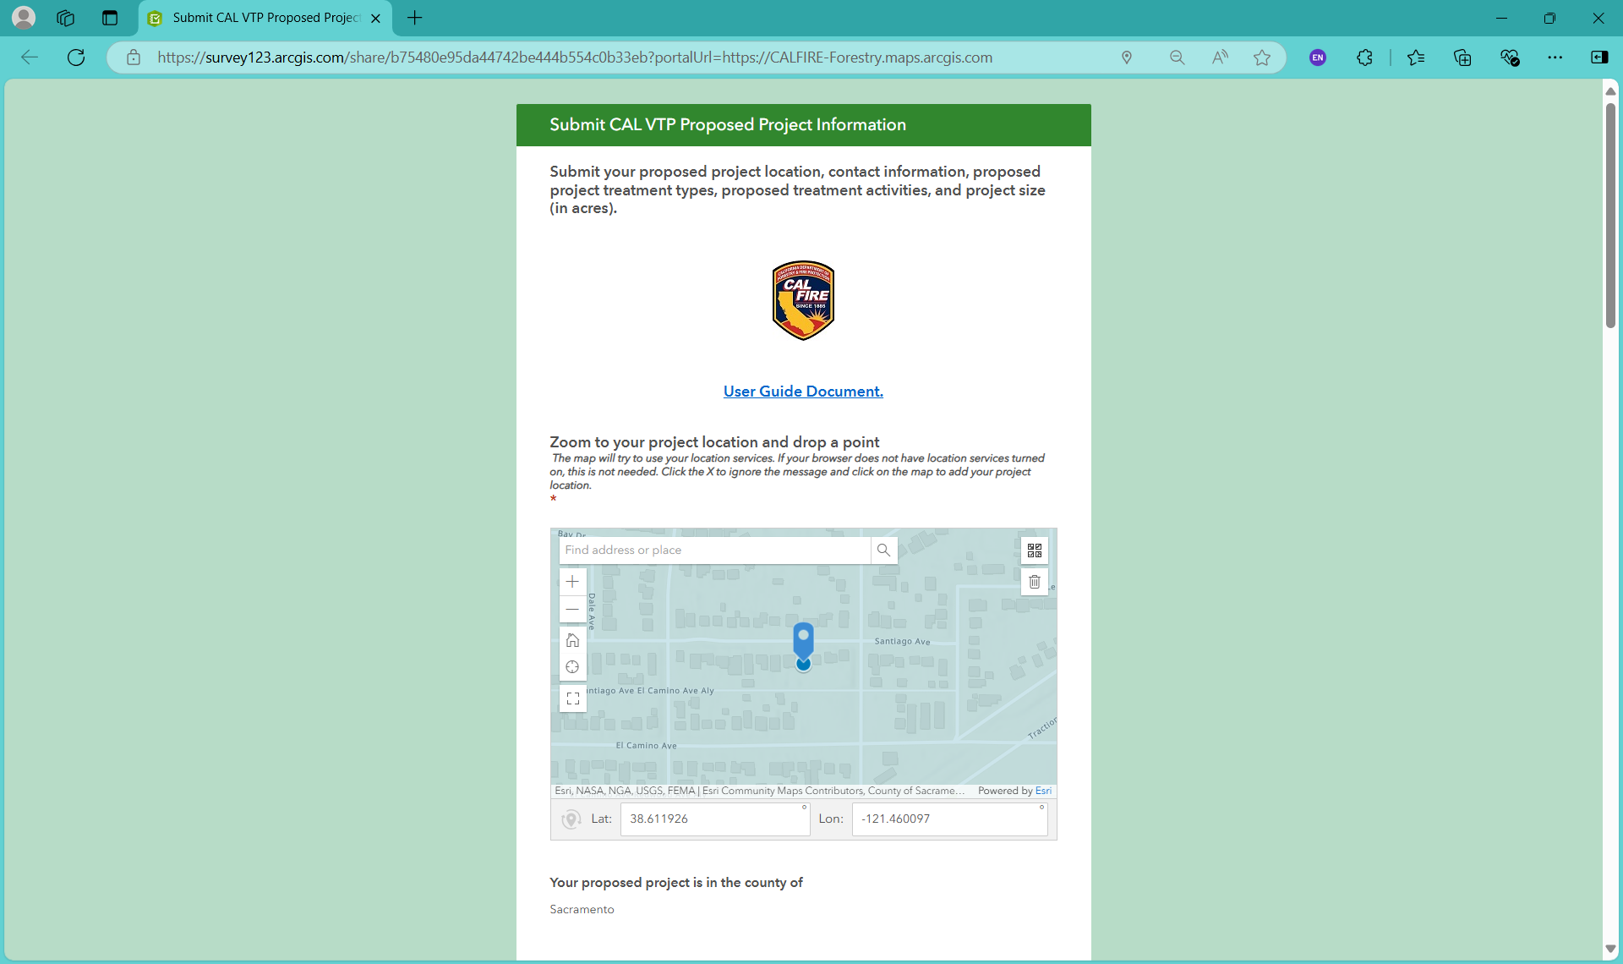

Figure 3. Online Submission Tool for a Proposed Project: Enter Proposed Project Contact Information.
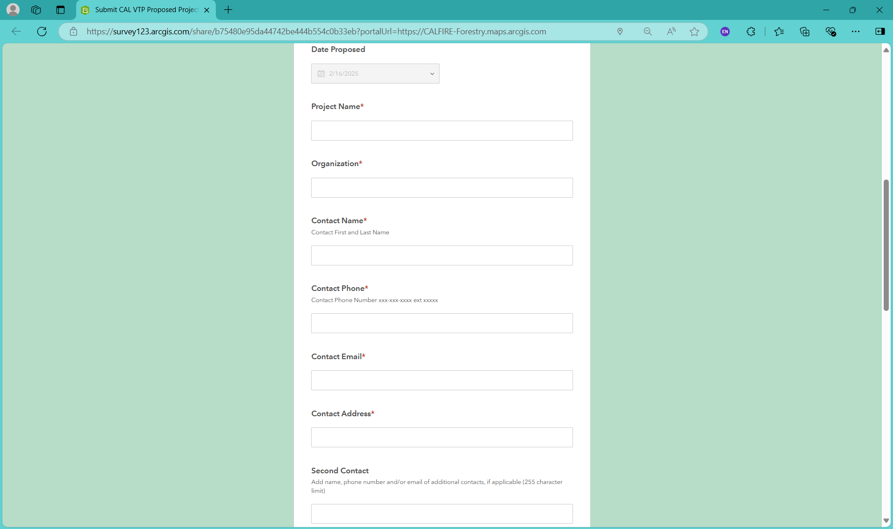

Figure 4. Online Submission Tool for a Proposed Project: Enter Treatment Types and Activities.
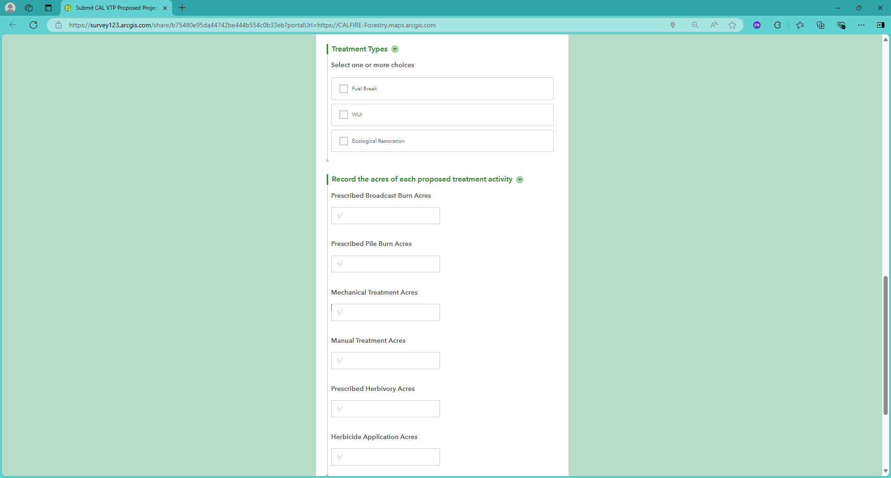

Figure 5. Online Submission Tool for a Proposed Project: Enter Comments and Submit.
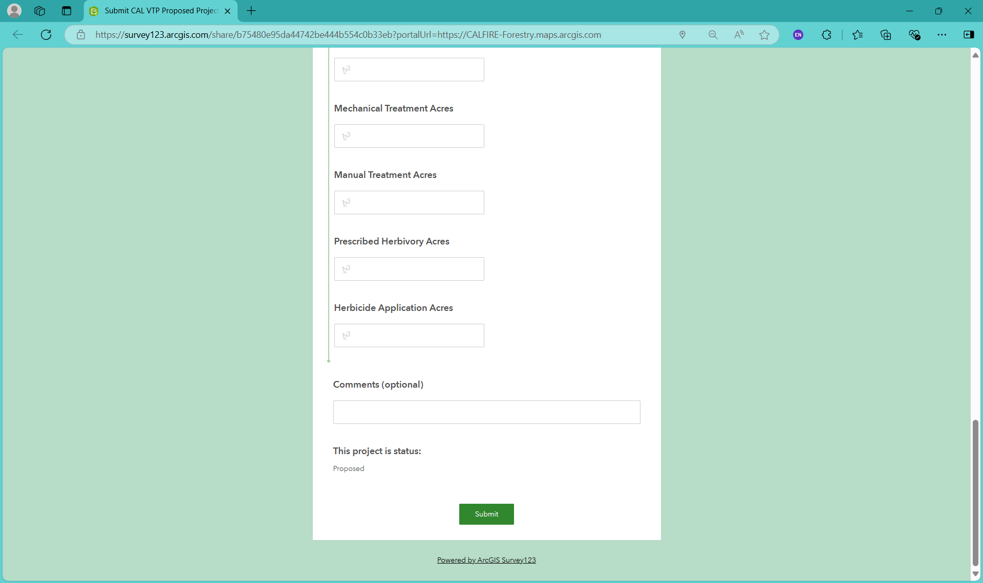

Figure 6. Online Viewer for Proposed Projects.
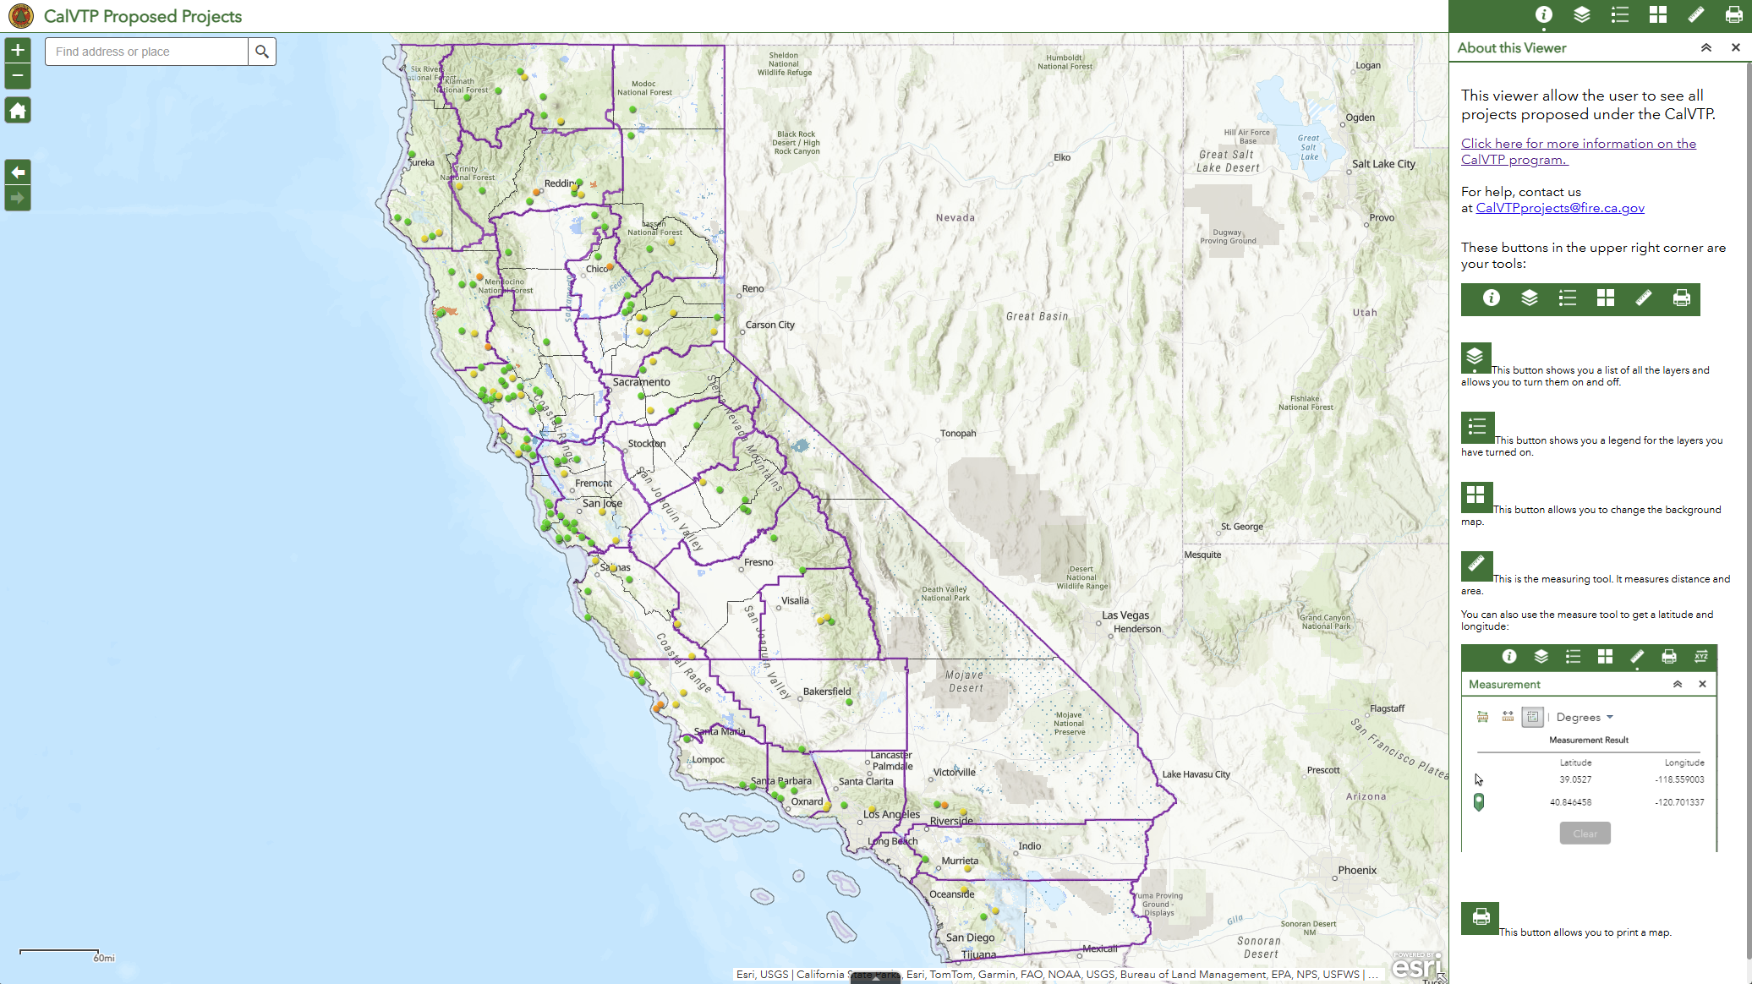

Figure 7. Manual Submission for Proposed Projects: Add Data for Proposed Project.
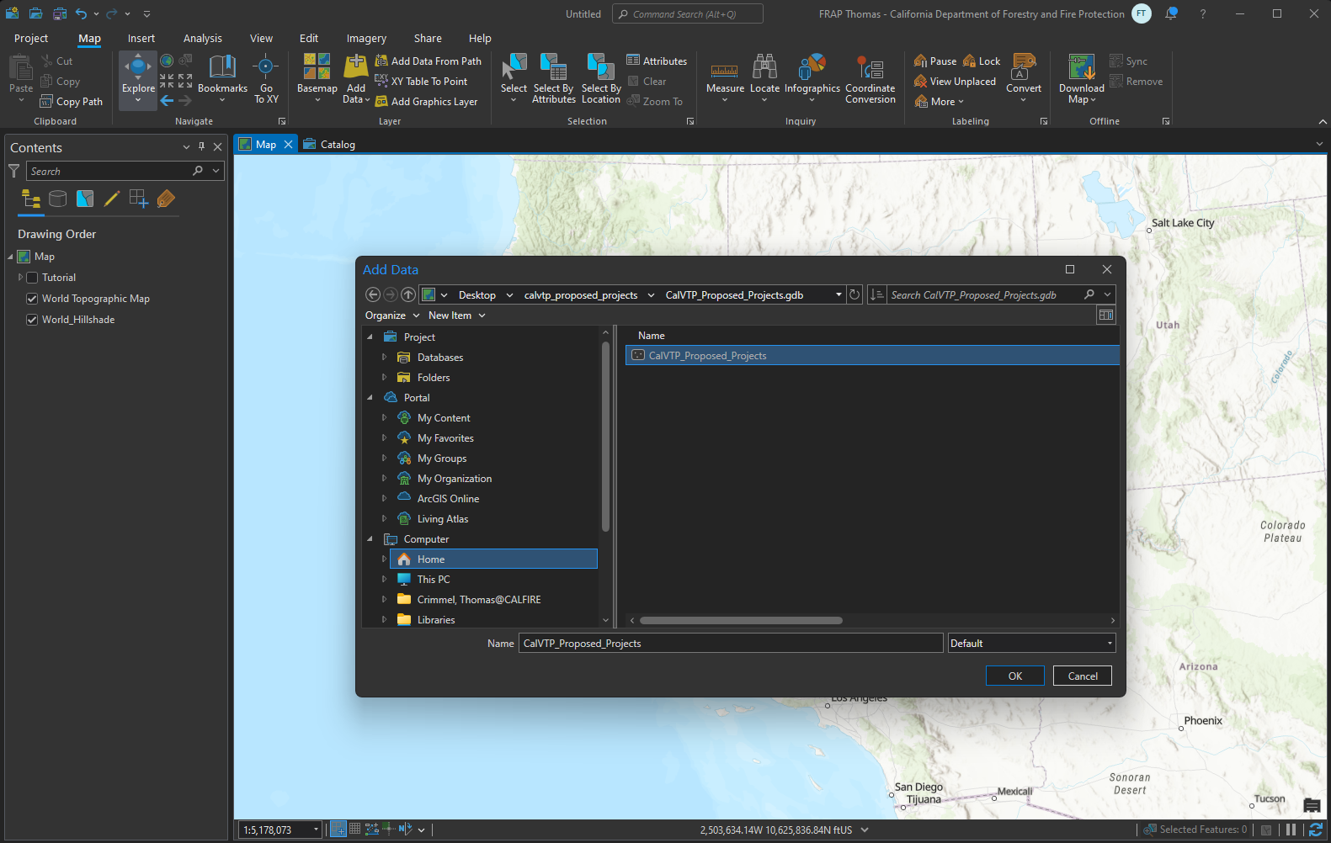

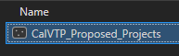


Figure 8. Manual Submission for Proposed Projects: Create Features for Proposed Project.
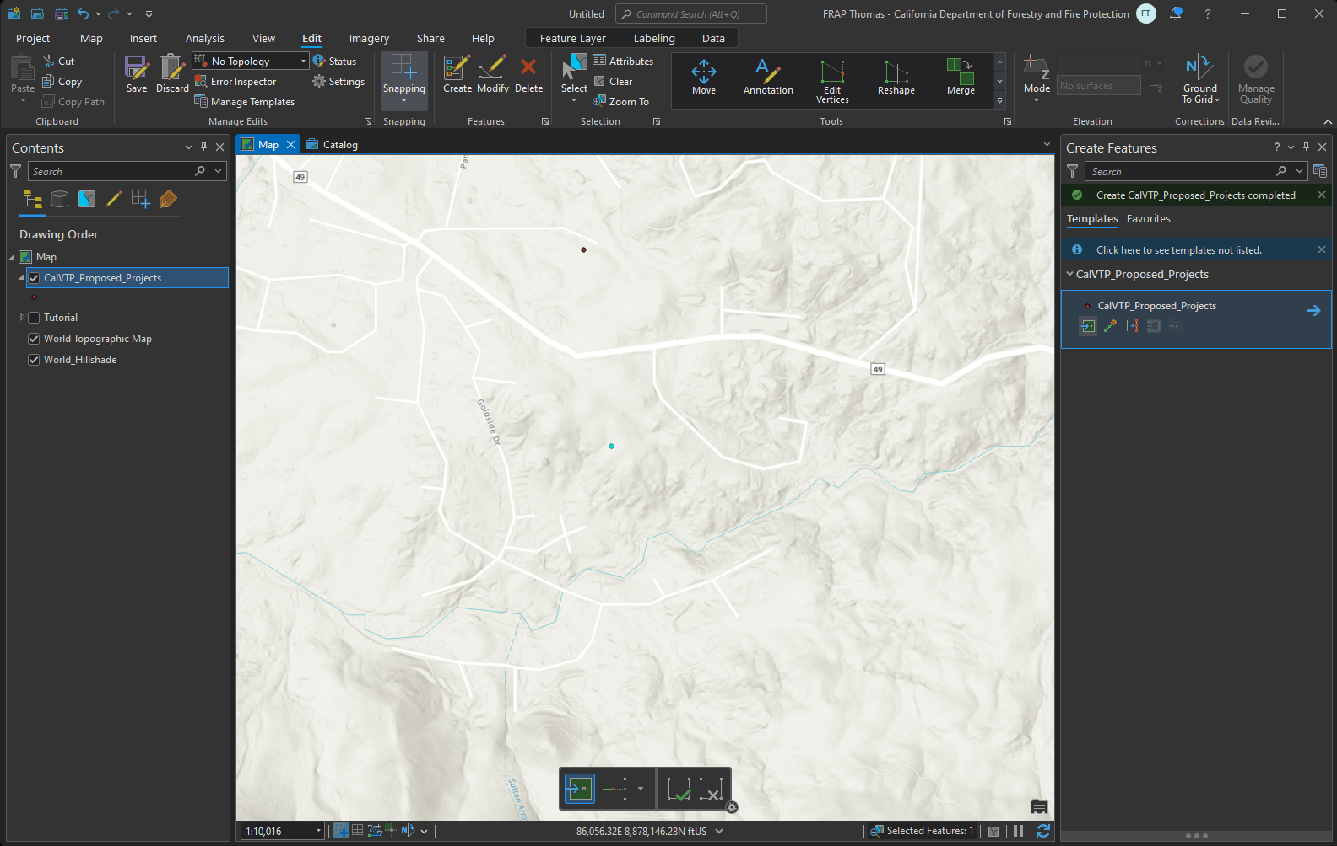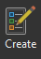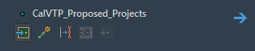

Figure 9. Manual Submission for Proposed Projects: Open and Edit Attribute Table for Proposed Project; Save Edits.

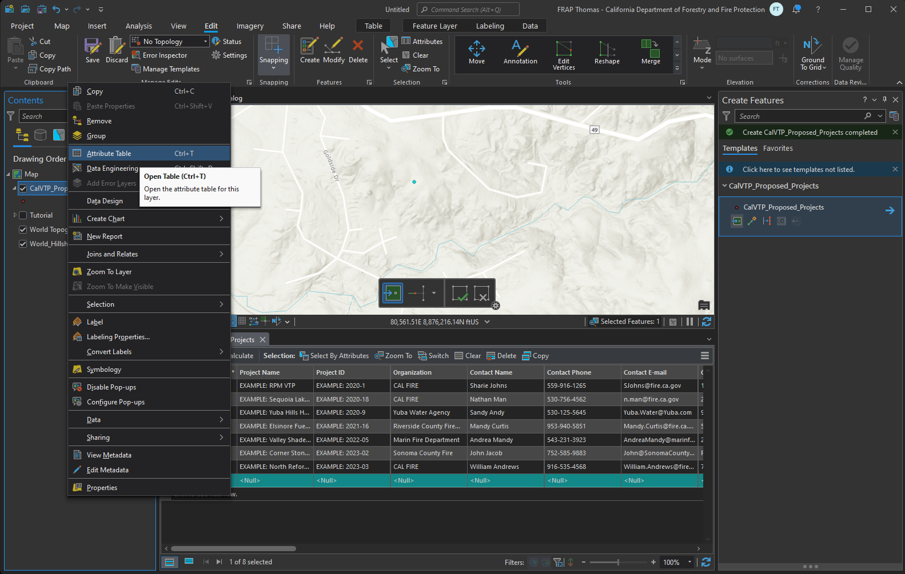

Figure 10. Online Submission Tool for Approved and Completed Projects: Click OK.
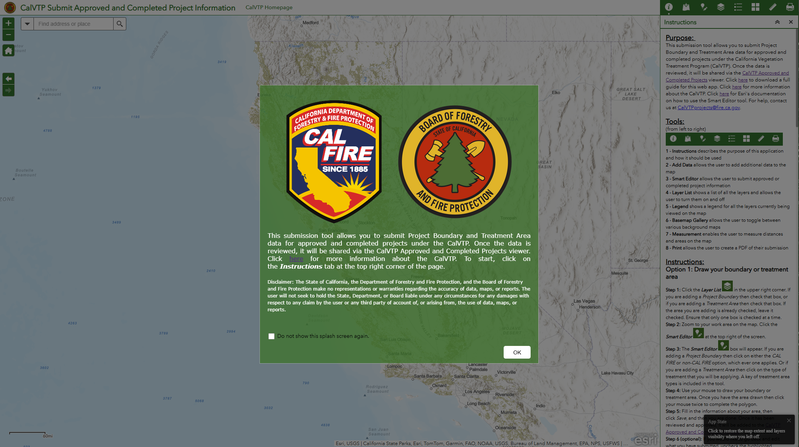

Figure 11. Online Submission Tool for Approved and Completed Projects: Uncheck CalVTP Treatment Areas EDIT view.
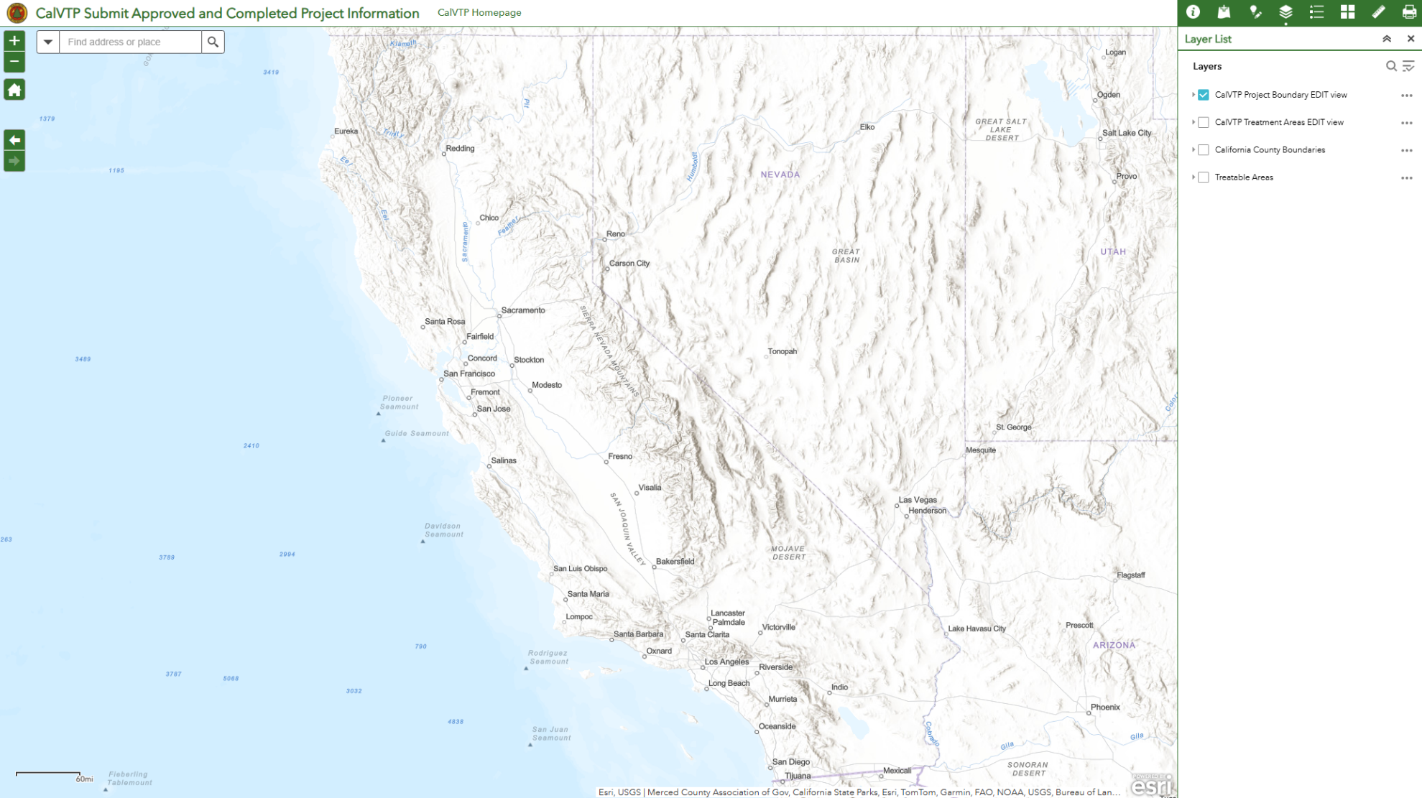
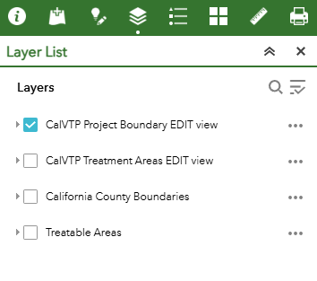

Figure 12. Online Submission Tool for Approved and Completed Projects: Uncheck CalVTP Project Boundary EDIT view.
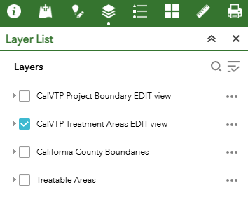
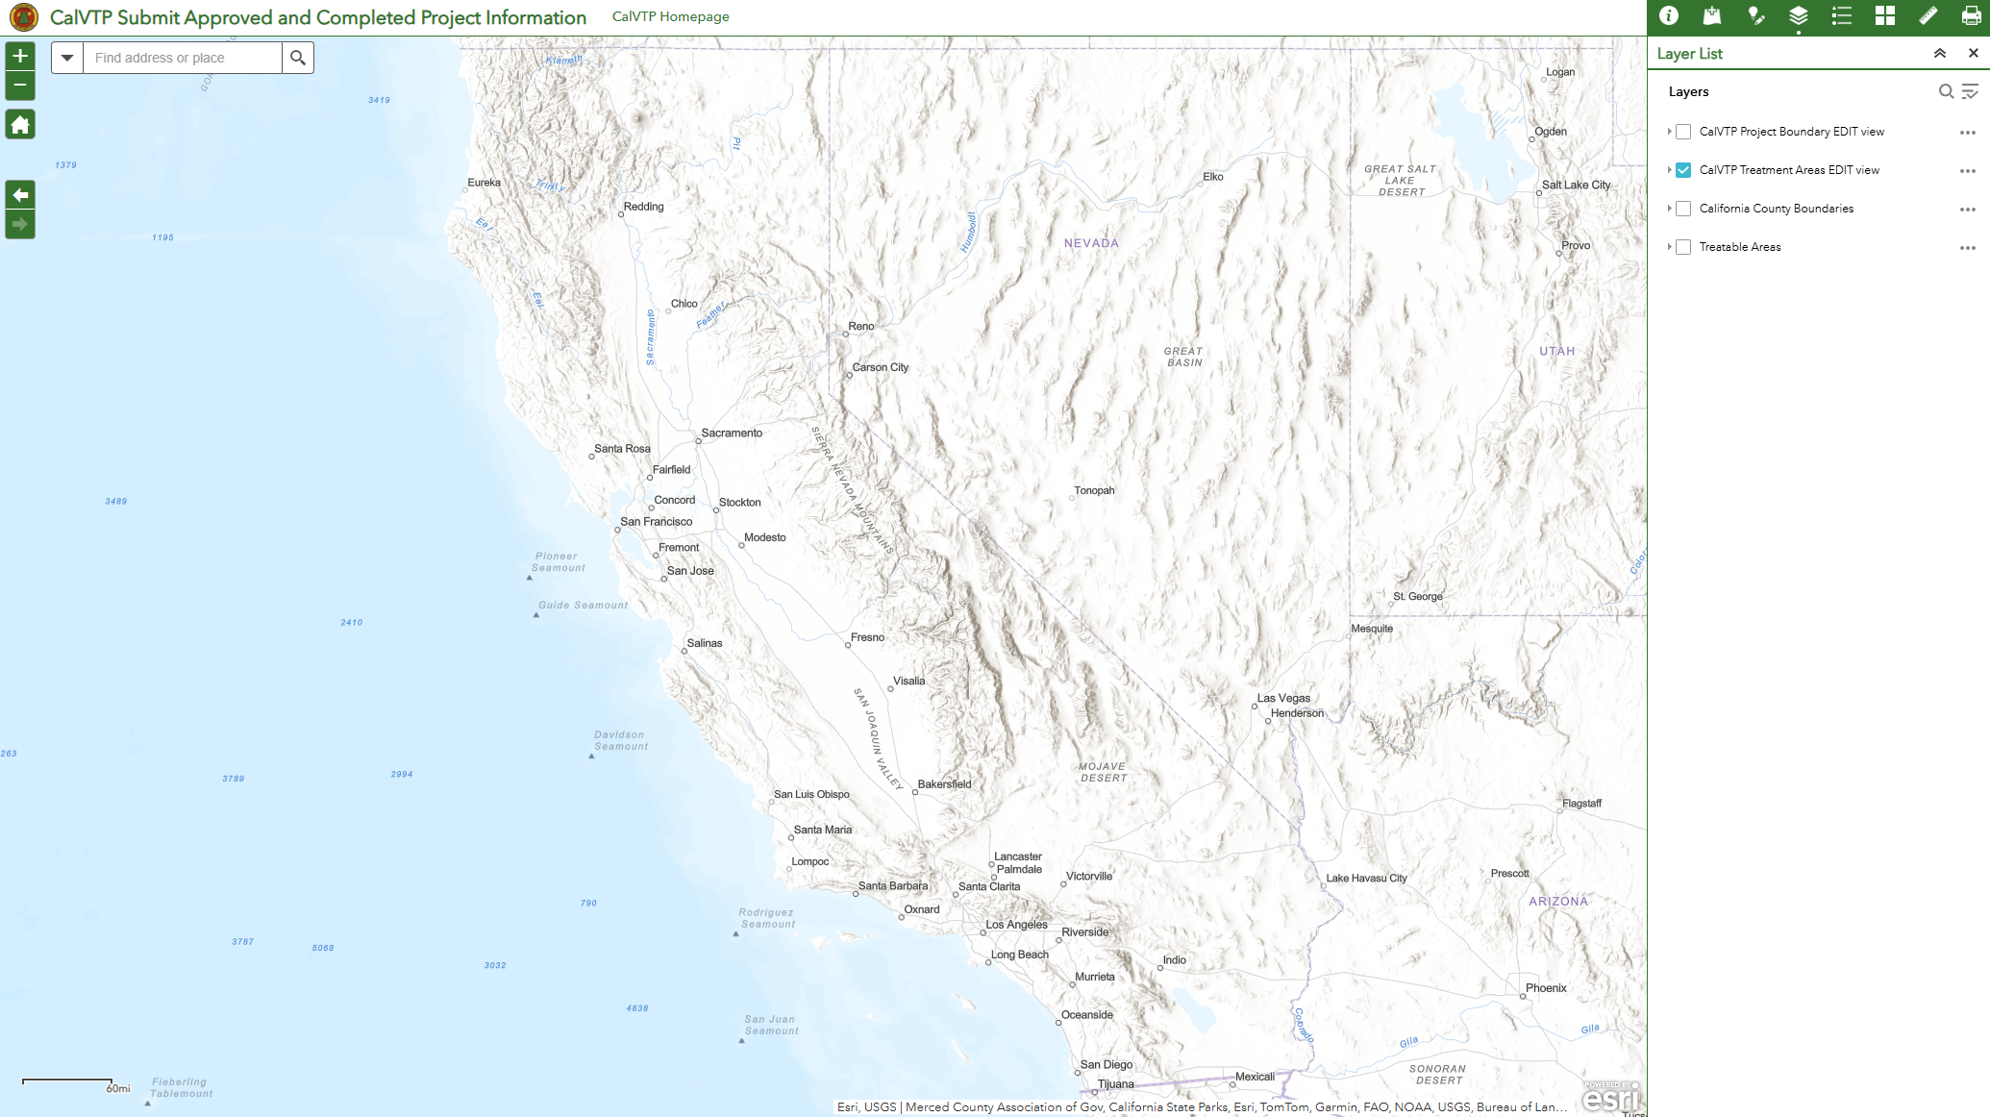

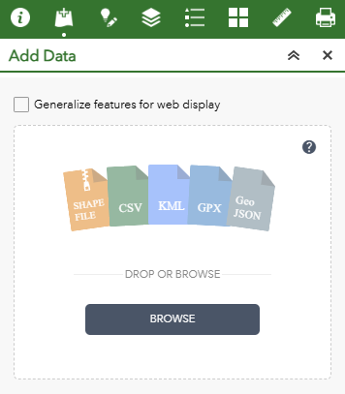
Figure 13. Online Submission Tool for Approved and Completed Projects: Uncheck Generalize features for web display.
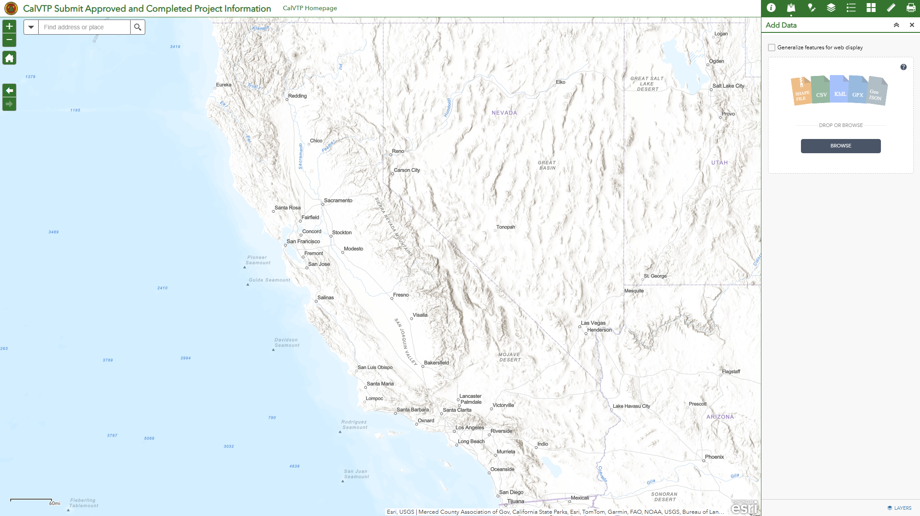

Figure 14. Online Submission Tool for Approved and Completed Projects: Upload Zipped Shapefile.
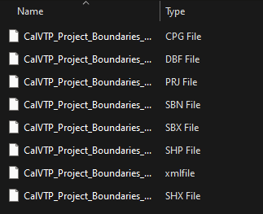
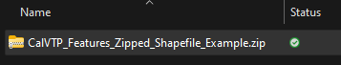
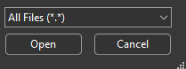
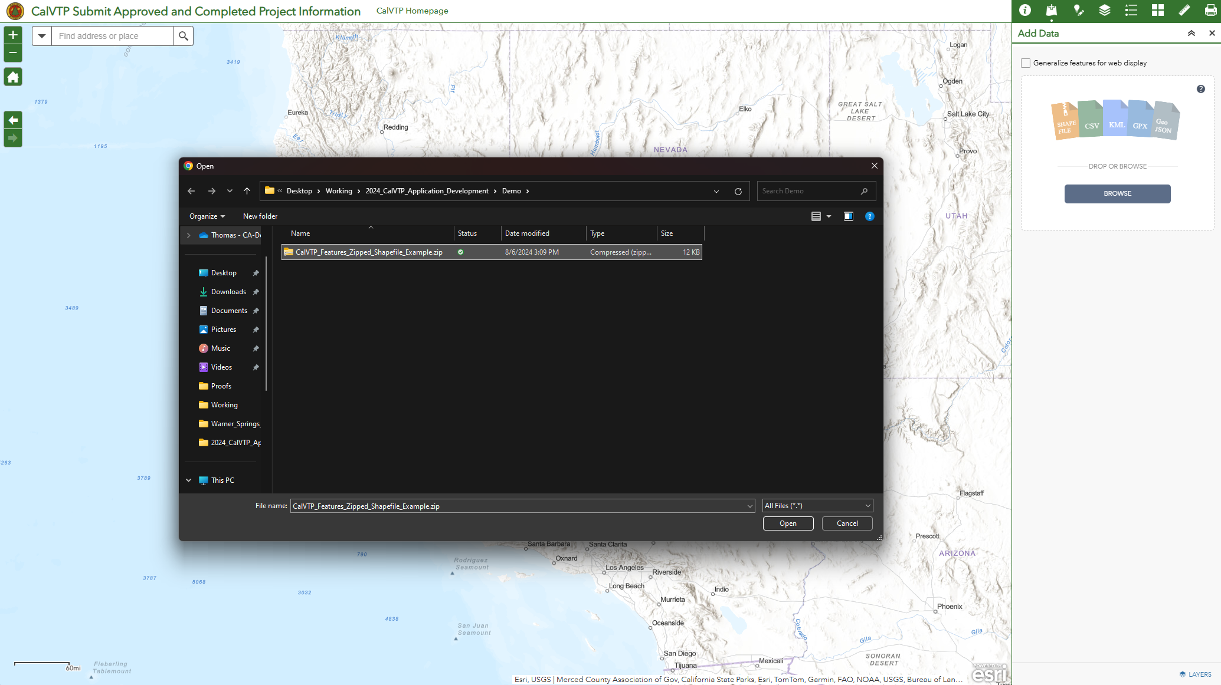

Figure 15. Online Submission Tool for Approved and Completed Projects: Use Smart Editor to Select Project Boundary.
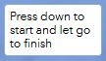
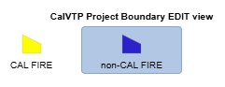
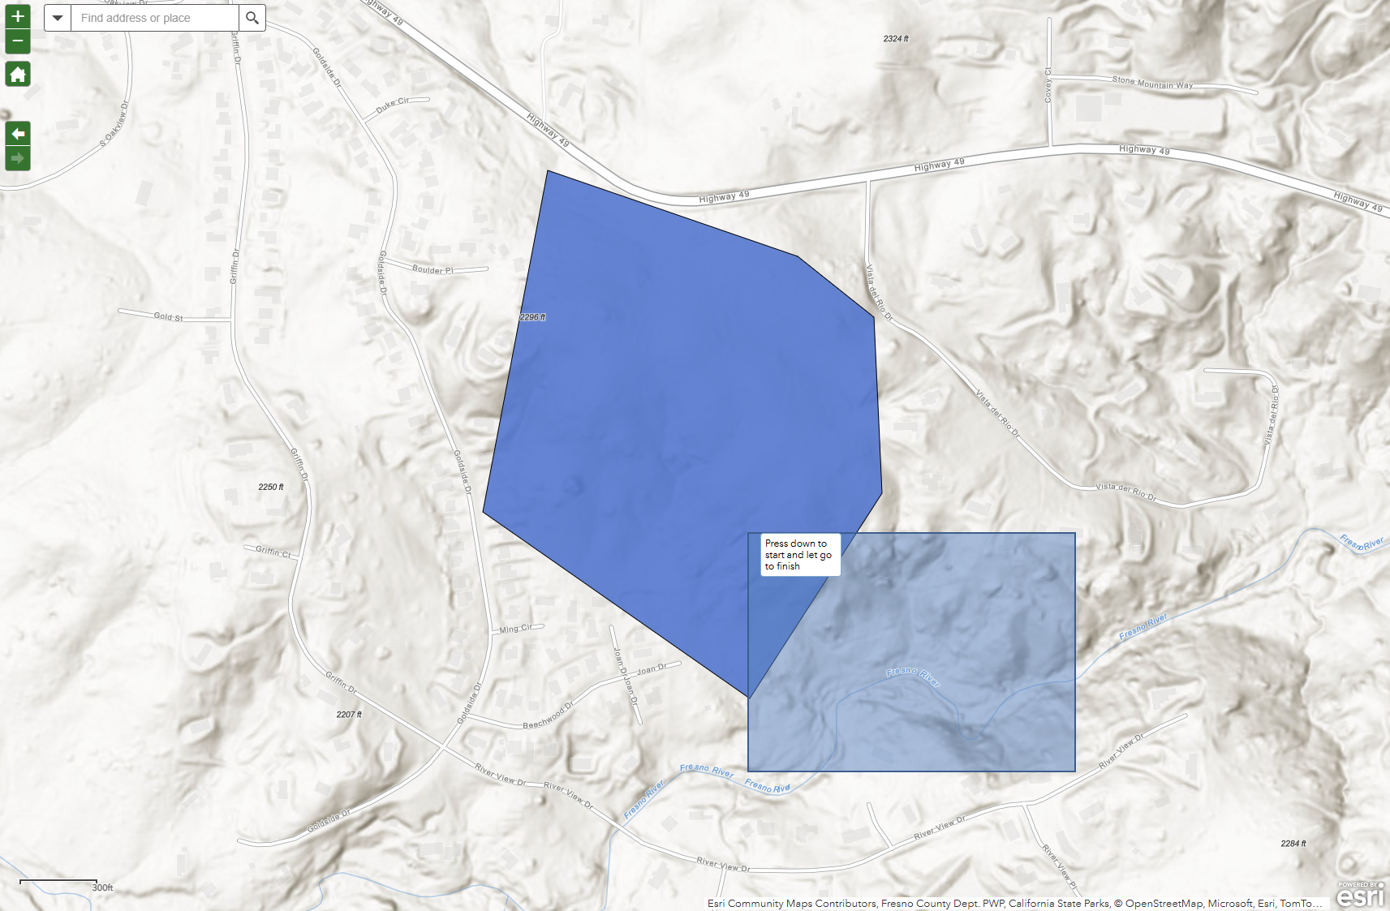
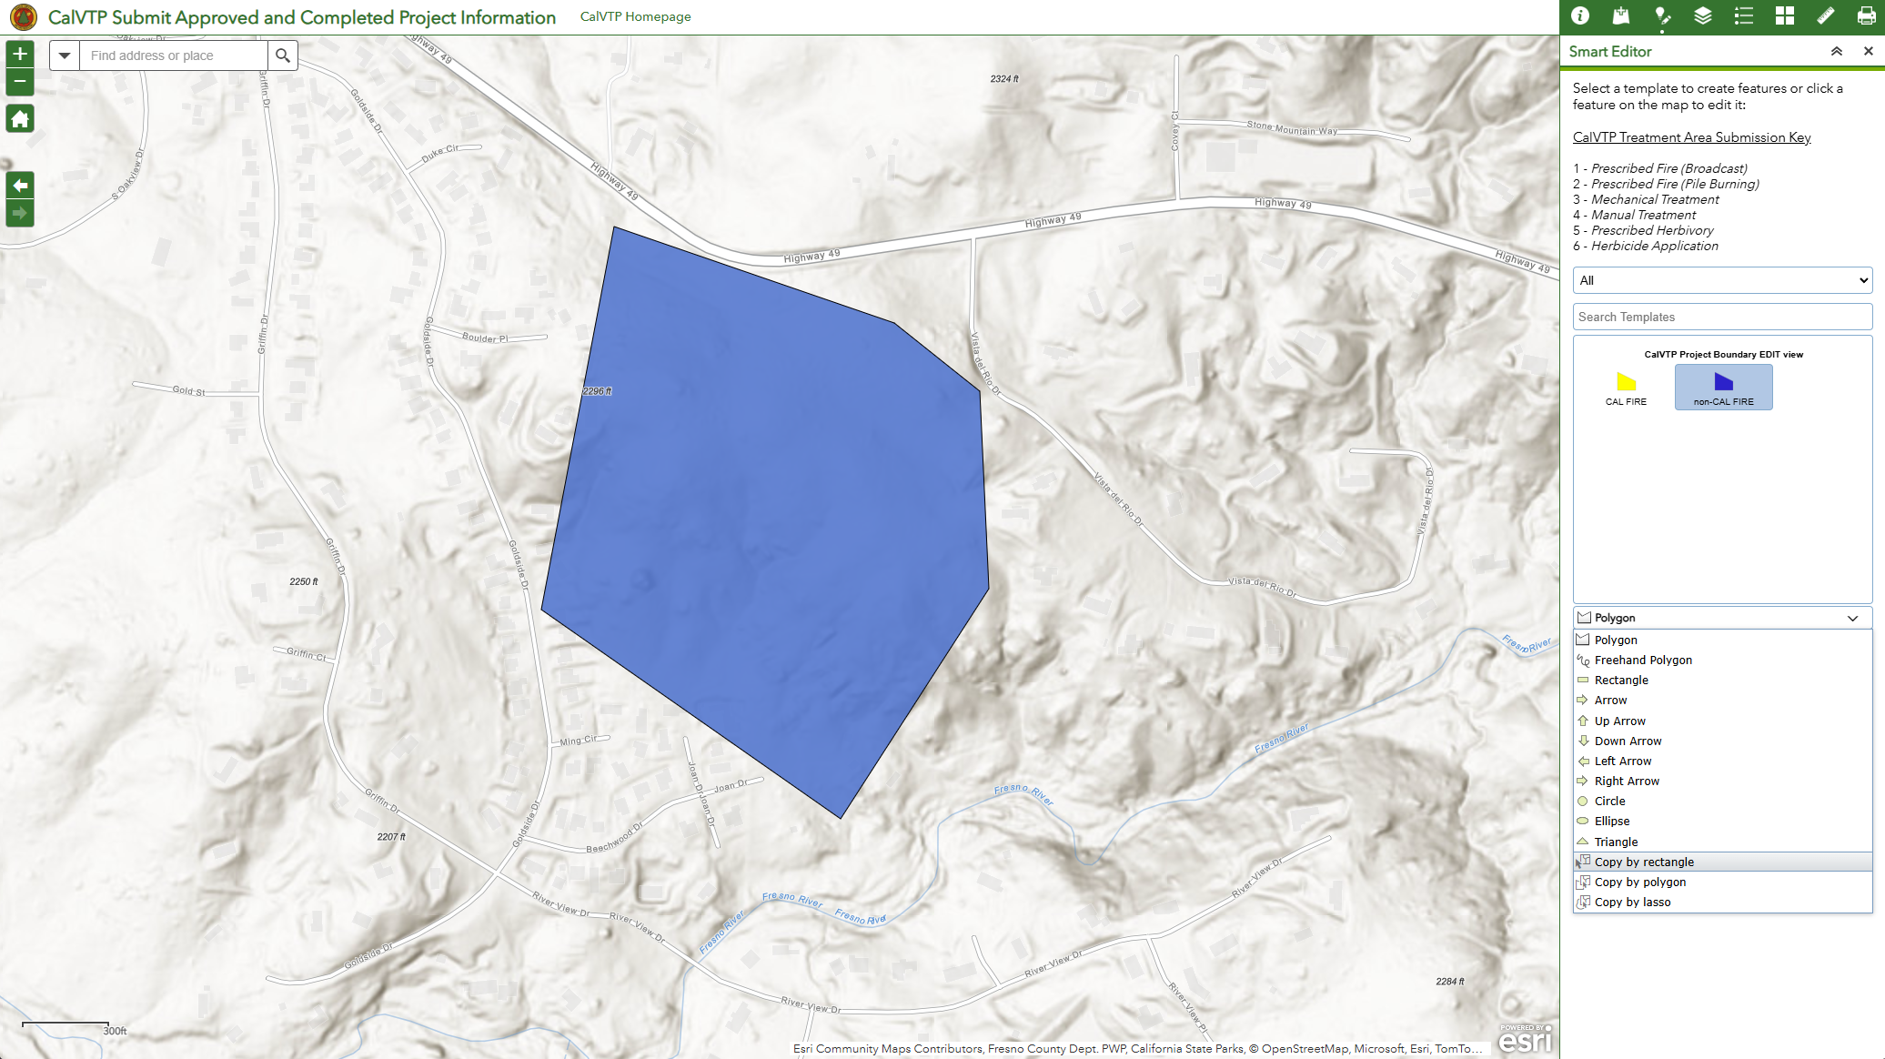

Figure 16. Online Submission Tool for Approved and Completed Projects: Use Smart Editor to Select Treatment Area.
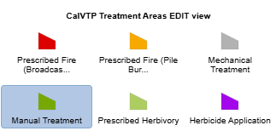
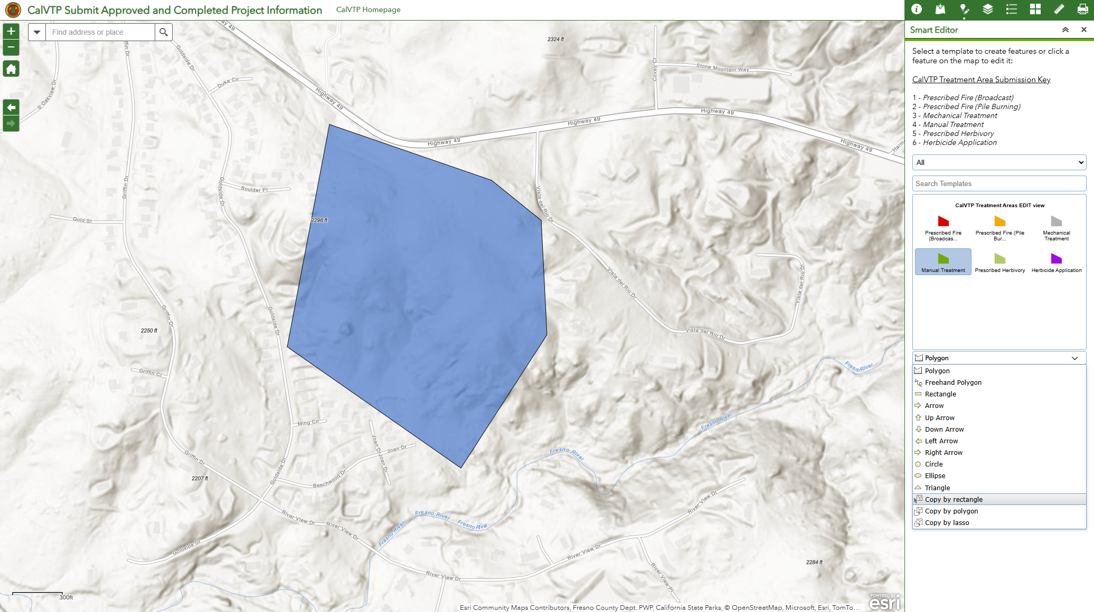

Figure 17. Online Submission Tool for Approved and Completed Projects: Apply Field Matching and Create Feature in Smart Editor.
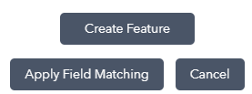
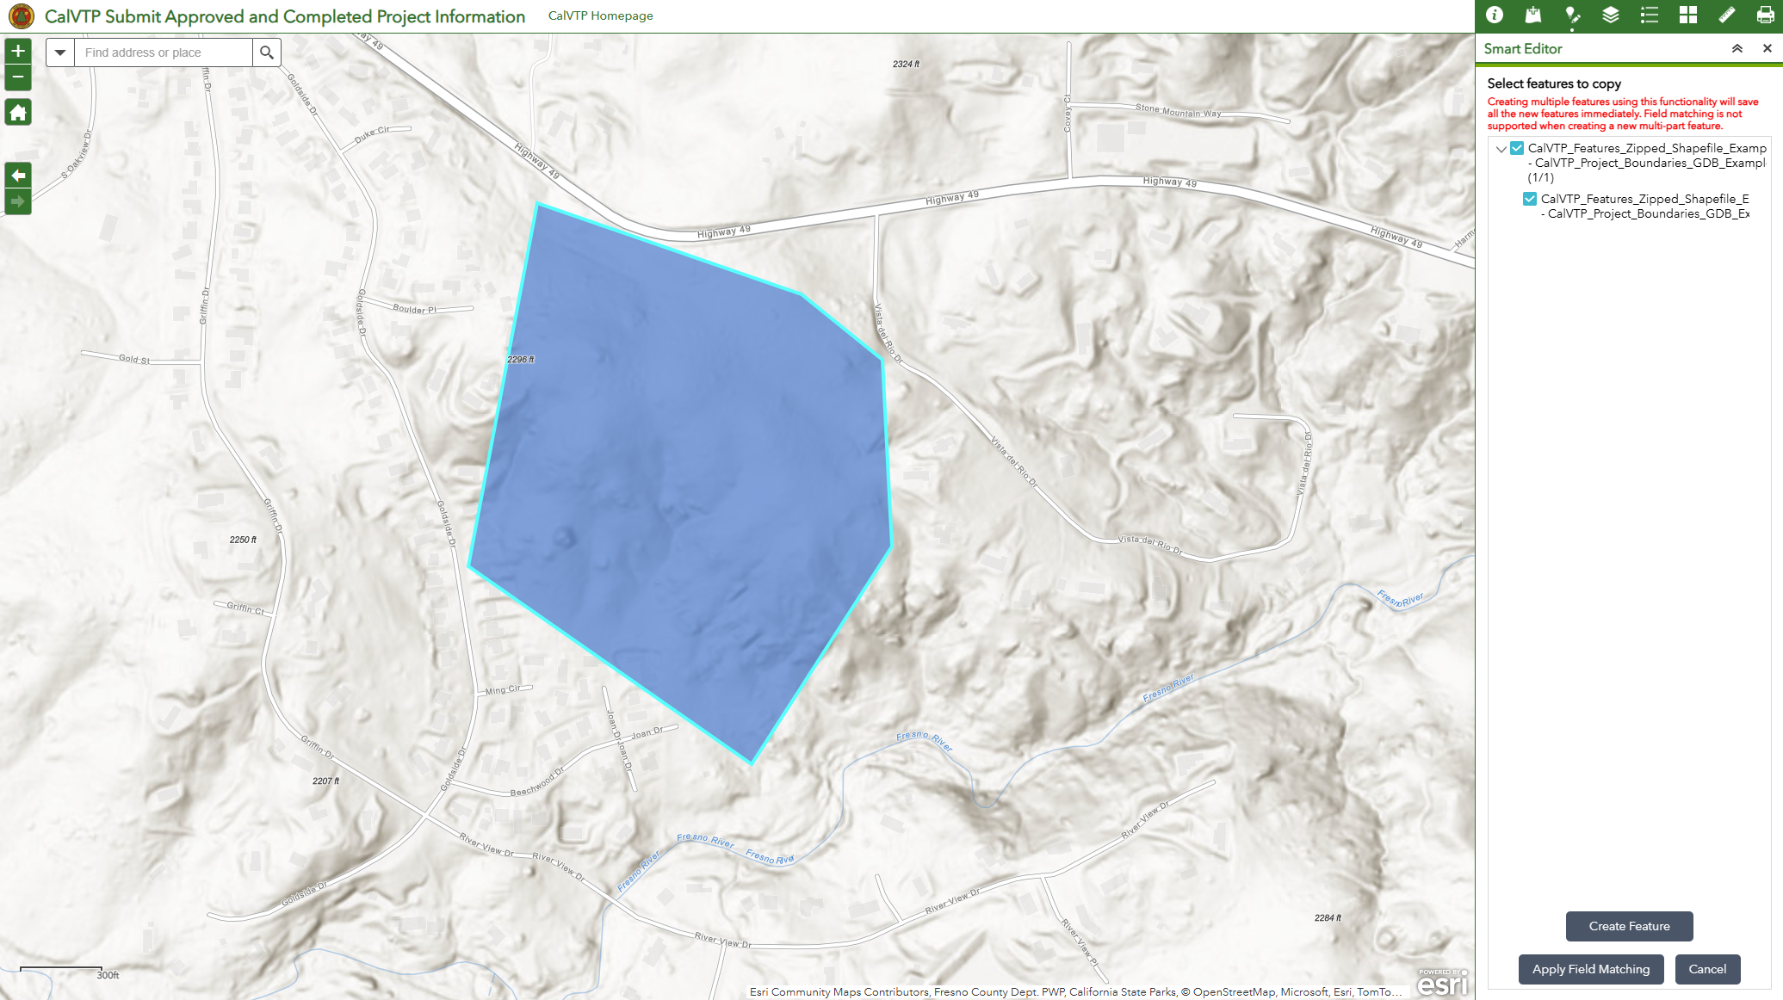

Figure 18. Online Submission Tool for Approved and Completed Projects: Apply Field Matching in Smart Editor.
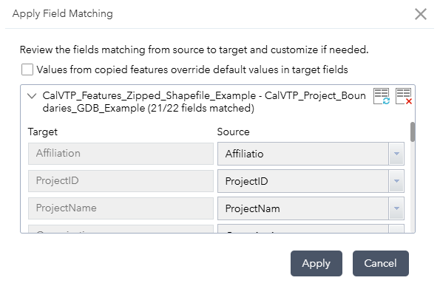
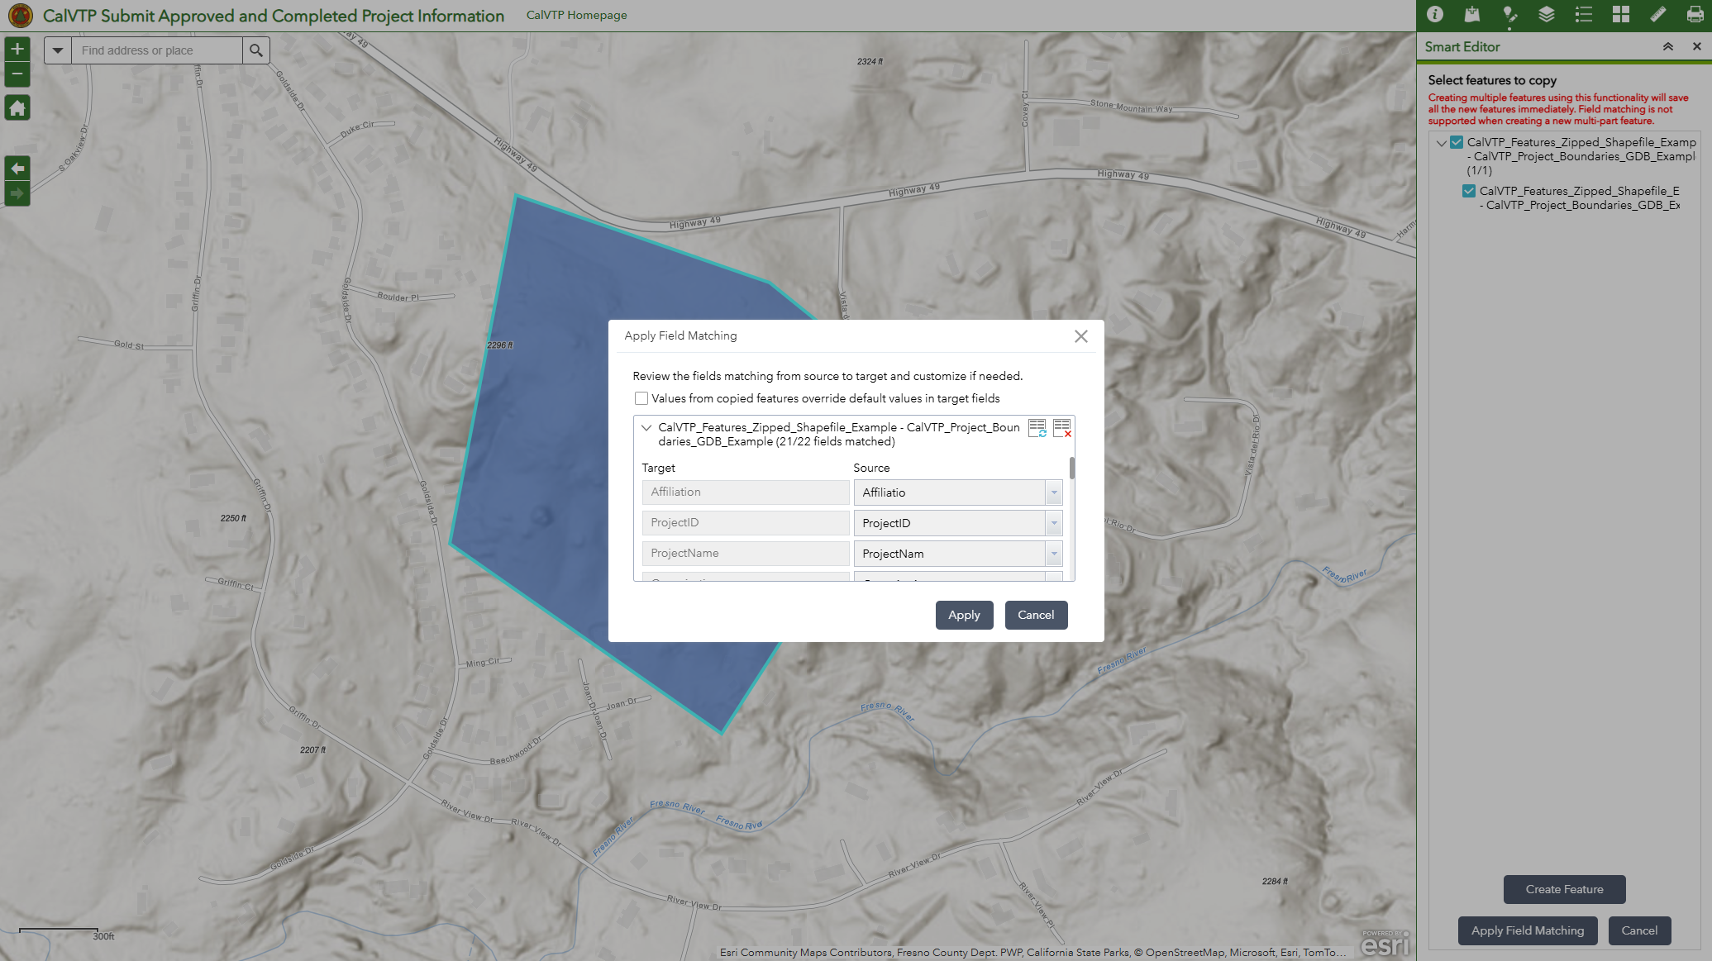

Figure 19. Online Submission Tool for Approved and Completed Projects: Complete Field Entries for Project Boundary.
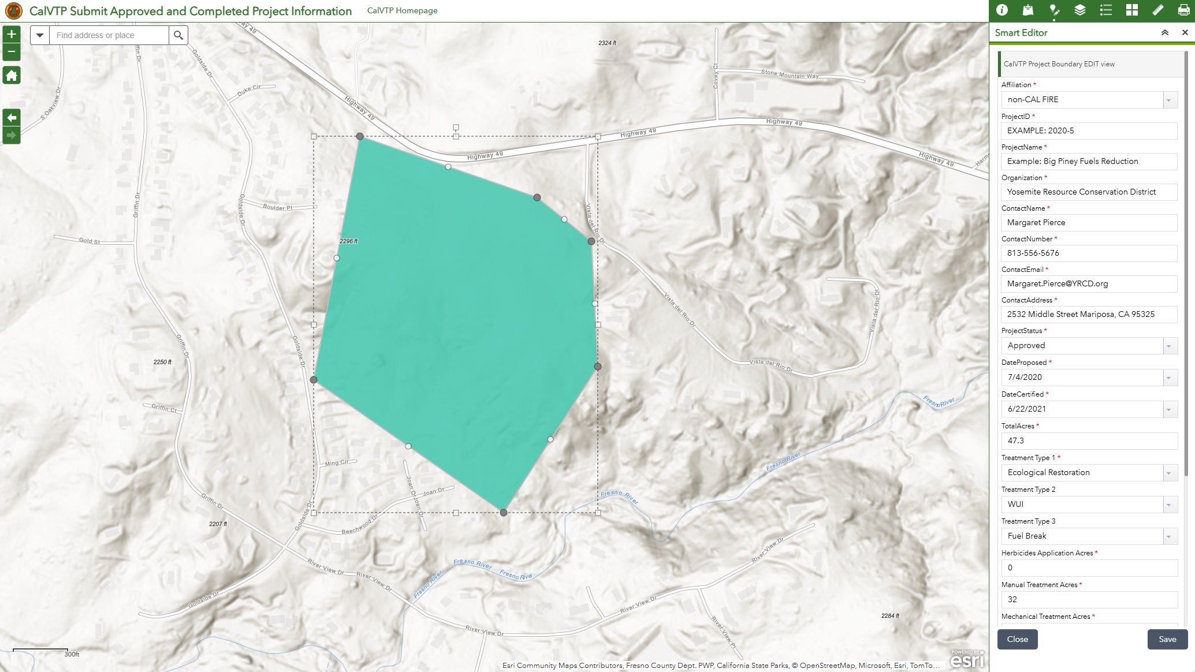

Figure 20. Online Submission Tool for Approved and Completed Projects: Complete Field Entries for Treatment Area.
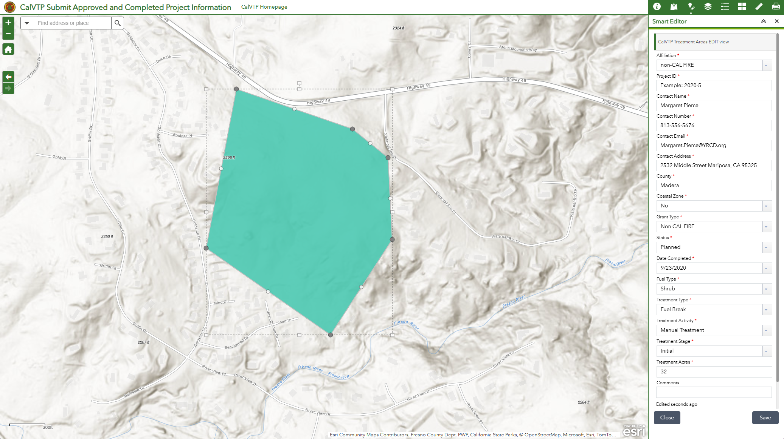

Figure 21. Online Viewer for Approved and Completed Projects.
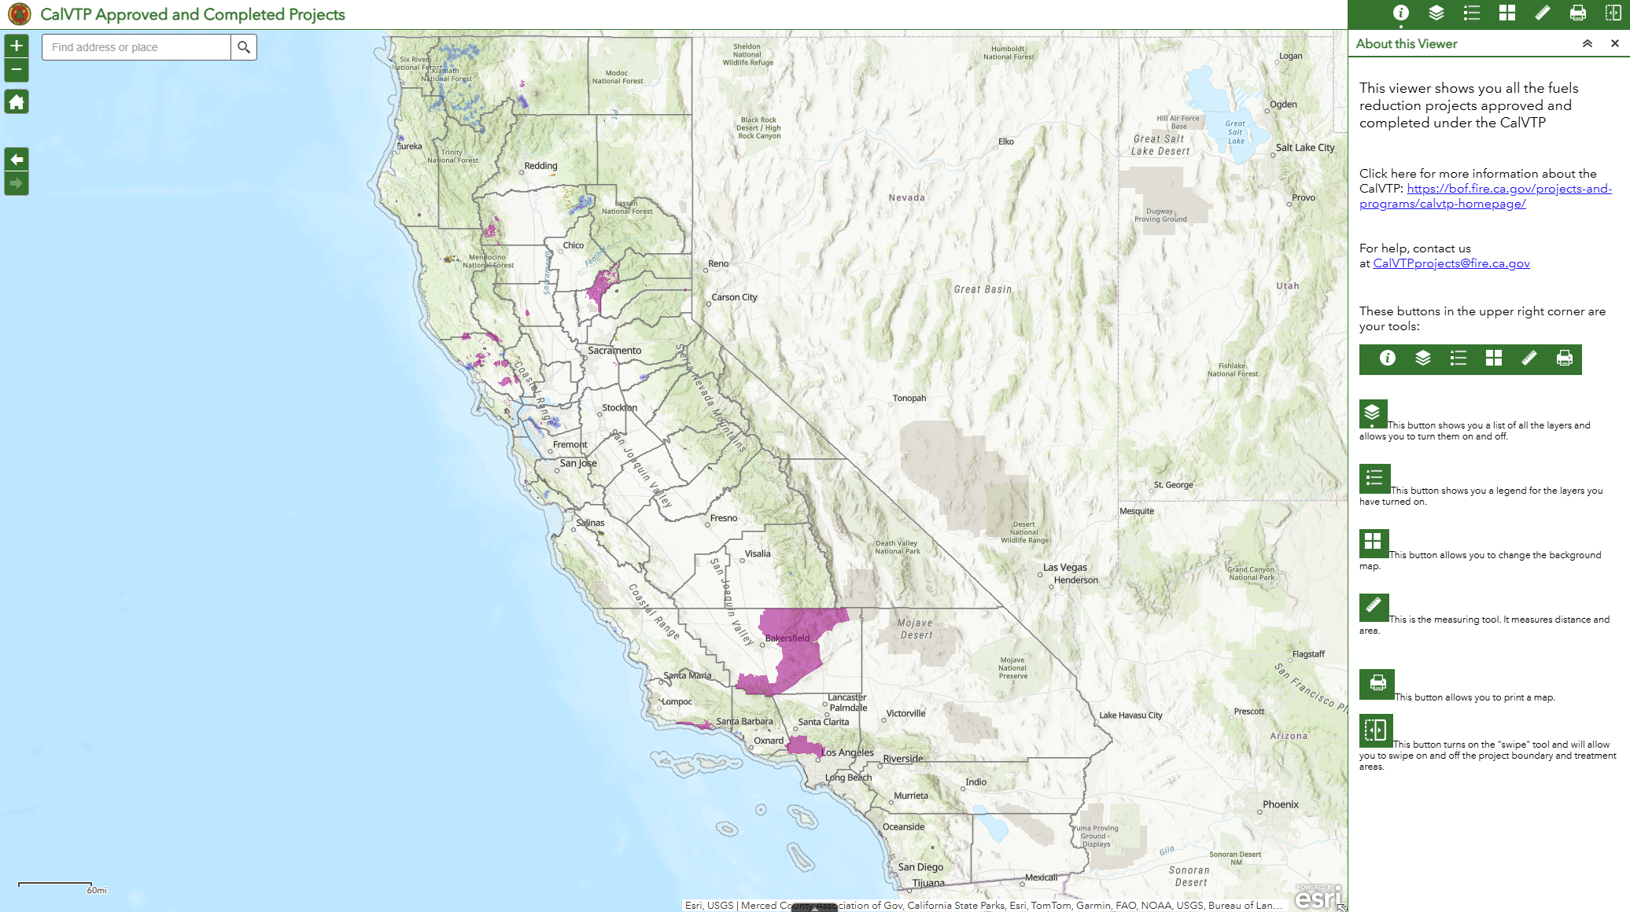

Figure 22. Online Box Submission Form for CalVTP Documents.
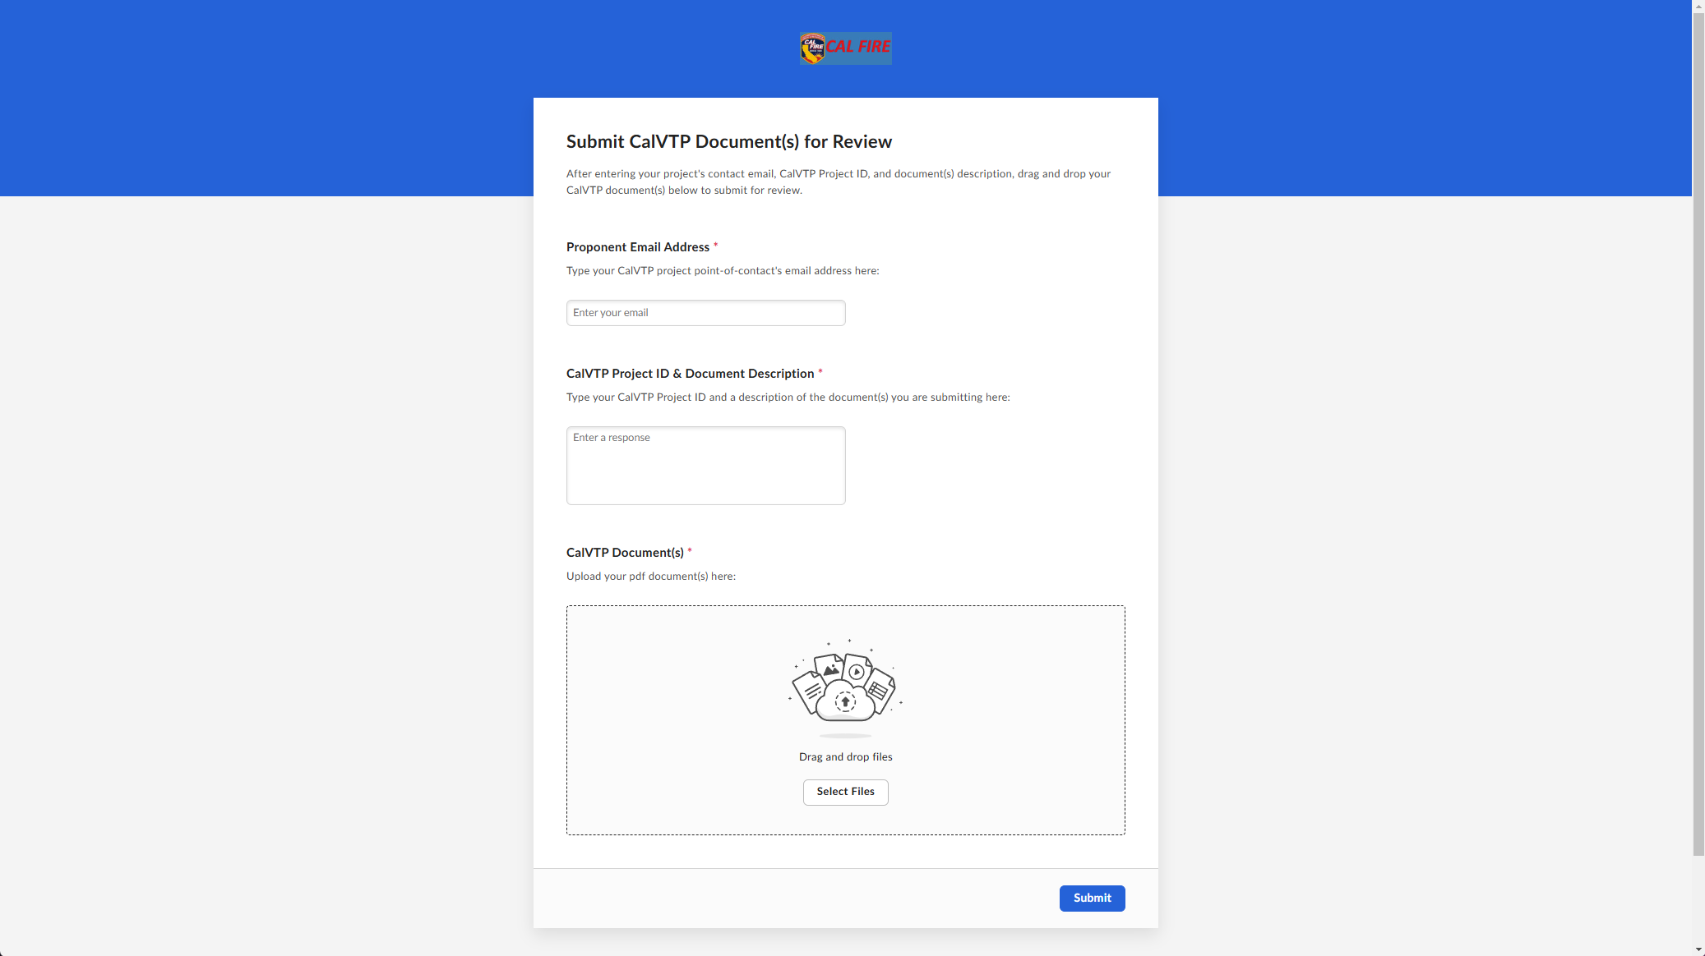

Figure 23. Manual Submission for Approved and Completed Projects: Add Data for Project Boundary.
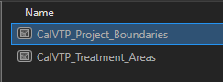
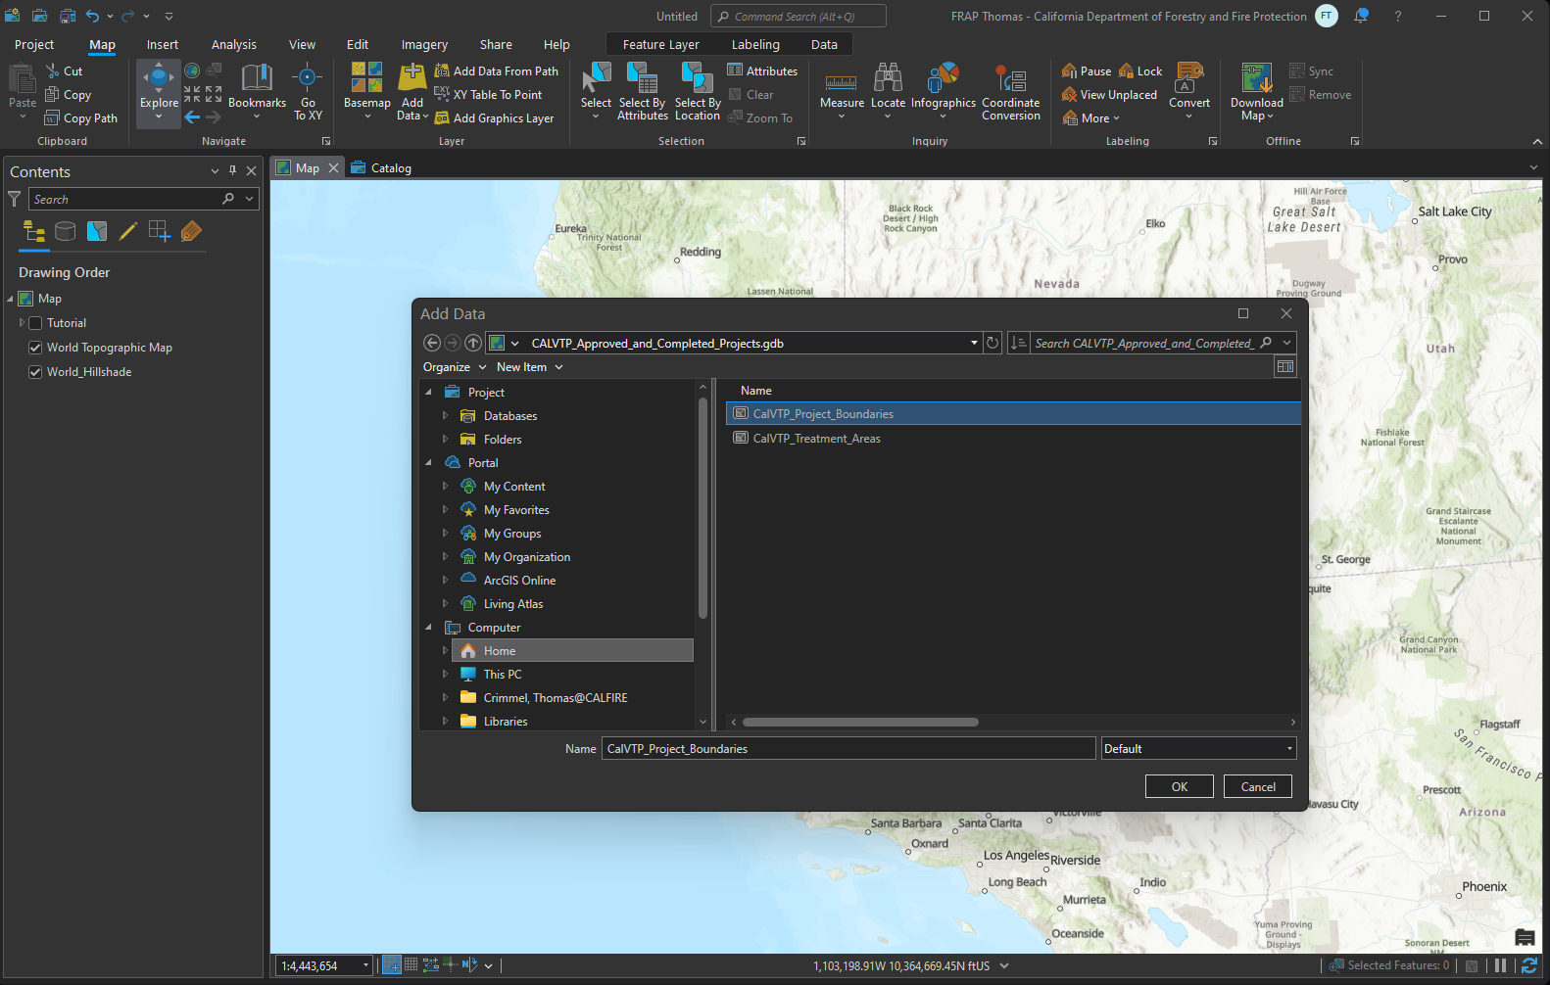

Figure 24. Manual Submission for Approved and Completed Projects: Create Features for Project Boundary.
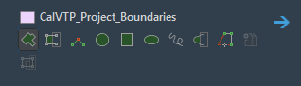
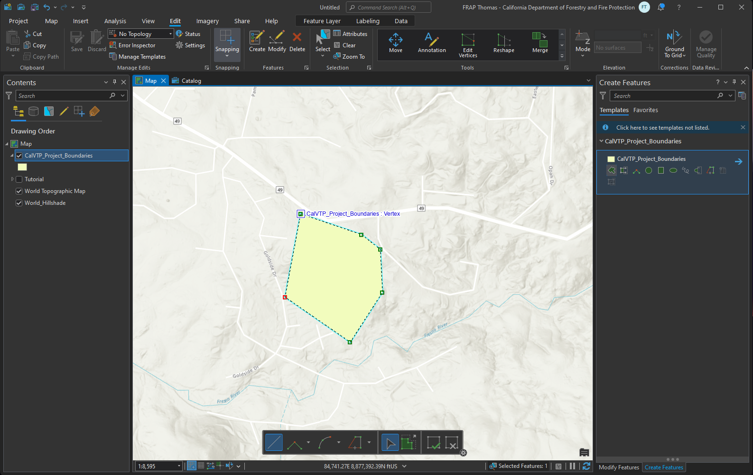

Figure 25. Manual Submission for Approved and Completed Projects: Open and Edit Attribute Table for Project Boundary; Save Edits.
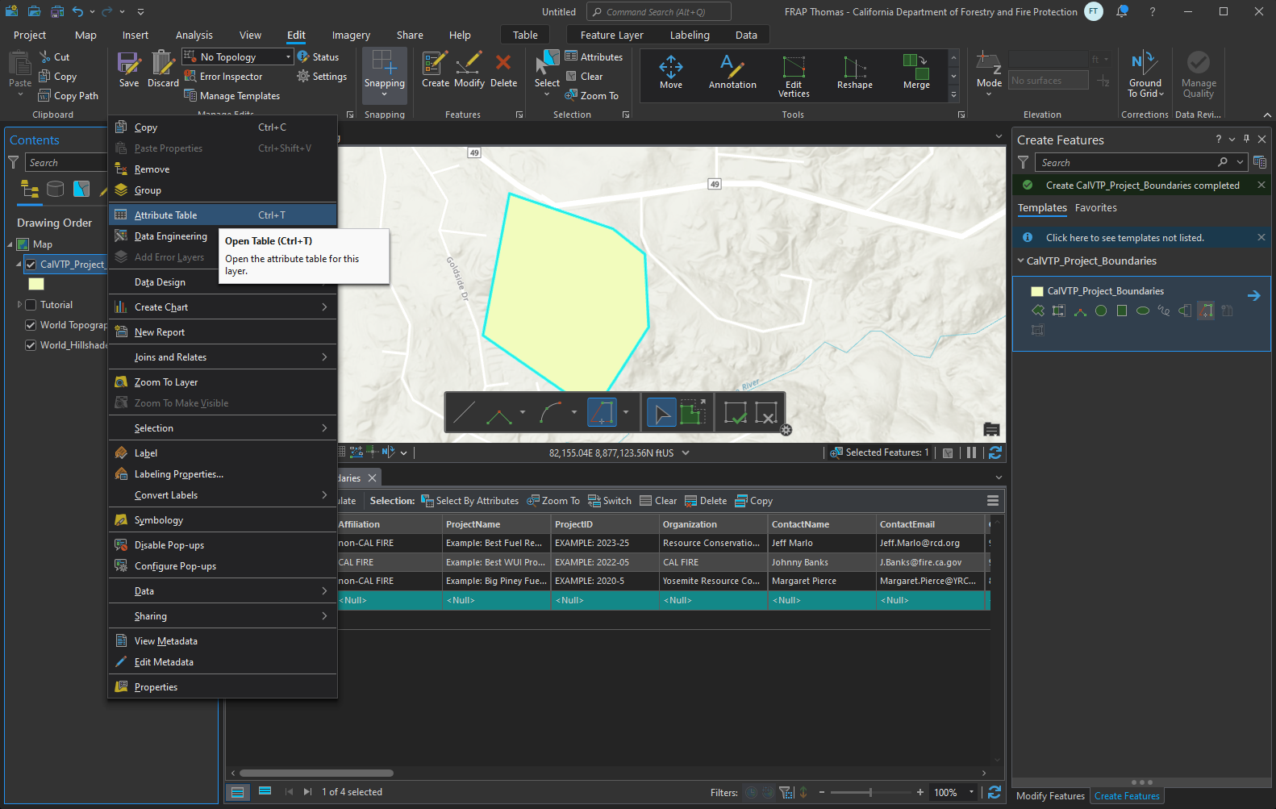

Figure 26. Manual Submission for Approved and Completed Projects: Add Data for Treatment Area.
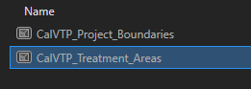
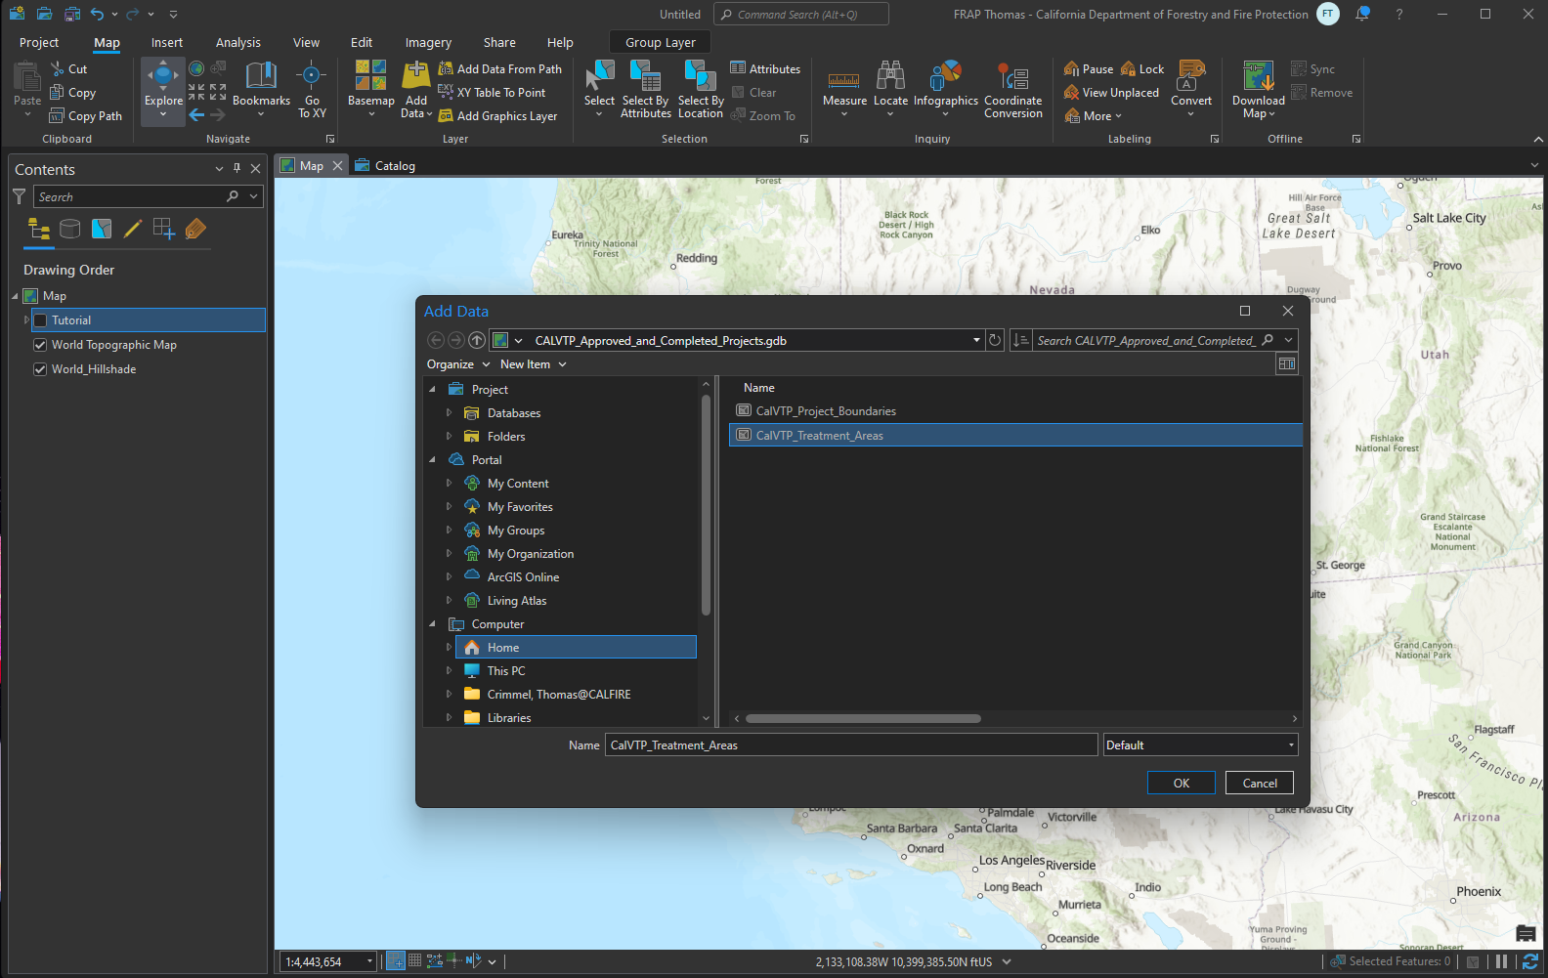

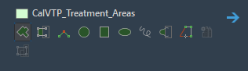
Figure 27. Manual Submission for Approved and Completed Projects: Create Features for Treatment Area.
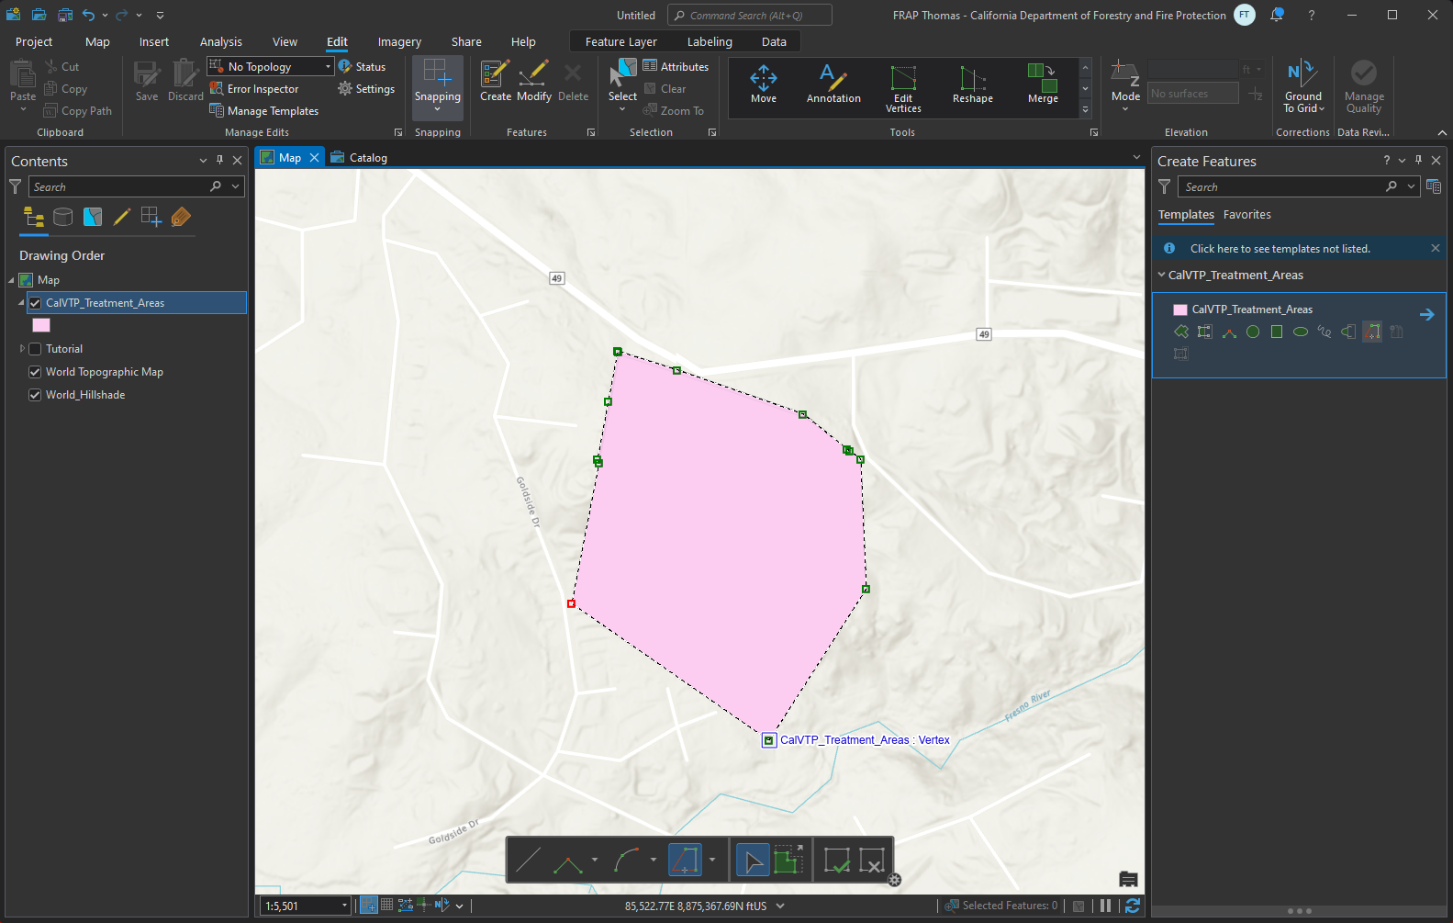

Figure 28. Manual Submission for Approved and Completed Projects: Open and Edit Attribute Table for Treatment Area; Save Edits.
