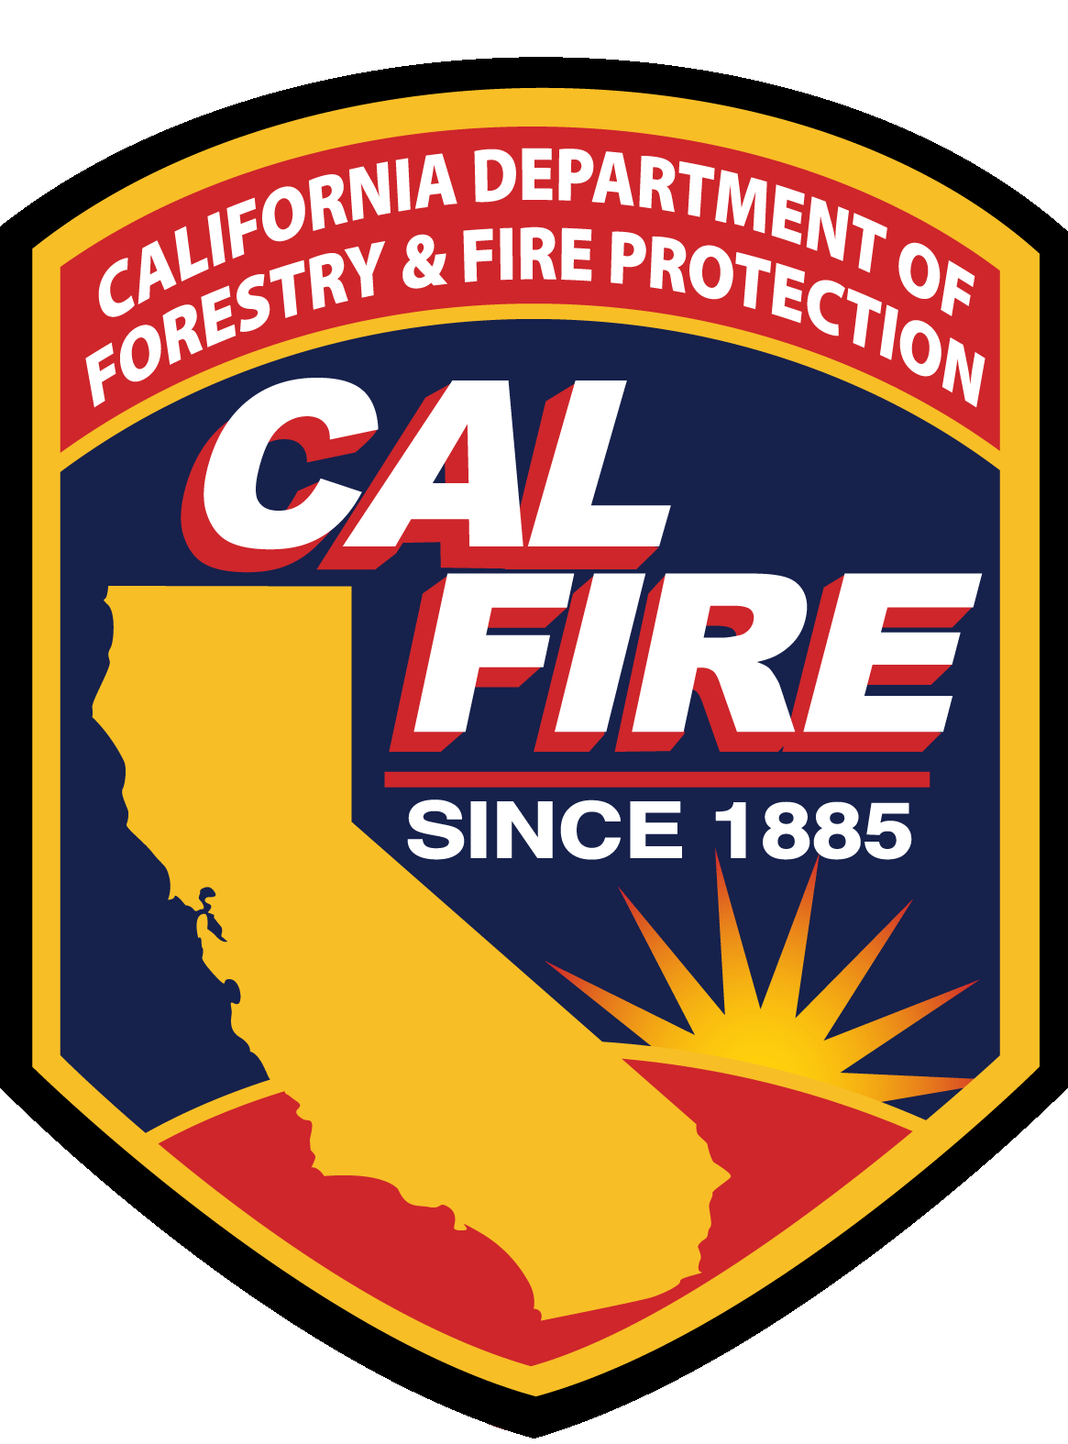
Example Sign Schematic for Applicants.
Funding for {title of project} has been made possible in part by the Governor and Legislature from the 2022/2023 State General Fund as administered by the California Department of Forestry and Fire Protection (CAL FIRE) Urban and Community Forestry Program.
[Your Agency Logo]

