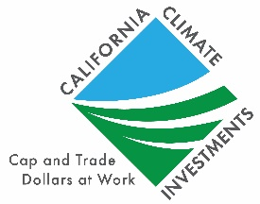
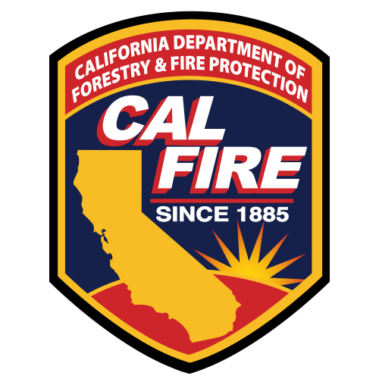

2023-2024 California Climate Investments

Wildfire Prevention (WP) Grants

Frequently Asked Questions

Grant Request Limits:

- The recommended funding amount is $3 million or less.
- Project equipment not to exceed a cumulative total of $750,000.
- Indirect Costs: 12% limit, unless a higher indirect rate is granted by CAL FIRE

Are there any recommendations for naming the project?

Make the name brief, with two to four words. It does not need to incorporate the area and type of treatment and project. Please do not include a full sentence as the name of the project.
Can you apply for two separate projects in the same application package?
Yes, you can do two projects for the same application package However, please ask your CAL FIRE local unit forester for more details.

Can WP Grants fund planning and design?

Yes, WP Grants can fund planning and design.

Our 501(c)(3) non-profit already started a hazardous fuels reduction program. Can we still apply?

Yes, you can still apply, but you will not be reimbursed for the work you have already done prior to the agreement date. You can apply for a grant for future work on the same project.

As a 501(c)(3) Fire Safe Council, can we use the funding to perform work on private land?

Yes, but you must secure written permission from the owner prior to conducting work on that property.

Is planting is allowed?

Planting is not an allowable activity under WP Grants.

Is maintenance allowed on previously created Hazardous Fuel Breaks?

Yes. Creation or maintenance of hazardous fuel breaks in strategic locations, as identified in CAL FIRE Unit Fire Plans, a Community Wildfire Protection Plan, or similar strategic planning document.

Can we upload our own maps to the Project Mapping Program?

You cannot upload your own shapefile maps through the Project Mapping Program. You will need to draw Geopoints and Polygon’s in the Project Mapping Program. You will also upload PDF maps within the Grants Portal.

How will projects be mapped?

- Applicants will be required to map proposed project locations in the Project Mapping Program and on pdf maps submitted through Grants Portal.
- Awarded grantees must provide project data reporting to CAL FIRE, including but not limited to, treated acres. CAL FIRE will provide grantees with the specific metrics and the reporting process.

Are Fiscal Sponsor Fees allowed to be included in the grant total along with other costs and expenses?

Yes, if these costs are directly related to the grant project. The fees will be evaluated as part of the overall grant budget.

How specific does the Treatment Influence Zone (TIZ) need to be mapped out for the Project Area?

Draw the TIZ areas as detailed as possible, it should not be a sketch.

What is the indirect cost?

Please review the Wildfire Prevention Grants Procedural Guide located on our website. It will go over what counts as indirect costs, required paperwork, and expenses that can be charged to those categories. It cannot exceed more than 12% of the cost of the grant unless a higher indirect rate is justified and granted by CAL FIRE.

If we underestimated the budget and don’t have enough funding to finish the project, how do we get more funding to finish the project?

You can apply for another grant to cover the unfinished phases of the project.

What is the maximum allowable indirect cost?

The inclusion of indirect costs is acceptable for direct award Wildfire Prevention Grant projects up to 12% of the total amount of direct grant funds provided to the grantee, minus equipment. Applicants may request from CAL FIRE a higher indirect cost rate by providing additional justification as to why a higher indirect rate is needed as well as including appropriate documentation substantiating the basis of the higher indirect rate (e.g., a copy of a federally approved Negotiated Indirect Cost Rate Agreement, etc.). Documentation related to the determination of the grantee’s indirect cost rate must be retained by the grantee for audit purposes. Please review the Wildfire Prevention Grants Procedural Guide for further indirect cost information.

Can the grant only pay for reimbursable expenses? Can it pay for the workers that do the project?

Yes, there are advances that allow you to pay for the workers. Advances must follow the requirements as specified in the procedural guide. The grantee must be responsible to pay the contractors (workers).
Would supplying equipment for a fire training program be appropriate for the Wildfire Prevention Grants?
The WP Grants funding strictly focuses on prevention and supplying training equipment would not be appropriate. There are other programs that focus on suppression by supplying firefighting equipment.
Can we do fuel reduction initially and have maintenance component to the end of the agreement?
Yes. For example, you can write in your application that for the first year you’re doing fuel reduction and the last several years you’re doing maintenance

Should I combine the different components of my projects such as fuel reduction and education in one application or should I submit them separately?

If your project has different components and they’re building on each other, there is no reason why you can’t put them all together. If the components of the project are separate, then yes, submit them separately.

What is an in-kind contribution or matching?

Matching or in-kind contributions are any contribution to the project (financial, volunteer time, employee time [paid by another funding source], services funded by another source, etc.) that contribute to achievement of the deliverables spelled out in the project application. CAL FIRE resources may not be used as match (i.e., crew day value).

Would applying for two grants from different sources at the same time negate our application through the Wildfire Prevention Grant Program?

Applying for multiple grant programs at the same time would not negate the application. However, it is expected that you would not enter an additional grant contract award for the same activities of the same project. If portions of the project were split, grants could be obtained from different sources for the split portions, not to exceed 100% of the project value. Attempts to bill two grants for the same work within a project would likely result in legal action by the State against the grantee.

What are the rules regarding conducting grant work on private property?

If the project will accomplish work on private property that is not owned by the grantee, the grantee must secure written permission prior to conducting work on that property. The land use agreements must be kept on file by the grantee and available for inspection by State personnel upon request.

Commercialization of forest products may occur as a part of work conducted during the grant. Since forest products income fluctuates, how can a potential grantee account for this during the application and grant phases of the project?

If commercializing occurs as a part of the process, any revenue from timber products will have to offset operating expenses. It is recommended that you use the price of forest products at the time of application to generate an estimate for budgeting purposes and not to speculate on the future price of any forest products expected to be generated by project implementation. The income must be accounted for as a net zero gain in the project budget by the end of the project.

Will the grant pay for State Department of Fish and Wildlife (DFW) application fees or costs to have CEQA work completed?

Yes. These items should be included in the budget worksheet for your project. Standard DFW fees for CEQA can be found at https://www.wildlife.ca.gov/Conservation/CEQA/Fees.

Our proposed Wildfire Prevention project includes several community outreach events. Can food be provided at these events and paid for by the grant?

There is nothing that specifically precludes this. However, it would not be a good use of grant funds and is strongly discouraged.

As a grantee, do we ever take possession of any funds?

If your project is selected for funding, there will be a mechanism for periodic reimbursement of the completed project work. Additionally, advanced payment of funds is allowed per the Advance Payment of Grant Funds section in the Wildfire Prevention Grants Program Procedural Guide.

Can we use the OES Form 130 in place of the Board resolution?

The OES form 130 will not work for the purpose of this grant. An approved action by the Board of Directors, specific to this project, will be required before entering a contract with the State. An unsigned, draft copy of the resolution can be submitted for the Project Application phase but the approved and signed resolution will be required prior to signing a grant award agreement. You may wish to include a note in your application that you are working on the Board approval requirement.

May an applicant submit additional documents with their application (i.e., cover letter, letters of support from fire safe councils, county representatives, etc.)?

Yes. We are interested in letters of support, but they should be received by CAL FIRE by the grant application due date to be considered. They will help illustrate community support. Please reference the project tracking number within the document and utilize the appropriate document naming convention for the electronic files when possible.

Can the grantee purchase Fire Engines or Water Tenders?

No. The Grantee can only purchase equipment utilized for wildfire prevention activities not for fire suppression activities.

Will this program pay for structural improvements to habitable structures?

No. The Wildfire Prevention Grants program is not intended to pay for structural improvements such as but not limited to ember changing vents, roof replacements and fire resistive fencing.

What are the critical changes to the FY23-24 WP Grant solicitation?

- Recommended funding amount is $3,000,000
- Project equipment not to exceed $750,000 cumulative
- Application process through new Grants Portal
- Project Influence Zone (PIZ) polygon no longer required or requested

