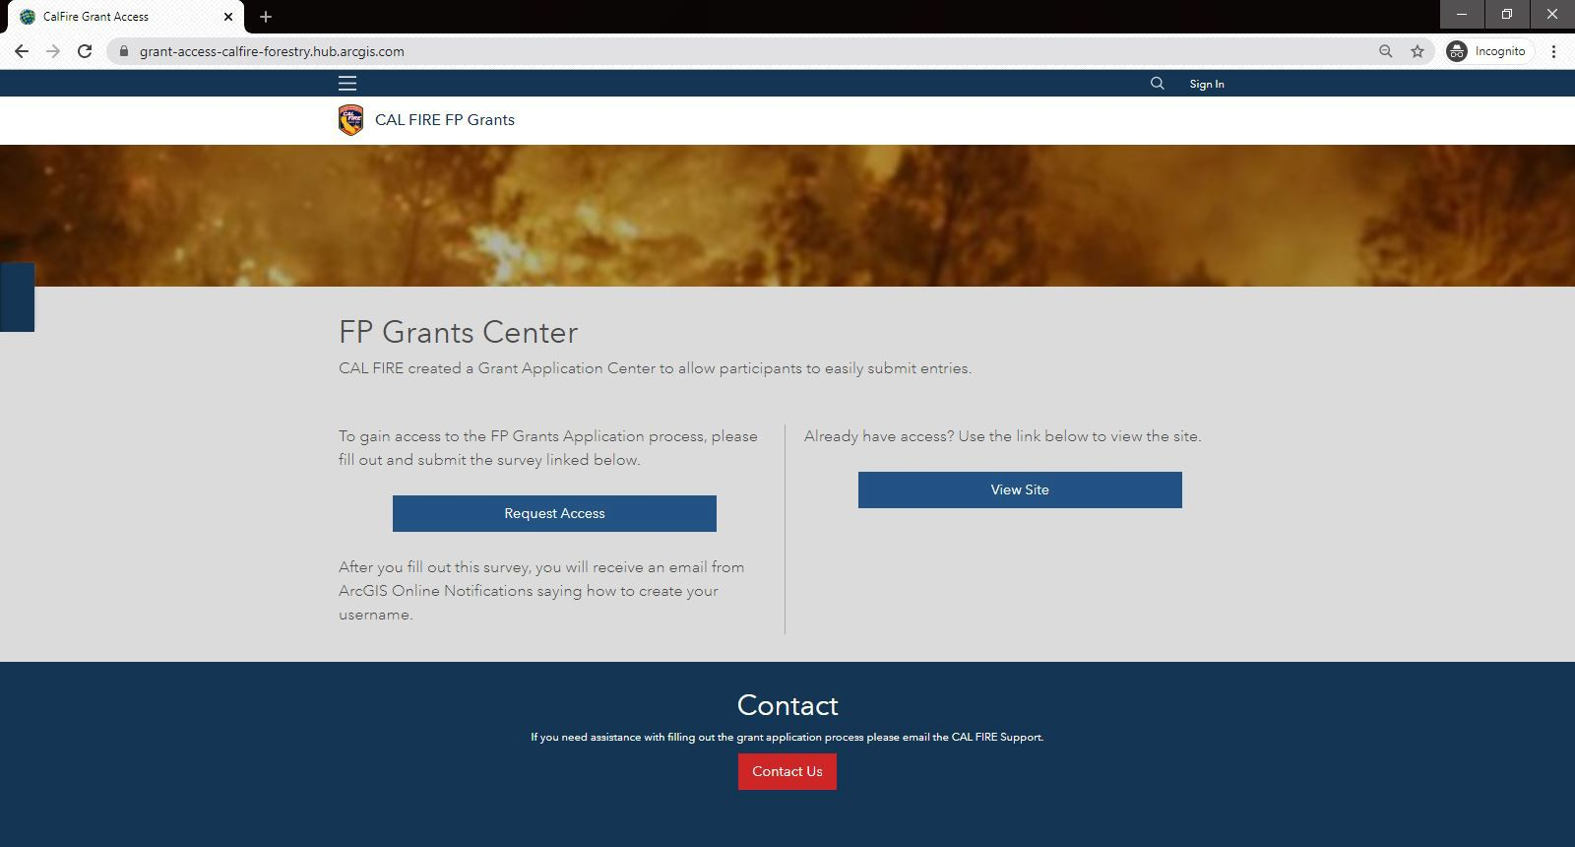
Fire Prevention Grants Project Mapping Program

Please email FPGrants@fire.ca.gov for questions.

Create the Geo Point and polygon(s) for your grant project. Grant applications without Geo Points and polygons will not be accepted, education and planning projects do not need polygons.

How to Request Access or log-in

- Click the link below to access the mapping website. https://grant-access-calfire-forestry.hub.arcgis.com/

- Select Request Access if you do not have a log-in. If you do have a log-in, select the View Site
option.

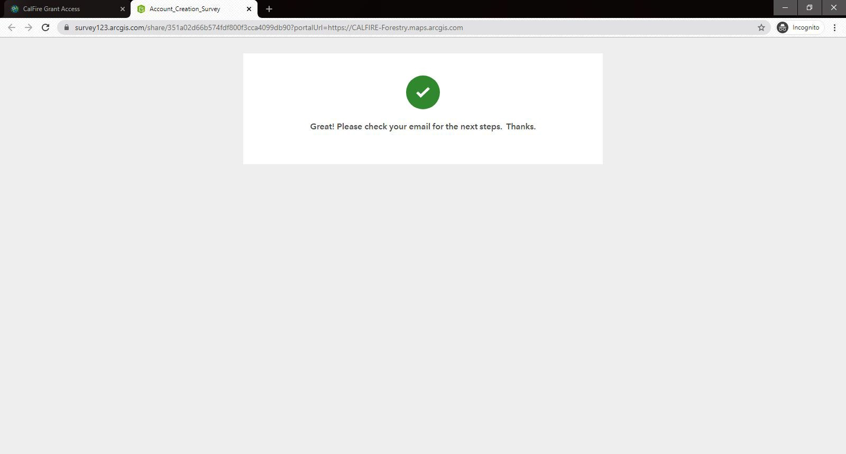
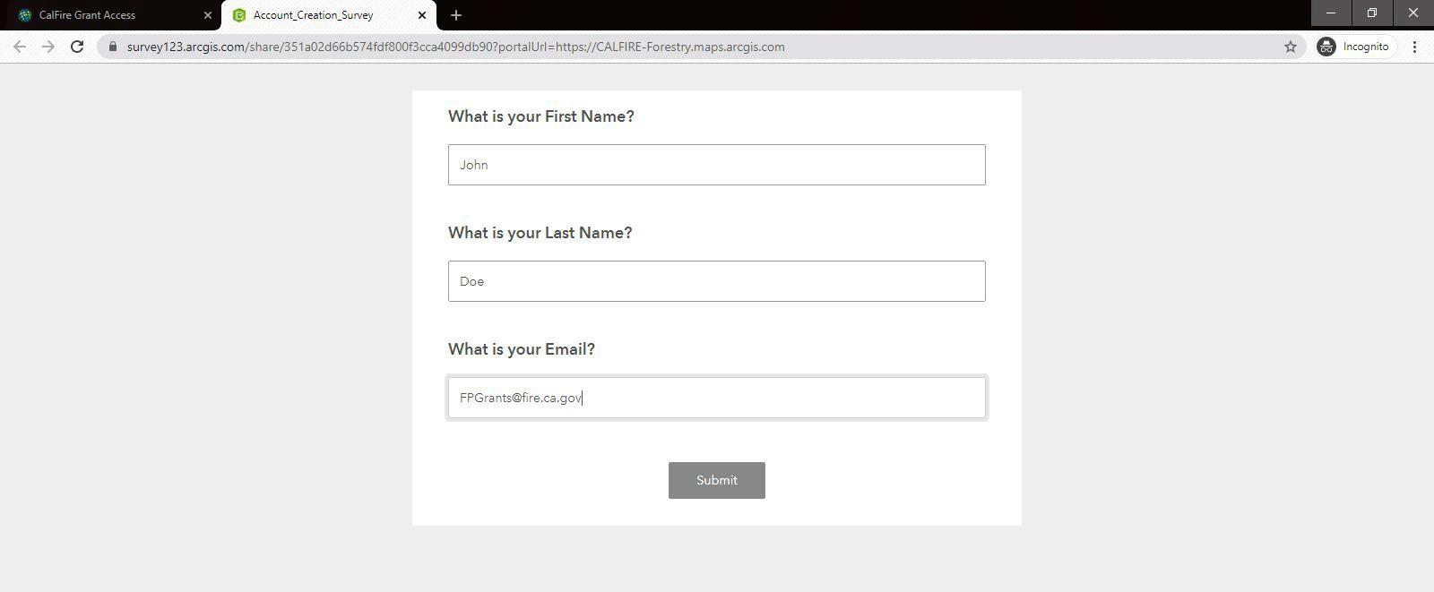
Requesting Access

If you do not have a log-in, click on Request Access. Enter info and click submit.

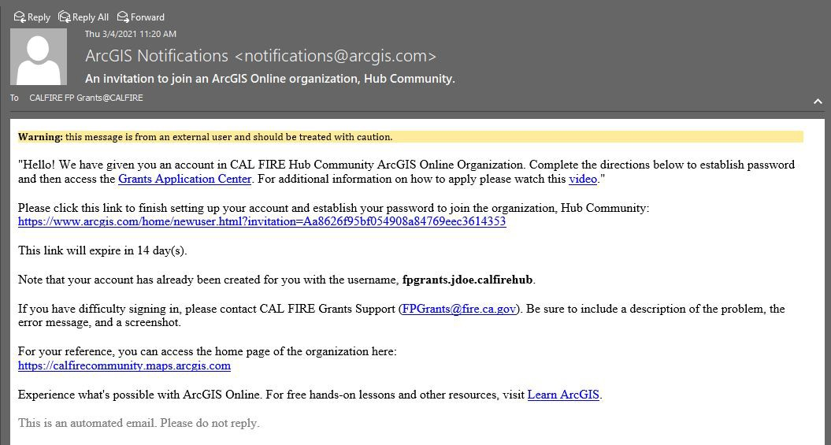
Once the log-in request is approved, an email will be sent from ArcGIS Notifications to the email address entered when you Requested Access. Your username will be in bold text in the email.

To finish setting up your account and to create a password, click the link in your email.

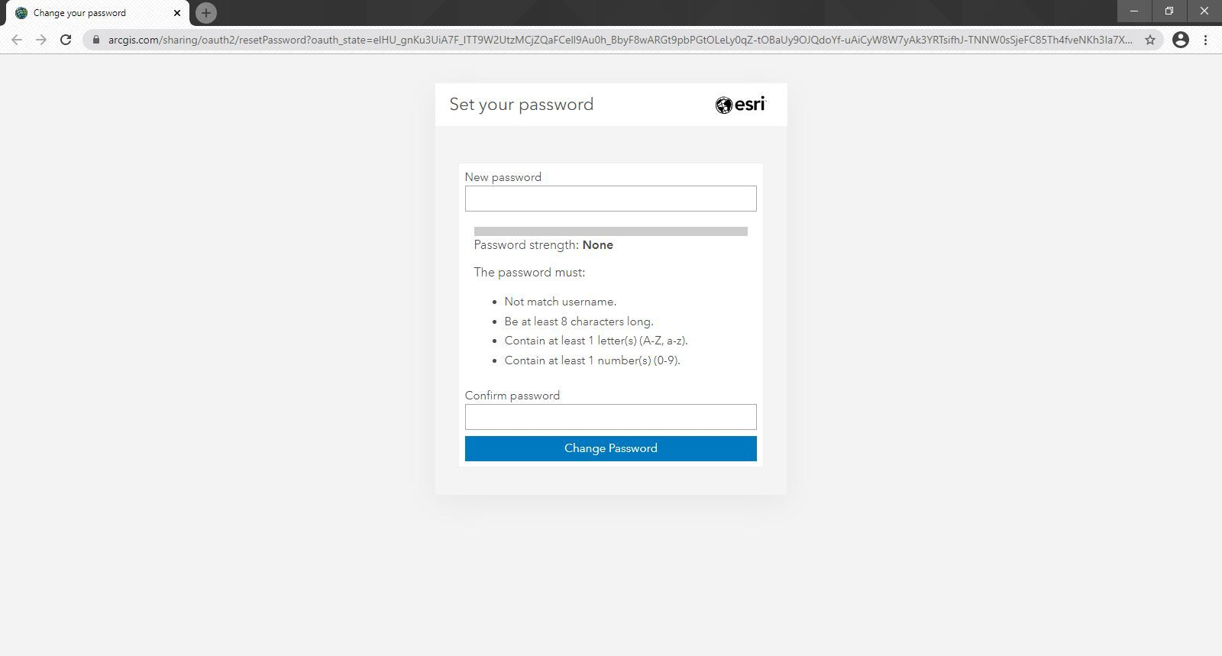
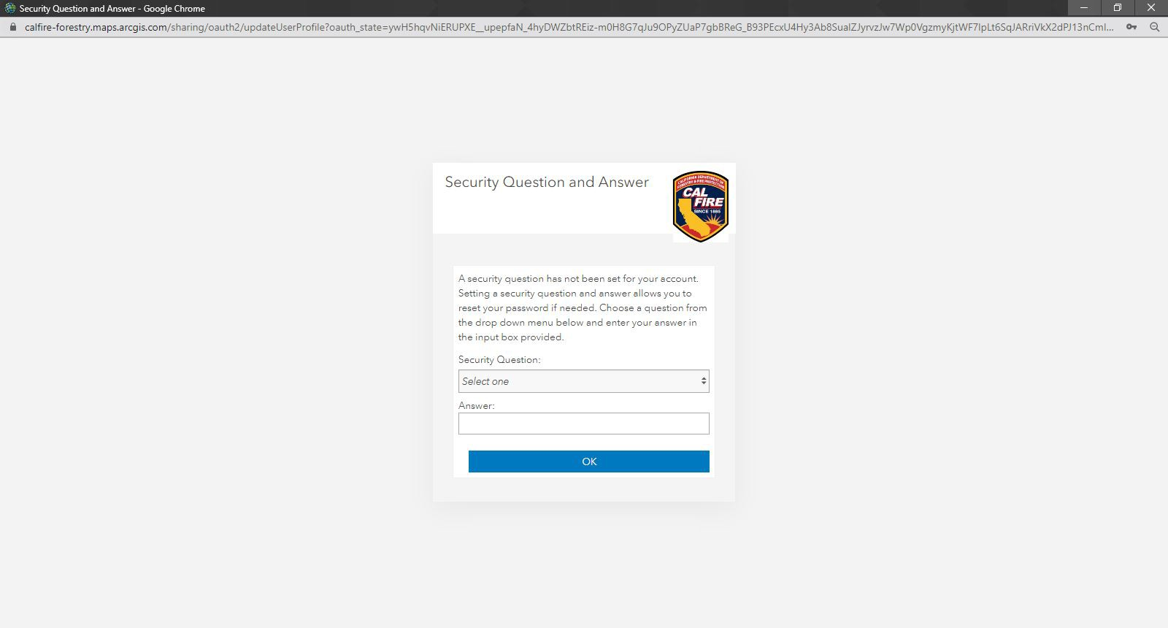
Create your new password and click Change Password

Set your security question and answer, click OK to save

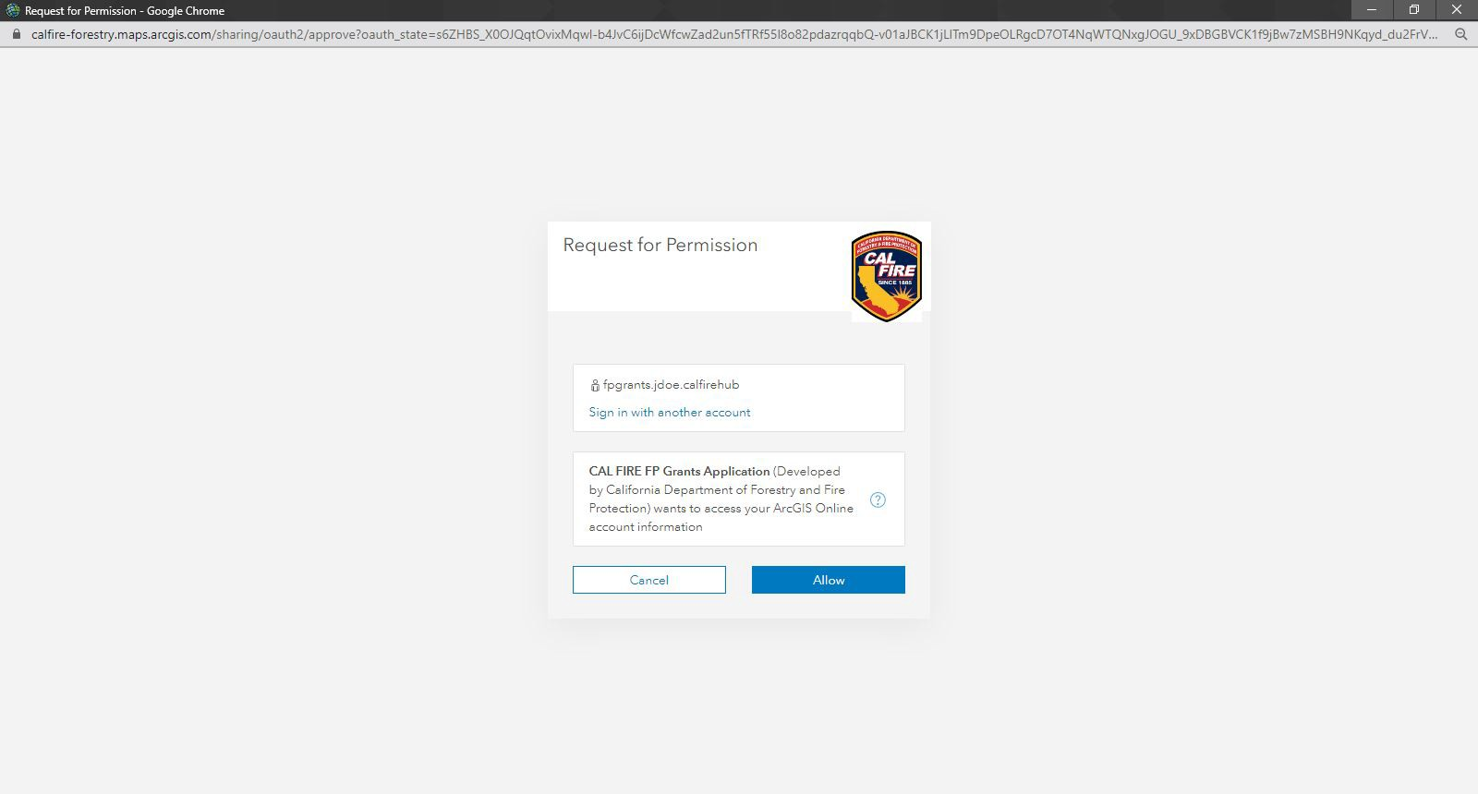
The site will direct you to login to access the Cal Fire Fire Prevention Grants Project Mapping Hub website

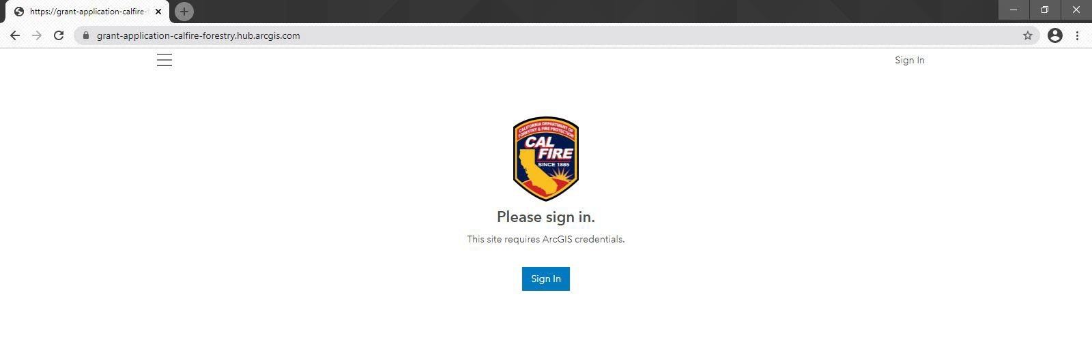
CAL FIRE Fire Prevention Grants Project Mapping Hub

- To begin the mapping portion of the grant application, click on the View Site option or follow the link below
https://grant-application-calfire-forestry.hub.arcgis.com/

- Next, sign in using your new calfirehub account username and password

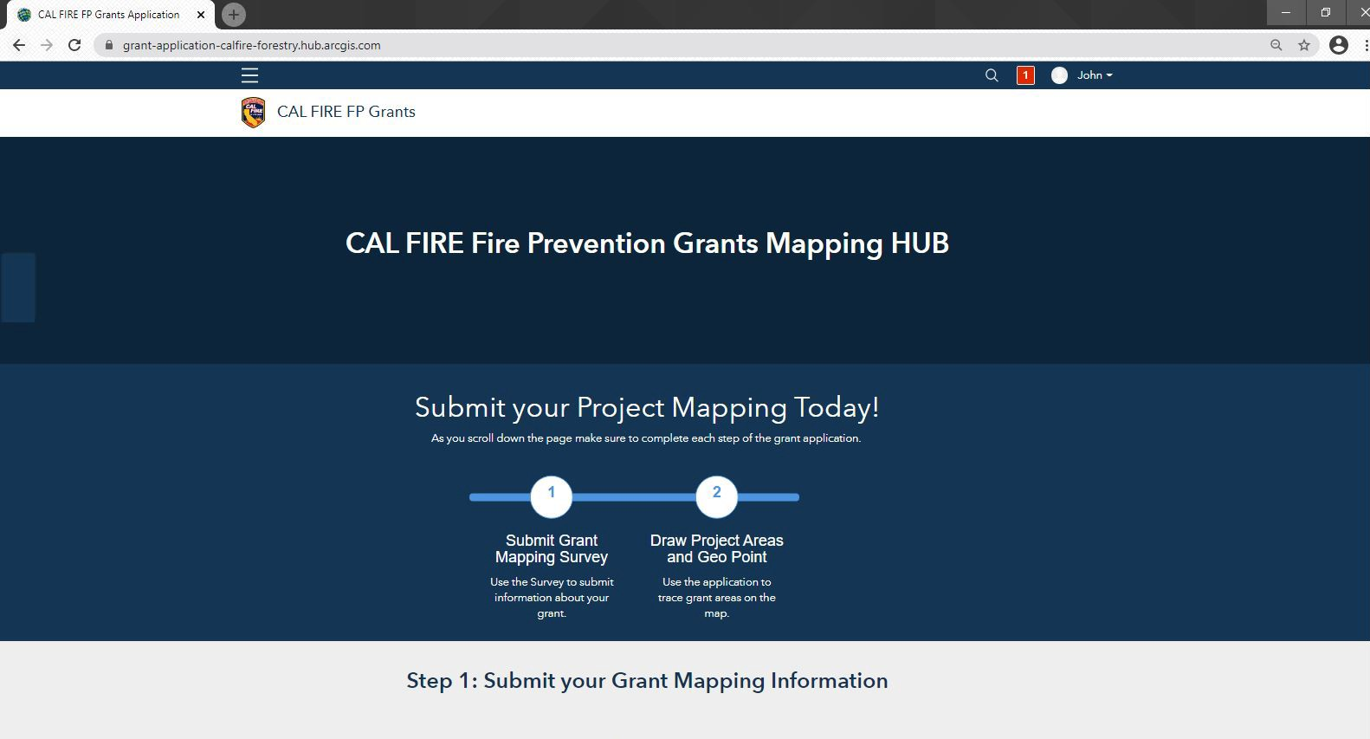
- After signing in, you will be required to complete the application project mapping process

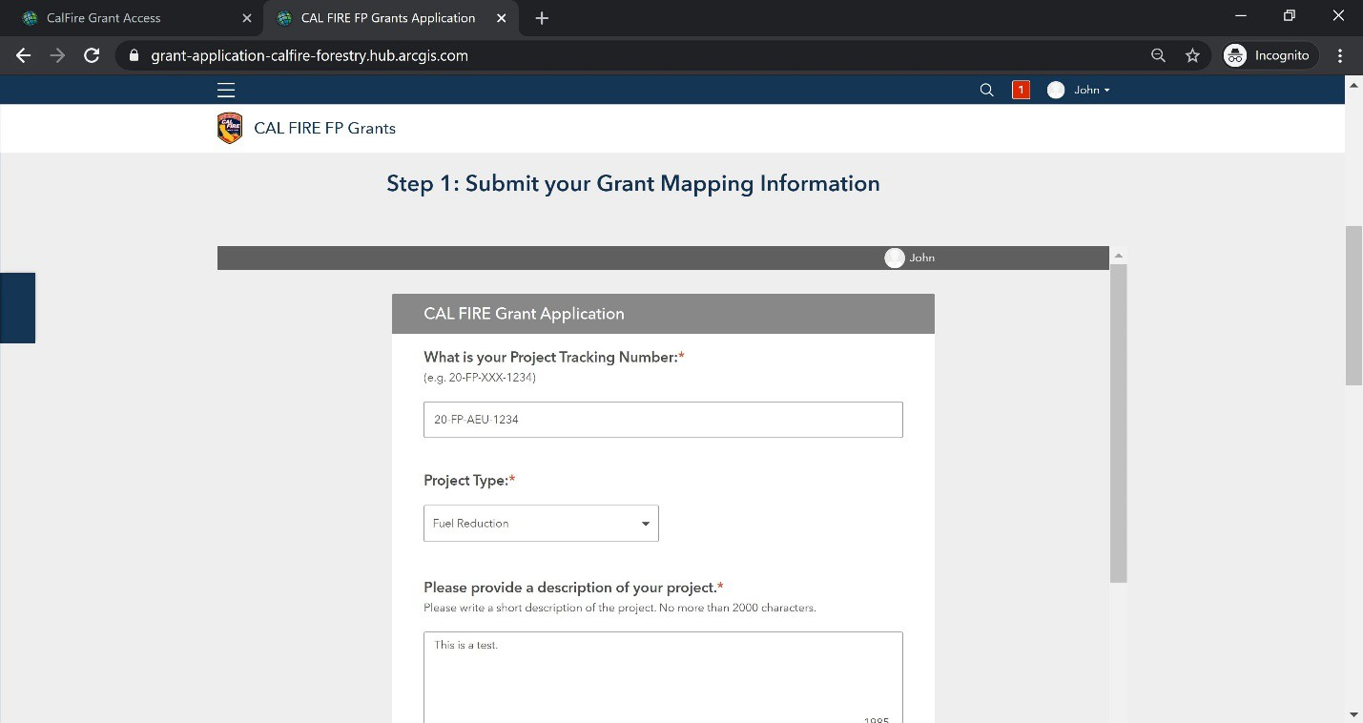
- Scroll down the page to complete Step 1: Submit your Grant Mapping Information
  - Project Tracking Number
  - Project Type
  - Project Description
  - Contact Info for project primary contact

- After completing the Grant Mapping Information, click Submit and continue scrolling down to complete the online mapping portion of the application.
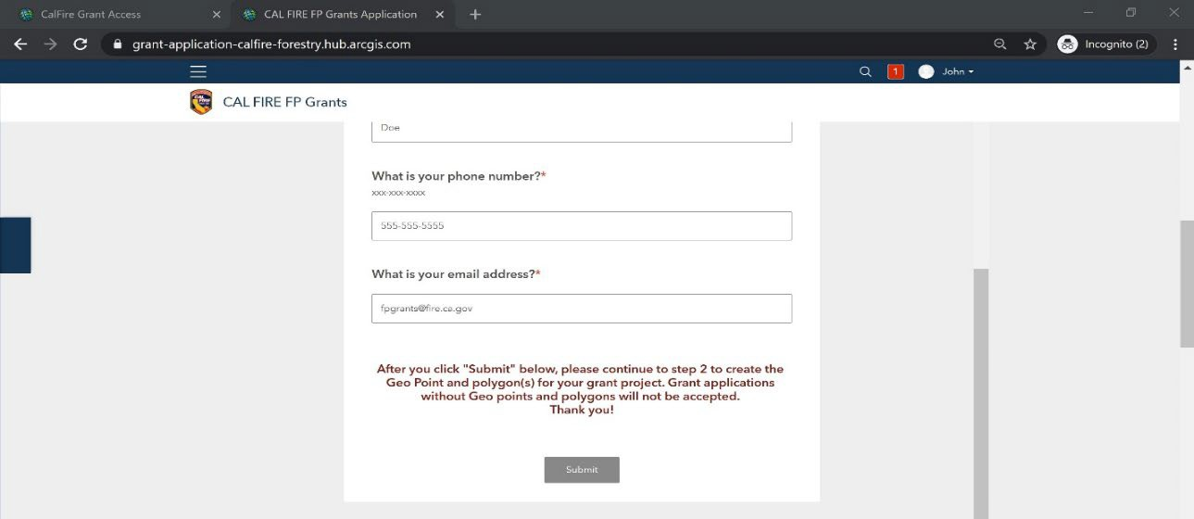

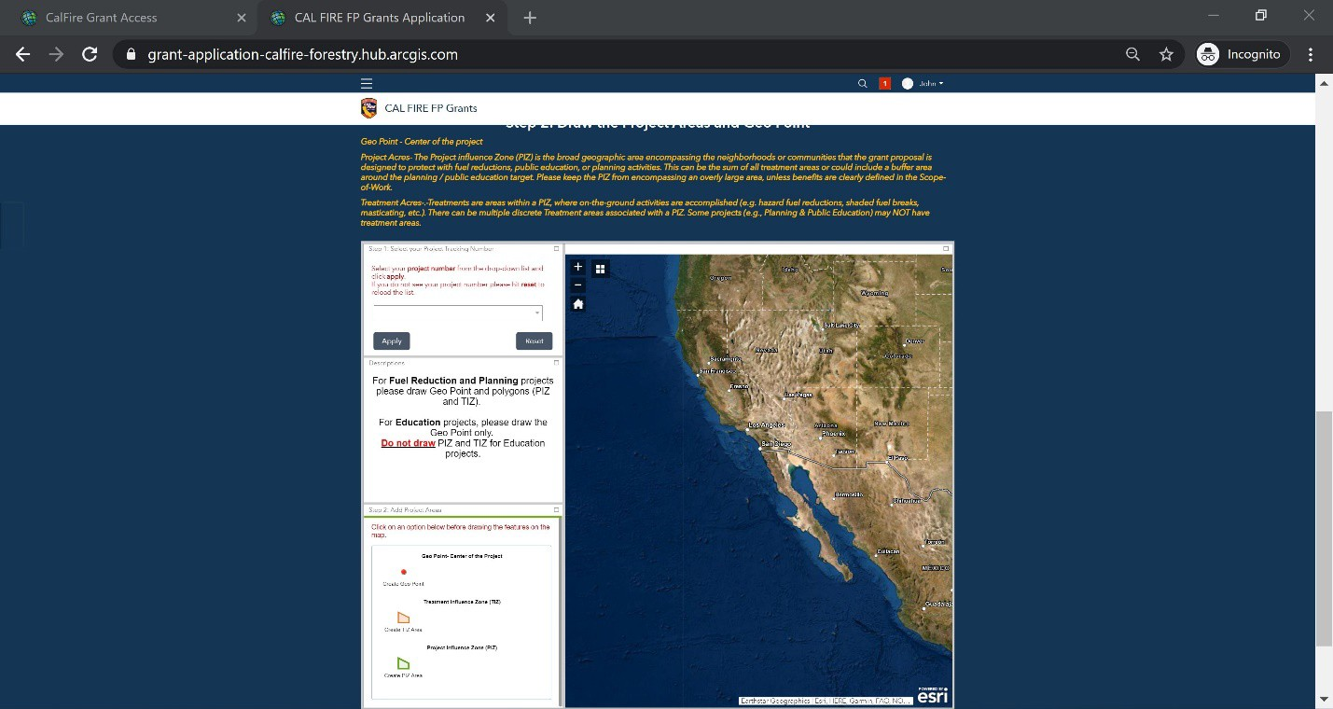
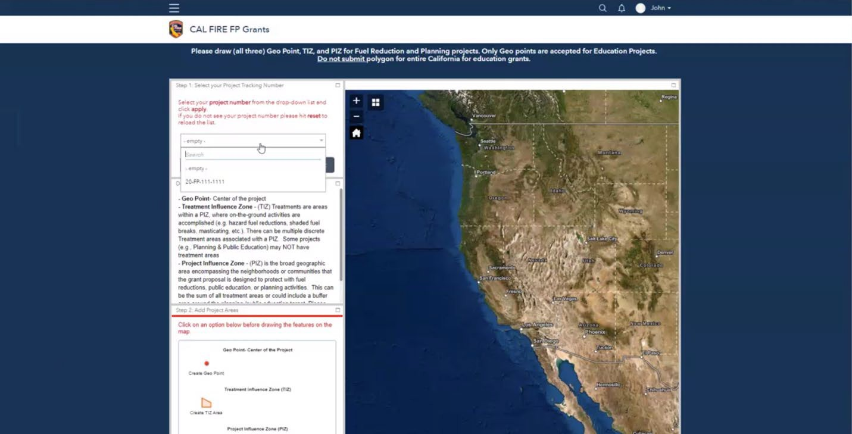
- In the second part of the application process, you will be asked to draw the Geo Point and the Treatment for your project Planning and Education Projects will only require a Geo Point.

- Using the drop-down menu, select your project number and select Apply

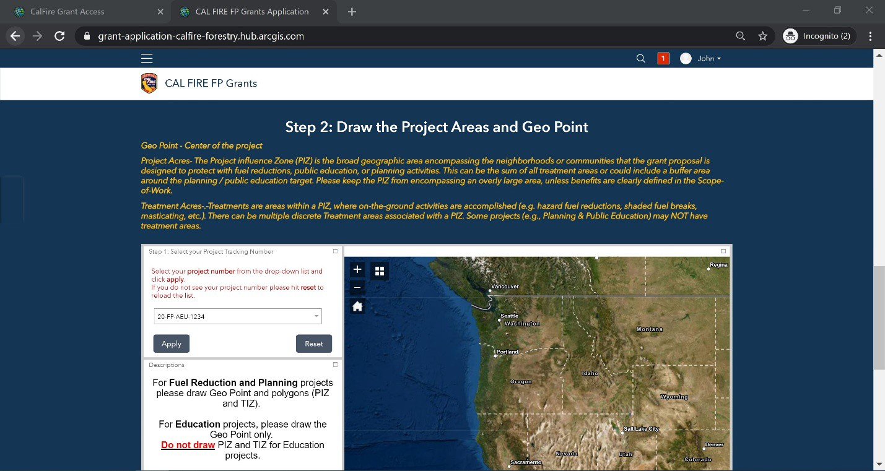
Note: If your project number does not display as an option in the drop down, click the Reset
button, and reopen the drop-down menu to select the project number. Click Apply to save.

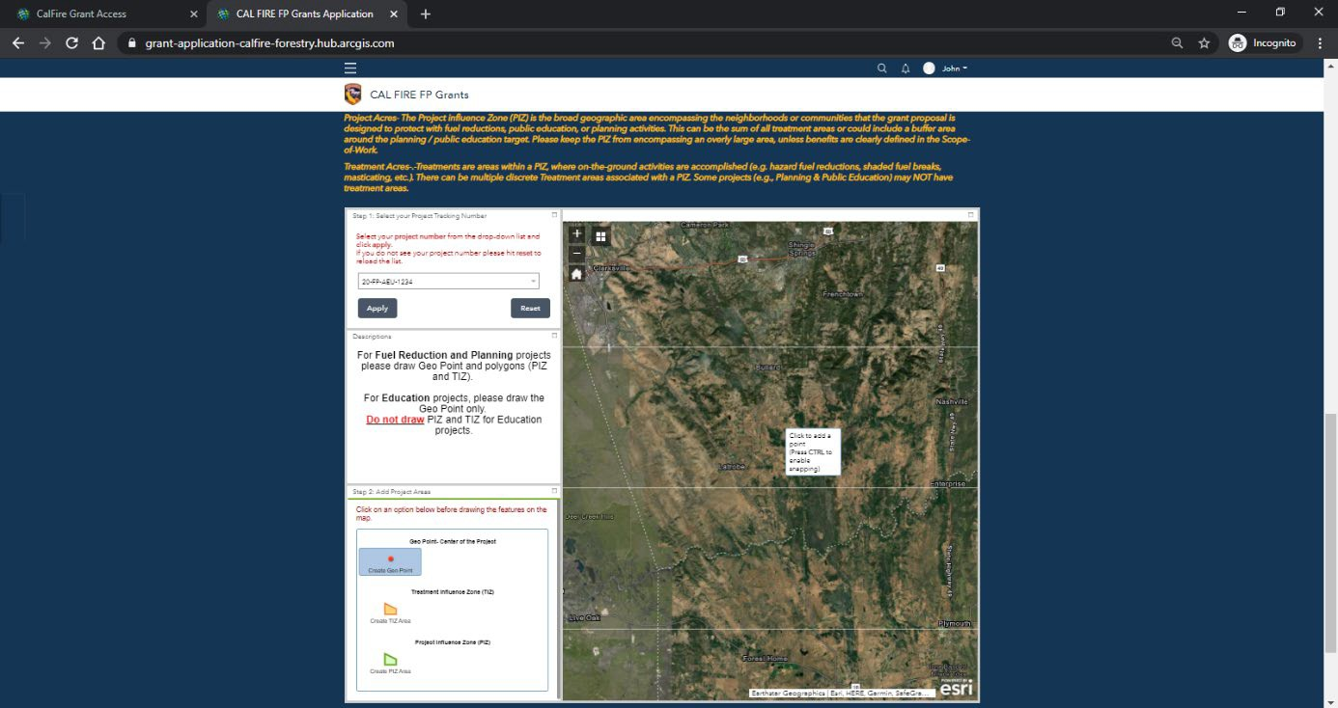
- To draw a Geo Point, select the Create Geo Point tool from the features option. Once selected, the tool will turn blue indicating that the tool is selected. To zoom into your areas of interest using the scroll wheel on your mouse or the plus (+) and minus (-) buttons on the top Once you have selected the Create Geo Point tool, move the cursor to the map and click on the location where you want the Geo Point to be placed

After you have drawn the Geo Point, click Save and Close. To delete an attempt, click Delete
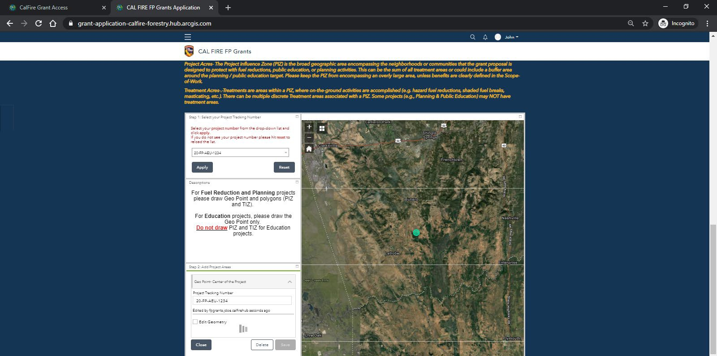
- To draw the Treatment Influence Zone(s) (TIZ), click the Create TIZ Area tool so that it is selected. Move the cursor to the area of interest on the map and begin to draw the perimeter of the treatment area(s). Remember to click on the map to draw the perimeter. When you are finished, double-click to close the boundary
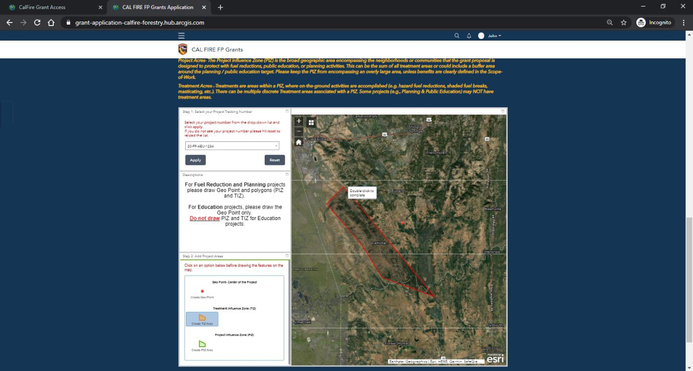

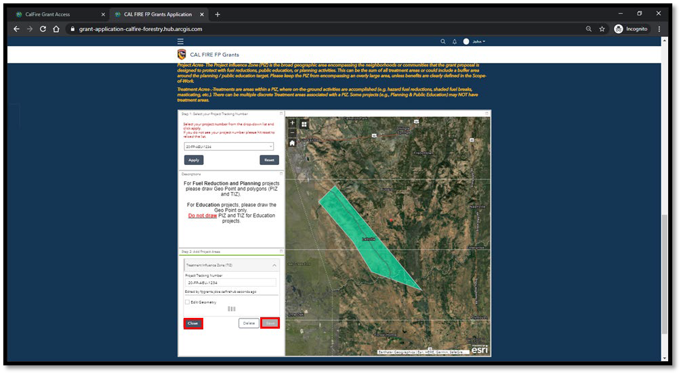
After you have drawn the Treatment Influence Zone(s), click Save and then Close

- In the third part of the application process, you will be asked to confirm drawing the required geometry for your selected project type. Enter your project tracking number and select your project type from the drop-down menu

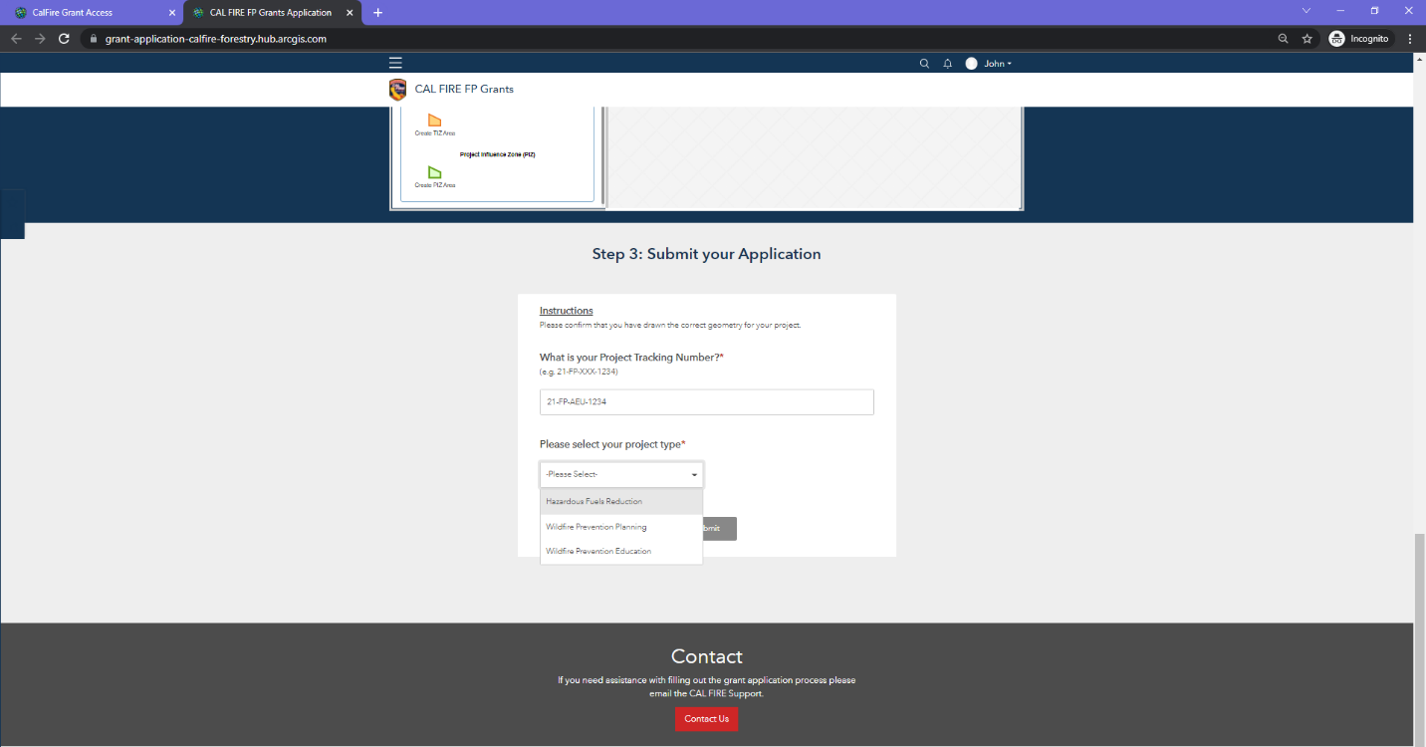

Once you have selected your project type from the drop-down menu, confirm that you have drawn the required geometry for your project. Select from the Yes/No options. Remember, you must draw a Geo Point and Treatment Influence Zone(s) (TIZ) for your Hazardous Fuels Reduction project. Wildfire Prevention Planning and Education Projects will require a Geo Point only.

Note: An application will be automatically rejected if an applicant fails to each draw required geometry for their project.

How to logout
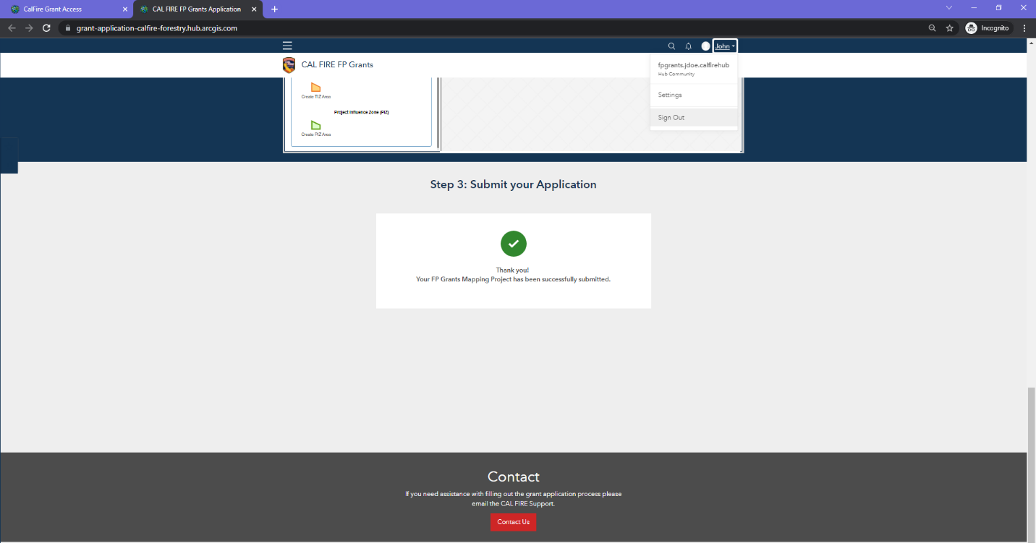
Once you have successfully completed the Fire Prevention Grants Mapping application, click on the username on the top tool bar and select Sign Out.

