

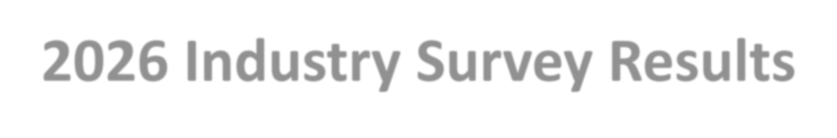
2026 Industry Survey Results
From California Environmental Protection Agency
March 2026


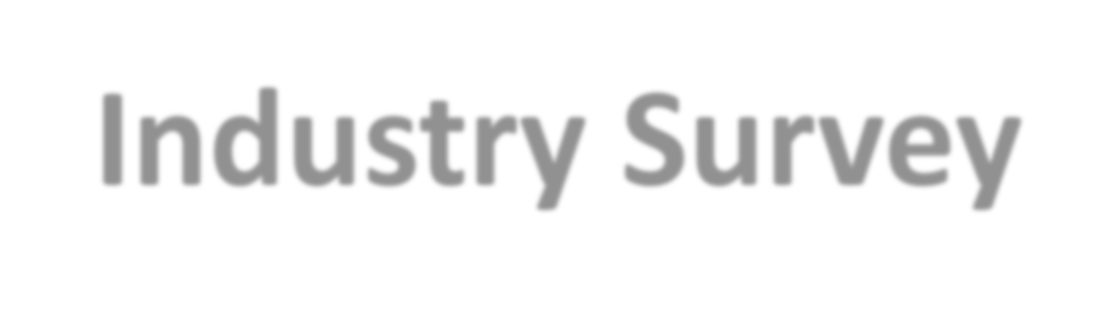
Industry Survey
- Used 2025 industry stakeholder group presentation to build survey questions
- Respondents were asked to rank a set of concerns identified in the 2025 survey for each program, and space was provided to add their own concerns and comments
- Short timeframe – March 2 to March 13, 2026
- 67,000 CERS lead users were invited to participate
- 682 responses were collected


APSA Program Challenges
Based on 655 respondents

Other Challenges and Issues, 8%

Varying multi- facility Plan oversight, 16.40%

Inconsistent “facility” determination, 16.70%
Inconsistent implementation of program requirements, 19%

Inaccurate review of industry standards, 17%

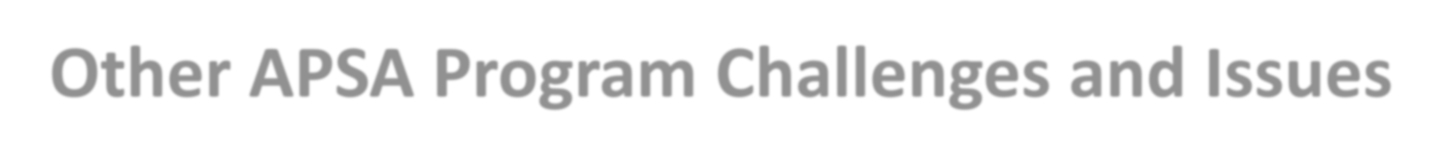
Other APSA Program Challenges and Issues
- APSA/SPCC overlap needs to be more clearly defined. We attempted to make an inspection checklist that met both APSA/SPCC guidelines and clearly indicated which inspection point met which rule. It was a near-impossible project. It would be so helpful for us to be provided with checklists that have been

Positive, 2%

approved by the local CUPA, have if/then notes (if your site has this, complete this next section, etc.), and that cite the regulatory requirement they're fulfilling.
- Regulators are poorly trained and typically not licensed as engineers. As industry is required to use licensed engineers to write Tier 2 SPCCs, anyone who is not a licensed engineer is not qualified to comment on the document and is practicing outside their area of expertise.
- Suggestion - CERS should provide a technical amendment page(s) in CERS to allow for the addition and/or subtraction of tanks/containers/equipment that will auto-populate signature pages for management approval and PE signature and send a DocuSign email to each with the base SPCC Plan provided.
Other, 35%

Negative, 21%

Neutral, 42%

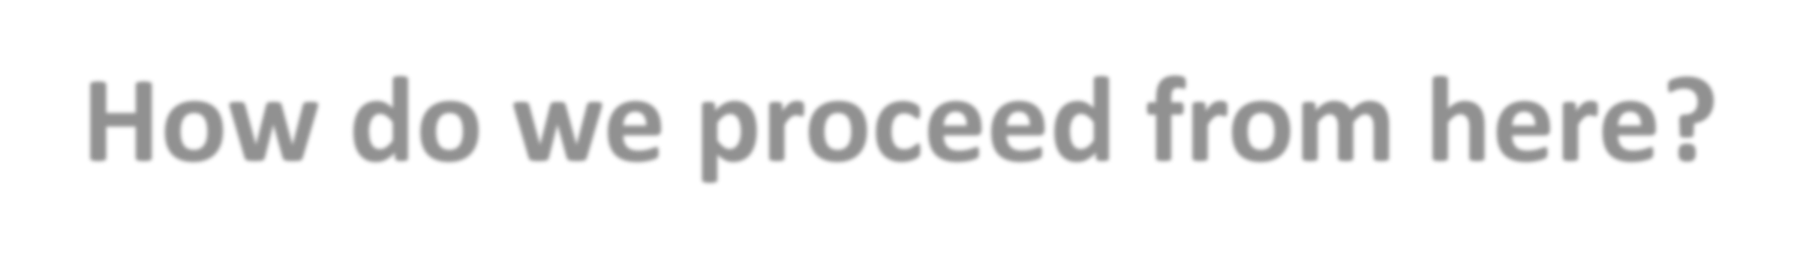
How do we proceed from here?
- Desire for collaboration and coordination throughout year
  - Maintain status quo or seek other ways for industry input
  - Goal is to improve the “Unified” in Unified Program
- Potential adjustments to the Industry Stakeholder Meeting (at future conferences)
  - Joint report on status of addressing industry concerns, accomplishments and emerging issues
  - Celebrate accomplishments!

