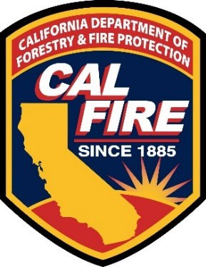

OFFICE OF THE STATE FIRE MARSHAL ABOVEGROUND PETROLEUM STORAGE ACT (APSA) ADVISORY COMMITTEE
CHARTER

Revised April 16, 2026

Purpose
The purpose of the Aboveground Petroleum Storage Act (APSA) Advisory Committee is to provide coordinated and consistent interpretation and guidance of the APSA Program throughout the State of California.
Goals and Objectives
The APSA Advisory Committee is being formed pursuant to Assembly Bill 1566 (Chapter 532, Statutes of 2012) to act in an advisory capacity on the APSA Program policies and has developed the following goals and objectives.
Goal: Professional, effective, and consistent delivery of the APSA Program throughout the State of California.
Objectives
- Develop regulations (California Code of Regulations, Title 19, Division 1).
- Provide recommendations on the state surcharge.
- Conduct analyses of APSA Program issues.
- Review and evaluate existing and future Unified Program regulations thataffect the APSA Program, including the Unified Program data dictionary.
- Develop standardized APSA Program templates and guidance documents for current use, as well as incorporation and use in the California Electronic Reporting System.
- Provide consistent interpretations and guidance for APSA Program concerns and issues.

- Review and evaluate APSA Program issues at therequest of the Unified Program Administrative and Advisory Group (UPAAG). Provide program-related assistance, if any, to UPAAG.
Membership
The APSA Advisory Committee is comprised of representatives from the Department of Forestry and Fire Protection (CAL FIRE) – Office of the State Fire Marshal (OSFM), Unified Program Agencies, federal and state agencies, fire service, the industry, industry standards organizations and other interested parties.
Other Unified Program Agency representatives and industry representatives may be included in discussions by APSA workgroups or subcommittees with approval of the chairperson.
The number of voting members shall not exceed 13, and the committee shall, to the extent possible, ensure that the number of regulators shall not exceed the number of industry representatives.
Member Commitments
- The OSFM “CUPA” Program Coordinator will be the chairperson. The APSA Issue Coordinator or a CUPA regional representative will act as co-chair(s). The chair will establish meeting dates, locations, and agendas, in coordination with the co-chair(s).
- Chair and co-chair(s) will forward advisory committee and workgroup status reports to UPAAG quarterly.
- All members will participate in scheduled meetings and conference calls when possible. Meeting minutes will be completed by OSFM staff.
- Members will provide timely review and comment on draft documents.
- Meetings will be held biannually or as frequently as necessary.
- Workgroups to address specific technical issues may be established; workgroup meetings will be held on an as-needed basis.

