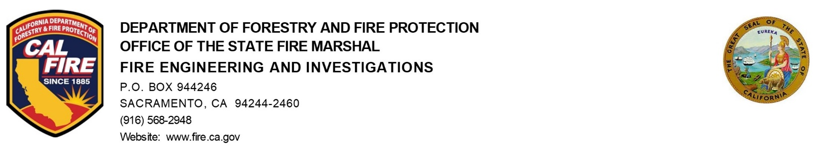

Date: May 30, 2024

To: Fire Alarm Advisory Committee

From: Greg Andersen, Chief of Fire Engineering & Investigations

SUBJECT/AGENDA ACTION ITEM:
CAL FIRE proposals to the International Code Council (ICC)

Recommended Actions:
Information Only

Background Information:

CAL FIRE/ Office of the State Fire Marshal submitted and presented several proposals at the 2024 International Code Council (ICC) Group A Committee Action Hearings (CAH) in Orlando, FL in April 2024 for the 2027 Edition of the International Codes.
International Fire Code (IFC) Proposal F137-24 proposed to add examples in a list format of locations where strobes shall be installed to section 907.5.2.3.1. The proposal is based on what is currently in the 2022 California Fire Code (CFC) as a California amendment to the 2021 IFC.

Analysis/Summary of Issue:

There continues to be an ongoing discussion within the fire alarm industry and other stakeholders regarding the appropriate interpretation of the term “Public use and Common use areas”. The intent of State Fire Marshal’s office of submitting the proposal to incorporate the California amendment to section 907.5.2.3.1 “Public use areas and common use areas” was to escalate the discussion to the national level and gather input from additional subject matter experts.

The ICC Fire Action Committee disapproved the proposal F137-24. However, the committee offered input on alternative options and identified issues with the proposed language, suggesting potential revisions, including the possibility of incorporating the list of examples to the Code and Commentary publication.

REVISE 2024 International Fire Code as follows:

907.5.2.3.1 Public use areas and common use areas. Visible alarm notification appliances shall be installed in rooms that are normally occupied and used by two or more persons, as well as provided in public use areas and common use areas. This includes, but is not limited to, the following spaces:
1. Band rooms.
2. Classrooms.
3. Corridors.
4. Gymnasiums.
5. Lobbies.
6. Meeting and conference rooms.
7. Multipurpose rooms.
8. Music practice rooms.
9. Occupational shops.
10. Occupied rooms where ambient noise impairs hearing of the fire alarm.
11. Sanitary facilities including restrooms, bathrooms, and shower rooms.
12. Shared office rooms used by two or more persons.
13. Huddle room, mother's room, phone room, quite-room, wellness-room, etc.
14. Storage room/area.
15. Exam rooms in medical office buildings.

Exception: Where employee work areas have audible alarm coverage, the notification appliance circuits serving the employee work areas shall be initially designed with not less than 20-percent spare capacity to account for the potential of adding visible notification appliances in the future to accommodate hearing-impaired employee(s).

Potential Industry Impacts:

It was identified that the proposed; “installed in rooms that are normally occupied and used by two or more persons”; a strobe is required in all areas of the building, basically requires strobes everywhere in the building.

The California amended definitions have added to the confusion and application of section 907.5.2.3.1.

[BE]PUBLIC-USE AREAS. Interior or exterior rooms or spaces that are made available to the general public.

PUBLIC-USE AREAS. [HCD 1-AC] Interior or exterior rooms or spaces of a building or facility that are made available to the general public and do not include common use areas. Public use areas may be provided at a building or facility that is privately or publicly owned.

PUBLIC USE. [DSA-AC] Interior or exterior rooms, spaces or elements that are made available to the public. Public use may be provided at a building or facility that is privately or publicly owned. Private interior or exterior rooms, spaces or elements associated with a residential dwelling unit provided by a public housing program or in a public housing facility are not public use areas and shall not be required to be made available to the public.

[BE]COMMON USE. Interior or exterior circulation paths, rooms, spaces or elements that are not for public use and are made available for the shared use of two or more people.

COMMON USE AREAS. [HCD 1-AC] Private use areas within multifamily residential facilities where the use of these areas is limited exclusively to owners, residents and their guests. The areas may be defined as rooms or spaces or elements inside or outside of a building.

Action Items:

Evaluate the F137-24 proposal and suggest an action:
- Submit a public comment with modification based on feedback from the committee to bring it back at the second CAH in Long Beach, CA in October 2024.
- Submit a public comment “As Submitted” and stand on the reason statement and not address any of the feedback from the committee.
- Do nothing. The proposal will just die and not be heard again.
- Does the California amendment to the section need to be changed based on the feedback from the ICC CAH feedback?

