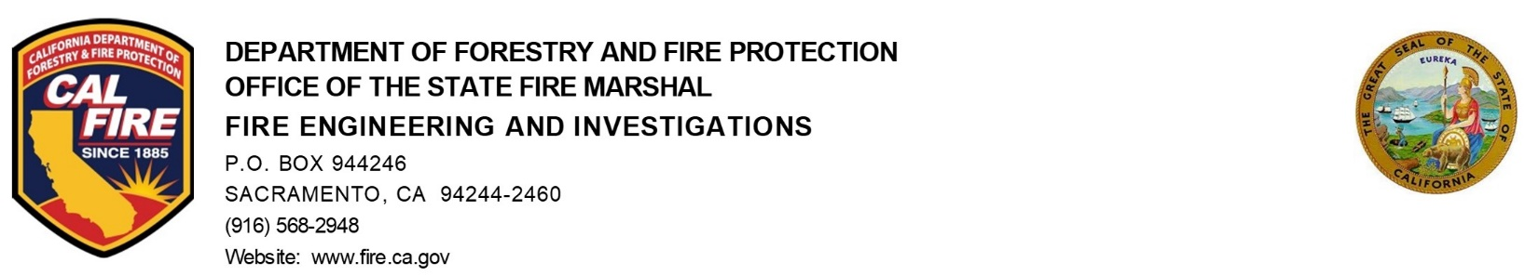

Date: May 30, 2024

To: Fire Alarm Advisory Committee

From: Greg Andersen, Chief of Fire Engineering & Investigations

SUBJECT/AGENDA ACTION ITEM:
Workgroup for proposals to make NFPA 72 and the California Fire Code consistent.

Recommended Actions:
Information only

Background Information:

The California Fire Code (CFC) has sections that were created over a long period of time. Some the sections with California language came from statute. NFPA 72 has made changes over years, modified and add definitions.

Analysis/Summary of Issue:

The current editions of the CFC use some different definitions than NFPA 72. The Fire Alarm Advisory Committee agreed moved that a workgroup be formed to address some of the issues. The workgroup would need to have the proposals for the next adoption of Title 24.

Potential Industry Impacts:

The correlation between the CFC and NFPA 72 would create clear guidelines for the industry and the AHJs.

Action Items:

