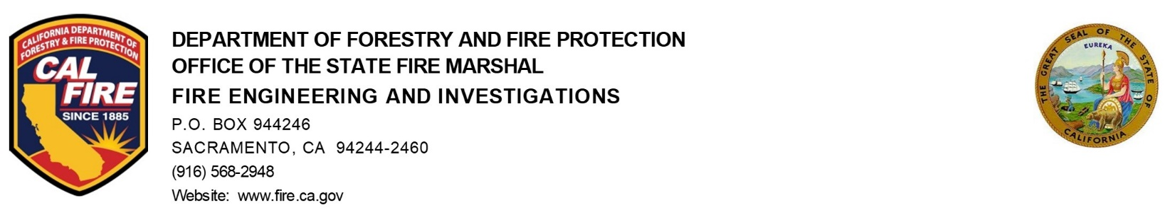

Date: May 15, 2024

To: General Fireworks Advisory Committee

From: Greg Andersen, Chief of Fire Engineering & Investigations

SUBJECT/AGENDA ACTION ITEM:
Workload Analysis Training for Enforcement of Illegal Fireworks

Recommended Actions:
Information Only

Background Information:

Assembly Bill 1403 requires the OSFM on or before January 1, 2025, the State Fire Marshal shall provide to the appropriate policy and budget committees of the respective houses of the Legislature a workload analysis of resources needed to further assist in the training of local fire and law enforcement personnel regarding all the following:
• The seizure, collection, transportation, and storage of seized fireworks.
• The enforcement of statewide programs concerning illegal and dangerous fireworks.
• Prosecution related to seized fireworks.
• Investigations of illegal and dangerous fireworks.

The bill also requires the OSFM on or before January 1, 2025, the State Fire Marshal shall collect and analyze data relating to:
Caused by the sale and use of both dangerous illegal fireworks and safe and sane fireworks:
- fires
- damages
- seizures
- arrests
- administrative citations
- fireworks disposal issues
The State Fire Marshal shall collect data pursuant to a methodology developed in consultation with the State Fire Marshal’s General Fireworks Advisory Committee.

Analysis/Summary of Issue:

The Fire Engineering & Investigations Arson & Bomb Unit is analyzing the required classes and staff to create and deliver the described classes/training for the local jurisdictions. Based on that need the division will complete the workload analysis for the described training.

The collection and analysis of the fireworks has been started. CAL FIRE has implemented the +1 Code collection on Sane & Sane Fireworks vs. dangerous fireworks for our system in CalStats on January 1, 2023. The CalStats has submitted requests for data field in the upcoming change for the national fire reporting system, NFIRS as it transitions to NERIS to emphasize the need for our mandated data points.

The office is starting a qualitative analysis of the fires caused by fireworks. The office will collect existing data from local departments that differentiate between Safe & Sane and dangerous fireworks. That would give a basis of comparison for the state to make a reasonable estimate of existing firework fires at a state level.

Potential Industry Impacts:

TBD

Action Items:

