NOTE: This CWPP Template is part of the California CWPP Toolkit, a free online resource that contains a comprehensive guide and other materials to help communities develop and implement CWPPs. This Template is an optional resource and can be customized to align with community needs. The CWPP Guide should be consulted when using this Template. (Users should delete this message in their final CWPP).

[COMMUNITY NAME]

Community Wildfire Protection Plan
[Cover image(s)]
  - [Date of plan approval or adoption]
LOGO
LOGO
LOGO
LOGO

Signature Page

The following signatories mutually agree on and approve the final contents of this CWPP:

[Name]  [Title e.g., Unit Chief]  [Organization e.g., CAL FIRE Unit Name] |  | Date
[Name]  [Title]  [Organization] |  | Date
[Name]  [Title]  [Organization] |  | Date

Acknowledgments
[TEXT]

Plan Contact Information
[POINT OF CONTACT]
[ORGANIZATION]
[PHONE]
[EMAIL]

Contents
Executive Summary 1
Introduction 2
Goals and Objectives 2
Roles and Responsibilities 2
Applicable Plans and Regulations 3
Planning Area / Community Information 3
Fire Protection Areas 5
Fire District Service Areas 5
Responsibility Areas 7
Federal Responsibility Areas 7
State Responsibility Areas 7
Local Responsibility Areas 7
CAL FIRE Units 9
Wildland-Urban Interface Identification 11
Assessment of Wildfire Hazard and Wildfire Risk 13
Wildfire Hazard 13
Wildfire Risk 15
Action Plan 17
Landscape Management / Prioritized Hazardous Fuel Reduction Treatments 18
Ignitability Measures for Structures 20
New Development Requirements 20
Existing Development 20
Ignitability Measures for Critical Infrastructure 21
Wildfire Response and Suppression Capabilities 21
Additional Actions 21
Appendices 22
Appendix A: CWPP Working Group Members and Stakeholders (Example) 23
Appendix B: Applicable Plans and Regulations (Example) 25
Appendix C: Public Outreach and Engagement 26
Appendix D: Community HVRA Prioritization and Risk Assessment table 27

Figures & Tables
[FORMATTED LIST WITH EXAMPLE TEXT]

Figure 1. Map of the [Community Name] CWPP planning area boundary 4
Figure 2. Map of the fire district service areas within the [Community] CWPP planning area 6
Figure 3. Map of the wildland fire responsibility areas within the [COMMUNITY] CWPP 8
Figure 4. Map of the CAL FIRE units related to the [COMMUNITY] CWPP planning area 10
Figure 5. Map of the identified wildland urban interface within the [COMMUNITY] CWPP planning area 12
Figure 6. [COMMUNITY] CWPP wildfire hazard assessment map 14
Figure 7. [COMMUINITY] CWPP wildfire risk map 16
Figure 8. Map of the [COMMUNITY] CWPP fuel treatment project priorities and locations 19
Figure 9. Defensible space distance requirements (Image credit: https://readyforwildfire.org/prepare-for-wildfire/defensible-space/) 20

Table 1. Members and Organizations of the [COMMUNITY NAME] CWPP [WORKING GROUP/ADVISORY COUNCIL/COMMITTEE] 2
Table 2. Summary of [COMMUNITY NAME] CWPP Planning Area and Community Information 3
Table 3. Fire districts within the [COMMUNITY] CWPP planning area 5
Table 4. [COMMUNITY] CWPP Action Plan 17
Table 5. [COMMUNITY] CWPP Fuel Treatment Project Priorities, Locations, Size and Methods of Treatment 18

Acronyms
[EXAMPLE TEXT]

BIA Bureau of Indian Affairs
BLM Bureau of Land Management
CAL FIRE California Department of Forestry and Fire Protection
CWPM Community Wildfire Preparedness and Mitigation (CAL FIRE – OSFM)
CWPP Community Wildfire Protection Plan
FAC Fire Adapted Community
FHSZ Fire Hazard Severity Zone
FRA Federal Responsibility Area
FRAP Fire and Resource Assessment Program
FSR Fire Safe Regulations
GIS Geographic Information System
HFRA Healthy Forests Restoration Act
HVRA Highly Valued Resource and Asset
LRA Local Responsibility Area
OSFM Office of the State Fire Marshal
SIZ Structure Ignition Zone
SRA State Responsibility Area
USFS United States Forest Service
VHFHSZ Very High Fire Hazard Severity Zone
WUI Wildland-Urban Interface

Executive Summary
[Suggested topics:
- Purpose and goals of the plan
- Summary of the plan’s history
- Major stakeholders and overview of plan development
- Summary of wildfire hazard and risk assessment outcomes, such as key geographic areas that are most at risk
- Summary of prioritized actions and critical needs associated with implementation and other information that is helpful for readers to understand the main points of the plan]

Introduction
Community Wildfire Protection Plans (CWPPs) are collaboratively developed plans focused on reducing wildfire risk to identified community values within a defined planning area. They serve as an important vehicle for assessing local wildfire hazard and risk, coordinating wildfire risk reduction activities, and providing a mechanism for project funding and implementation.
[ADDITIONAL TEXT]
[Suggested Topics: a dedicated section to confirm that the CWPP has met the minimum plan requirements
- list of CWPP goals and objectives
- overview of whether this plan is a new CWPP or is an update to a previous version (if an update, an explanation of what is updated)]

Goals and Objectives
The goals of the [COMMUNITY NAME] CWPP, which was collaboratively developed, are:
- [TEXT]
- [TEXT]
- [TEXT]
- [TEXT]
Objectives to implement the CWPP goals are:
- [TEXT]
- [TEXT]
- [TEXT]
- [TEXT]

Roles and Responsibilities
The following CWPP [WORKING GROUP/ADVISORY COUNCIL/COMMITTEE] hold primary responsibility for the plan development and implementation.
Table 1. Members and Organizations of the [COMMUNITY NAME] CWPP [WORKING GROUP/ADVISORY COUNCIL/COMMITTEE]
CWPP Working Group
Name | Organization/Agency | Title | CWPP Role
[NAME] | [NAME] | [TITLE] | [ROLE]
[NAME] | [NAME] | [TITLE] | [ROLE]
[NAME] | [NAME] | [TITLE] | [ROLE]
[NAME] | [NAME] | [TITLE] | [ROLE]
[NAME] | [NAME] | [TITLE] | [ROLE]
[ADDITIONAL TEXT]

Applicable Plans and Regulations
This section provides an overview of applicable local, state, and federal plans and regulations that shows the relationship between the [COMMUNITY NAME] CWPP and other relevant information, such as policies, actions, ordinances, and legislation. [ADDITIONAL TEXT; ALSO REFER TO APPENDIX B]

Planning Area / Community Information
The following table (Table X) provides a summary of the [COMMUNITY NAME] CWPP planning area and key community information. A map of the planning area boundary is provided in Figure X. [ADDITIONAL TEXT]
Table 2. Summary of [COMMUNITY NAME] CWPP Planning Area and Community Information
CWPP Planning Area and Community Information
Topic | Summary | Additional Notes
Planning Area Boundaries | [KEY DATA / SUMMARY POINTS] | [ADDITIONAL INFORMATION (e.g., data sources, notes, etc.)]
Population | [KEY DATA / SUMMARY POINTS] | [ADDITIONAL INFORMATION (e.g., data sources, notes, etc.)]
Land Ownership | [KEY DATA / SUMMARY POINTS] | [ADDITIONAL INFORMATION (e.g., data sources, notes, etc.)]
Fire Environment | [KEY DATA / SUMMARY POINTS] | [ADDITIONAL INFORMATION (e.g., data sources, notes, etc.)]
Land Use and Development Patterns | [KEY DATA / SUMMARY POINTS] | [ADDITIONAL INFORMATION (e.g., data sources, notes, etc.)]
Socioeconomic Characteristics | [KEY DATA / SUMMARY POINTS] | [ADDITIONAL INFORMATION (e.g., data sources, notes, etc.)]

Figure 1. Map of the [Community Name] CWPP planning area boundary
[INSERT MAP (JPEG/ PNG / TIFF)]

Fire Protection Areas
[TEXT]

Fire District Service Areas
[TEXT- Reference to map showing fire protection district boundaries]
Fire districts listed in Table 3 are responsible for providing fire protection within the [COMMUNITY] CWPP planning area.
Table 3. Fire Districts within the [COMMUNITY] CWPP Planning Area
Fire Districts in CWPP Planning Area
Fire District | Administrative Authority | Description of Geographic Area
[FIRE DISTRICT NAME] | [NAME] | [TEXT]
[FIRE DISTRICT NAME] | [NAME] | [TEXT]
[FIRE DISTRICT NAME] | [NAME] | [TEXT]
[FIRE DISTRICT NAME] | [NAME] | [TEXT]
[FIRE DISTRICT NAME] | [NAME] | [TEXT]
[FIRE DISTRICT NAME] | [NAME] | [TEXT]
[ADDITIONAL TEXT]

Figure 2. Map of the fire district service areas within the [Community] CWPP planning area
[INSERT MAP (JPEG/ PNG / TIFF)]

Responsibility Areas
The following wildland fire responsibility areas are within the [COMMUNITY] CWPP planning area which determines the legal and financial responsibility for wildland fire prevention and protection within each of these areas. [ADDITIONAL TEXT]

Federal Responsibility Areas
[TEXT]

State Responsibility Areas
[TEXT]

Local Responsibility Areas
[TEXT]

Figure 3. Map of the wildland fire responsibility areas within the [COMMUNITY] CWPP
[INSERT MAP (JPEG/ PNG / TIFF)]

CAL FIRE Units
[TEXT]

Figure 4. Map of the CAL FIRE units related to the [COMMUNITY] CWPP planning area
[INSERT MAP (JPEG/ PNG / TIFF)]

Wildland-Urban Interface Identification
[TEXT]

Figure 5. Map of the identified wildland urban interface within the [COMMUNITY] CWPP planning area
[INSERT MAP (JPEG/ PNG / TIFF)]

Assessment of Wildfire Hazard and Wildfire Risk
[TEXT]

Wildfire Hazard
The [COMMUNITY] CWPP working group used the following process to incorporate a wildfire hazard assessment and associated map into the CWPP planning process.
[TEXT]

Figure 6. [COMMUNITY] CWPP wildfire hazard assessment map
[INSERT MAP (JPEG/ PNG / TIFF)]

Wildfire Risk
The following steps were undertaken to assess the wildfire risk within the [COMMUNITY] CWPP planning process. (See Appendix D example of a basic community HVRA prioritization and risk assessment table)
[TEXT]

Figure 7. [COMMUINITY] CWPP wildfire risk map
[INSERT MAP (JPEG/ PNG / TIFF)]

Action Plan
The following [COMMUNITY] CWPP Action Plan summarizes and integrates the information and findings from the CWPP to provide specific implementing projects, programs, or other mechanisms to help achieve the CWPP goals and objectives. The Action Plan includes specific actions pertaining to:
- Landscape management and prioritized fuel reduction treatments
- Reducing structural ignitability
- Any other actions related to hazard and risk reduction within the planning area that help achieve the plan’s goals and objectives
The [COMMUNITY] CWPP action plan also includes the lead agencies responsible for each action, timeframe for implementation, type of resources needed, and metrics for tracking progress and outcomes.
[TEXT]
Table 4. [COMMUNITY] CWPP Action Plan
CWPP Action Plan
Action | Lead(s) | Priority | Timeframe | Resources Required | Metric for Success | Notes
GOAL 1: (example) Reduce the potential for catastrophic wildfires
Objective 1.1 (example): Develop interagency response capability that is effective in responding to expected fire incidents
- Action (example) Sign resource agreements | Agencies, Fire Protection District(s) | High | Desired date of completion | Resource 1  Resource 2 | Agreement(s) signed
- Action
- Action
Objective 1.2:
- Action
- Action
- Action
GOAL 2: (example) Reduce structure losses from wildfires
Objective 2.1 (example): Retrofit all structures to comply with current wildfire construction standards
- Action (example) Establish a WUI retrofit campaign | Local Fire Safe Council | High | Desired date of completion | Resource 1  Resource 2 | Number of homes engaged in program
- Action
- Action
GOAL 3:
Objective 3.1:
- Action
- Action
- Action
GOAL 4:
Objective 4.1:
- Action
- Action
- Action

Landscape Management / Prioritized Hazardous Fuel Reduction Treatments
The following areas within the [COMMUNITY] CWPP planning area have been identified and prioritized for hazardous fuel reduction treatments (Table X; Figure X).

Table 5. [COMMUNITY] CWPP Fuel Treatment Project Priorities, Locations, Size and Methods of Treatment
Fuel Treatment Projects and Priorities
Priority | Name | Location | Size | Method(s)
1 | [NAME] | [TEXT] | [ACRES] | [TEXT]
2 | [NAME] | [TEXT] | [ACRES] | [TEXT]
3 | [NAME] | [TEXT] | [ACRES] | [TEXT]
[TEXT]

Figure 8. Map of the [COMMUNITY] CWPP fuel treatment project priorities and locations
[INSERT MAP (JPEG/ PNG / TIFF)]

Ignitability Measures for Structures
[TEXT]

New Development Requirements
[TEXT]

California Fire Safe Regulations
[TEXT]

California WUI Building Code Requirements
[TEXT]

Defensible Space
[TEXT]

Existing Development
[TEXT]

Defensible Space
[TEXT]
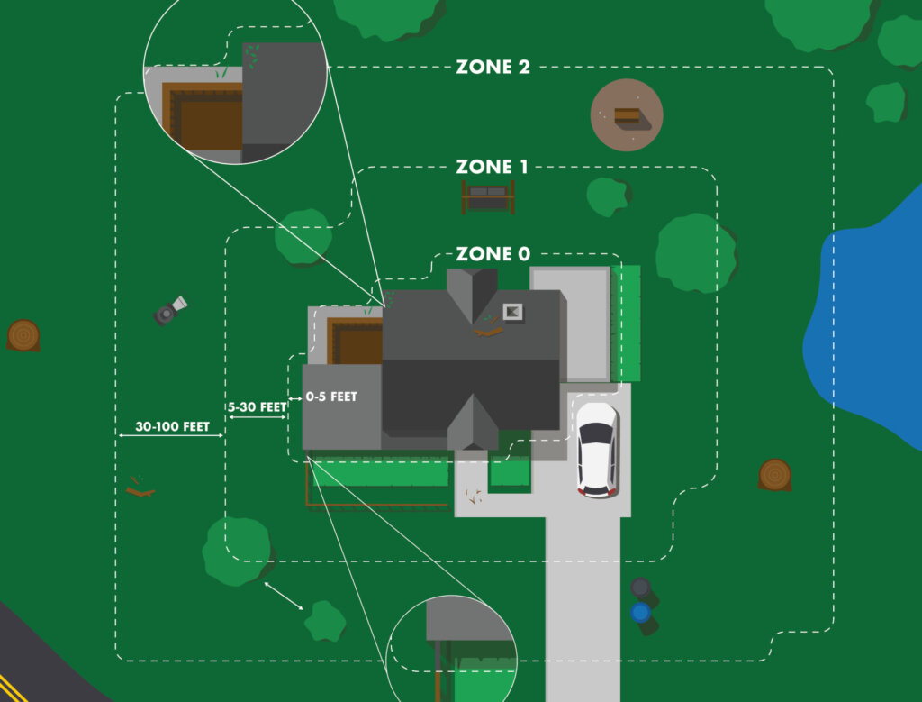
Figure 9. Defensible space distance requirements (Image credit: https://readyforwildfire.org/prepare-for-wildfire/defensible-space/)

Parcel-Level Assessments
[TEXT]

Ignitability Measures for Critical Infrastructure
In addition to individual private parcel structure ignitability measures, the [COMMUNITY] CWPP is addressing the reduction of structural ignitability to critical infrastructure in the following ways:
[TEXT]

Wildfire Response and Suppression Capabilities
An assessment of the wildfire response and suppression capabilities within the [COMMUNITY] CWPP was undertaken to evaluate whether the current resources, organization, and strategies are appropriate for the expected wildfire impingements, and if not, what requires improvement. The following was evaluated:
- Emergency social services support capabilities
- Post fire recovery support capabilities
- Other response support (utilities, public works, etc.)
From this evaluation the following has been determined: [TEXT]

Additional Actions
[TEXT]

Appendices
[Include any supplementation information not contained in the main body of the plan, such as documentation of community engagement and public outreach, methodology of the hazard and risk assessment, and additional analyses or baseline data. Depending on how the CWPP is structured, appendices may also be to provide greater details for individual communities within the planning area.]

Appendix A: CWPP Working Group Members and Stakeholders (Example)
This example worksheet helps identify potential CWPP working group members, federal agencies, local experts, and interested parties. Note that not all listed agencies and organizations may be applicable.
CWPP Working Group Members and Stakeholders
Agency / Organization | Primary Contact | Alternate Contact | Role
Federal Government
U.S. Forest Service
Bureau of Indian Affairs
Bureau of Land Management
National Parks
US Fish and Wildlife
State / Tribal Governments
California Department of Forestry and Fire Protection
California Department of Transportation
California Office of Emergency Services
California Air Resources Board
University of California Cooperative Extension
Tribal Nations
Local Jurisdiction Departments
Planning / Building Department
Fire Department / Fire Protection Districts
Public Works Department
Geographic Information Systems Department
Local Elected Officials
Emergency Services
Sheriff’s Office
Elected Officials / other Local Leadership
Local Fire / Forestry and Natural Resource Groups or Organizations
Fire Safe Councils
Forest Management Groups
Firewise Community Leaders
Resource Conservation Districts or Land Trusts
Watershed Council / Collaboratives
Prescribed Burn Associations
Critical Infrastructure
Critical Infrastructure Companies or Districts
Electric / Power Utilities
Water Utility Districts
Air Quality Management District
Other Organizations
Homeowner Associations
Non-governmental Organizations
Volunteer Organizations
Other Special Districts and Councils

Appendix B: Applicable Plans and Regulations (Example)
[Examples of Plans and Regulations reviewed to inform the CWPP planning process and content development. Update list to reflect applicable local plans and regulations. State legislation should also be monitored for any additional impacts on CWPP planning and regulatory considerations.]
Applicable Plans and Regulations
 | Resource Title (and applicable sections) | Additional Notes or Links
Federal (examples)
 | Healthy Forests Restoration Act
 | Disaster Mitigation Act (Stafford Act)
 | National Fire Plan
 | National Cohesive Wildland Fire Management Strategy
 | Wildland Fire Mitigation and Management Commission Report
State (examples)
 | 2018 Strategic Fire Plan for California (Board of Forestry and Fire Protection)
 | California’s Wildfire and Forest Resilience Action Plan (2021)
 | California State Hazard Mitigation Plan (2023)
Public Resources Code
Division 4. Forests, Forestry and Range and Forage Lands
California Code of Regulations
Title 14. Natural Resources
Division 1.5 Department of Forestry and Fire Protection
Title 24. Building Standards Code
Part 2 – California Building Code (Chapter 7A)
Part 2.5 – California Residential Code
Part 9 – California Fire Code
Part 12 – California Referenced Standards Code
California Government Code
Title 5. Local Agencies
Title 7. Planning and Land Use
California Health and Safety Code
Division 12. Fires and Fire Protection
 | California Environmental Quality Act
Local (examples)
 | General Plan
 | Municipal Code
 | Multi-Jurisdictional or Local Hazard Mitigation Plan
 | Local Coastal Program
 | Utility Wildfire Mitigation Plan
 | Emergency Management Plan
 | CAL FIRE Unit Fire Plan
 | Community / Urban Forestry Plan
 | Local CWPPs
 | Evacuation Plan

Appendix C: Public Outreach and Engagement
[If not already described in the plan, add documentation on the public outreach and engagement activities that were conducted to support CWPP development.]

Appendix D: Community HVRA Prioritization and Risk Assessment table
[Example of a basic community HVRA prioritization and risk assessment table.]

CWPP HVRA Priorities Risk Weighting
HVRA |  | Weight | Sub-Category Weight |  | Combined Weight | Wildfire Threat  Impact
Wildfire Threat Impact:  Beneficial impact: (-1 least beneficial to -5 most beneficial)  No impact: 0  Negative impact: (1 least negative impact to 5 most negative impact) |  |  |  |  |  | Extreme | Very High | High | Moderate | Low
Human Life
 | Critical Facilities
 | Evacuation Routes
Property
 | Residential Properties
 | Commercial Properties
 | Critical Infrastructure
 | Non-Critical Infrastructure
Natural Resources
 | Watersheds
 | Critical Habitat/ Species
 | Non-Critical Habitat/ Species
 | Critical Ecosystem/Forest Health
 | Non-Critical Ecosystem/Forest Health

